Jean de Florette – Jour #1
Directions : Partenaire A
Partner A : Give your partner French clues for each of the 6 words that are written below the word cloud.
Partner B: Listen to your partner’s clues and highlight/circle the word s/he describes in your word cloud.
Repeat, switching roles
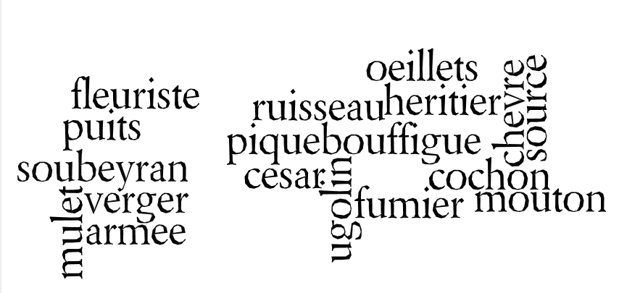

César fleuriste Ugolin œillets puits source

Directions : Partenaire B
Partner A : Give your partner French clues for each of the 6 words that are written below the word cloud.
Partner B: Listen to your partner’s clues and highlight/circle the word s/he describes in your word cloud.
Repeat, switching roles
Soubeyran Pique-bouffigue cochon verger mulet ruisseau

Jean de Florette – Jour #3
Partenaire A
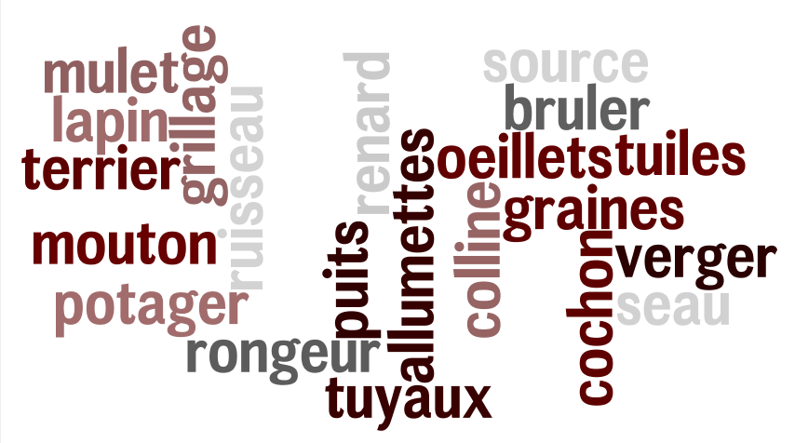
lapin allumette tuyaux grains potager colline

Partenaire B

seau terrier rongeur lapin tuiles bruler

Jean de Florette – Jour #4
Partenaire A
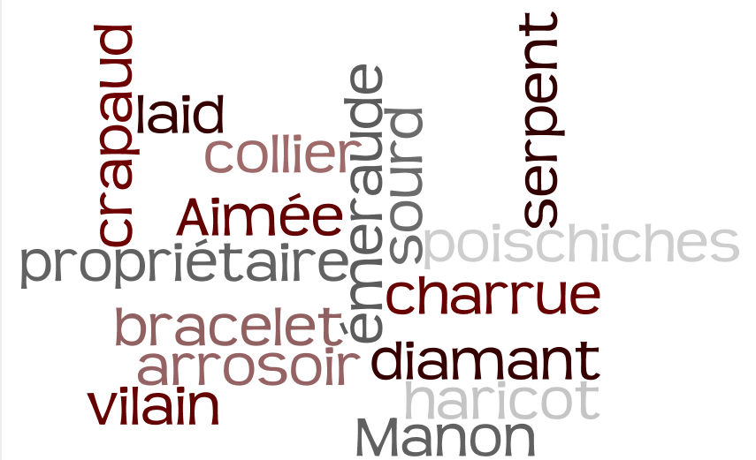
pois chiches crapaud charrue diamant laid émeraude

Partenaire B
vilain arrosoir propriétaire collier sourd Aimée

