Quiz 1 (Screenshot)

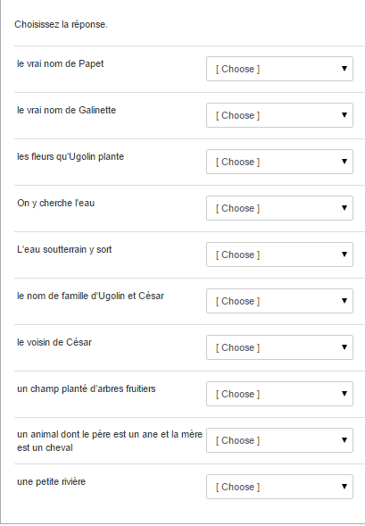

Quiz 2 (Screen shot)

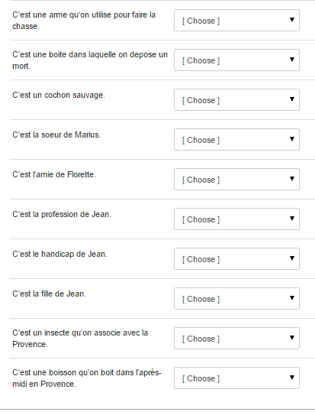

Quiz 3 (Screen shot)

