Français 2 Nom _________________________________________
Activité de Partenaire – Les Chevaliers (Partenaire A)

Partie A
Imagine that you won the lottery and bought a French castle. After you moved in, you had several portraits that you found sent away to be cleaned. Unfortunately, an intern at the art restoration workshop got your paintings mixed up with someone else’s and is calling you in a panic. Luckily, you took a picture of your portraits before sending them in. Describe each of the paintings below and answer your partner’s questions so that s/he can identify which paintings are yours.

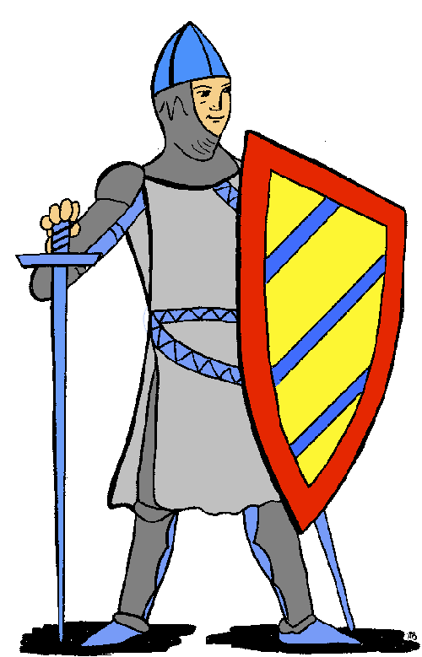 | 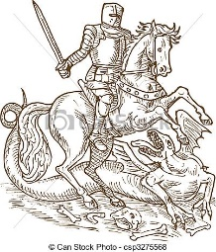 | 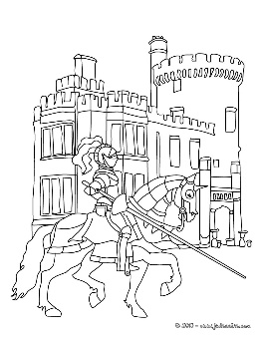 | 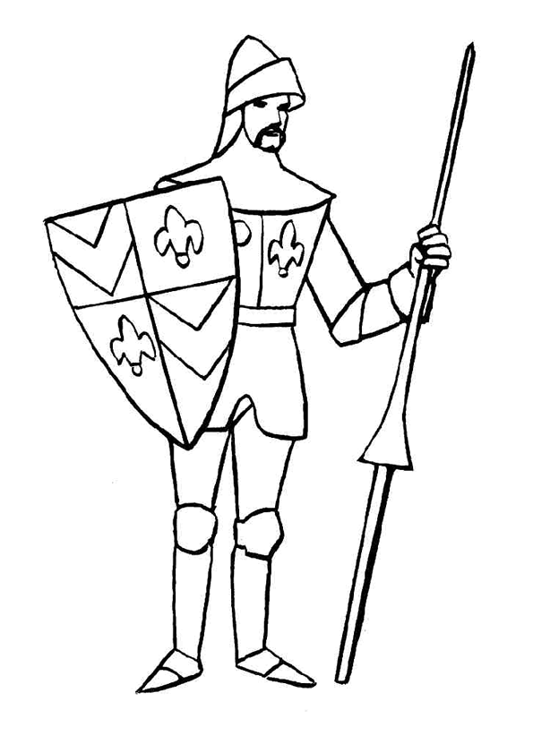
#1 | #2 | #3 | #4
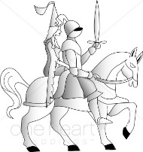 | 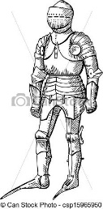 | 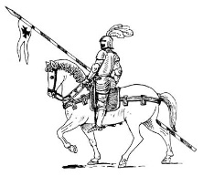 | 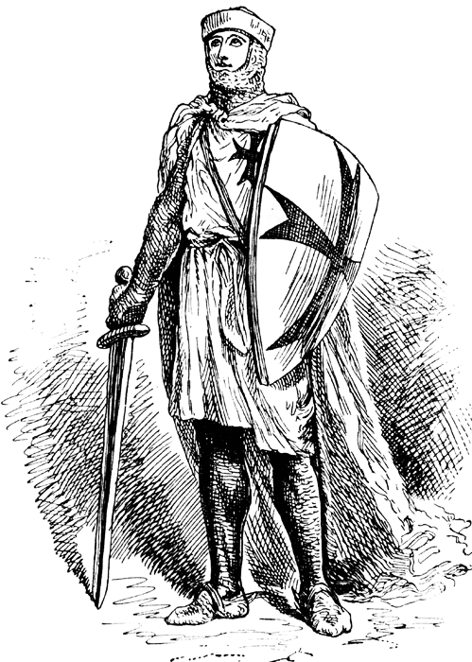
#5 | #6 | #7 | #8

Partie B
Now it is your turn to play the role of the intern. The pictures that you have in your workshop are on the back of this page. Write the number that your partner gives you under each portrait s/he describes. Here are some questions you can ask in order to help you identify each picture:

1. Le chevalier avait...
- une lance ?
- une épée ?
- un bouclier ?
- une bannière ?
2. Il montait à cheval?
3. Il portait…
- une cotte de mailles ?
- une armure de plates ?
- un heaume ?
- un casque ?
4. Il y avait... sur son bouclier/son casque?
- une plume
- une croix
- des fleurs de lys
5. Il attaquait… ?
- un dragon
6. Il joutait ?

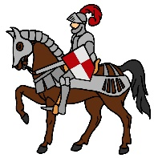 | 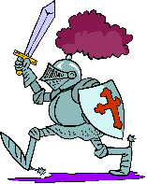 | 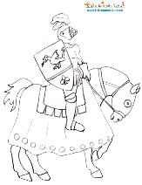
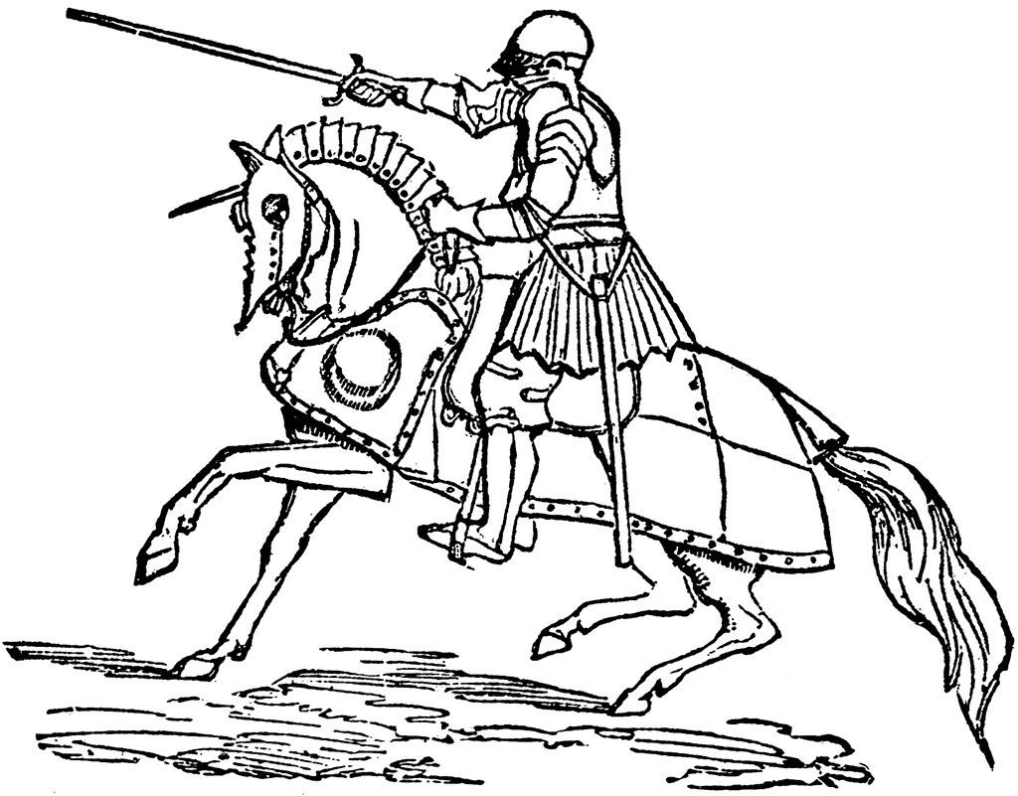 | 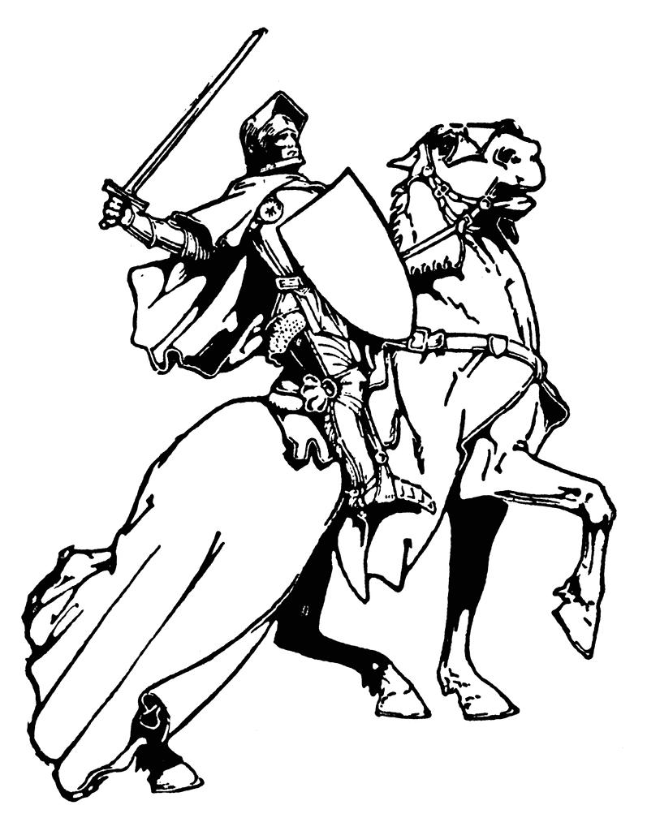 | 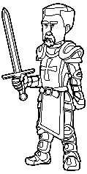 | 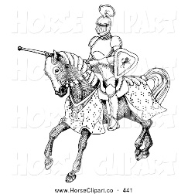 | 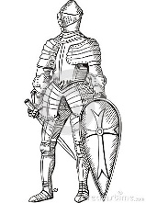
 |  |  | 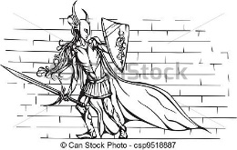
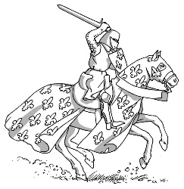 | 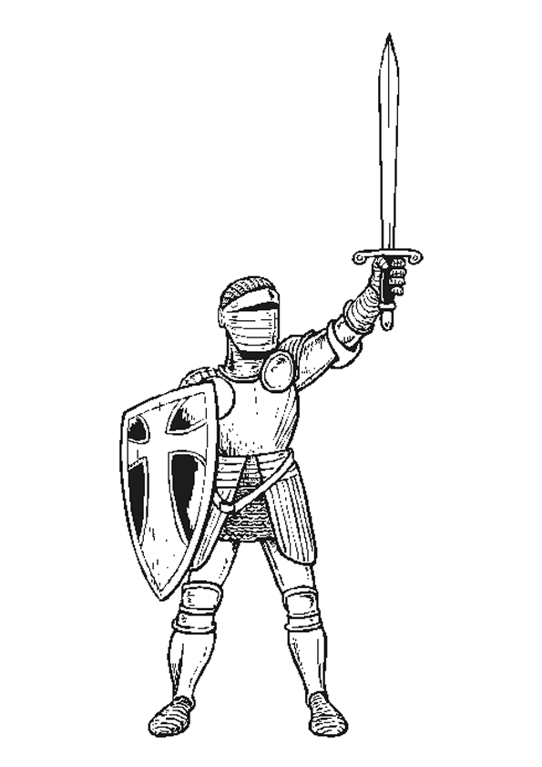 | 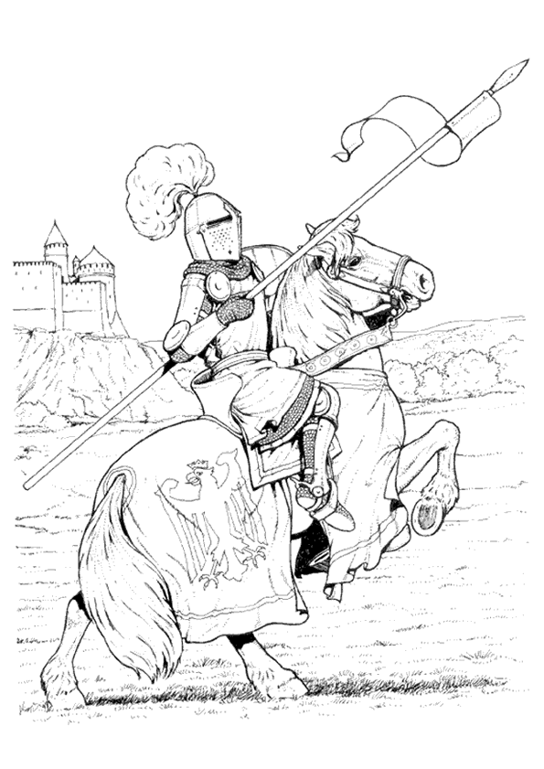 |  | 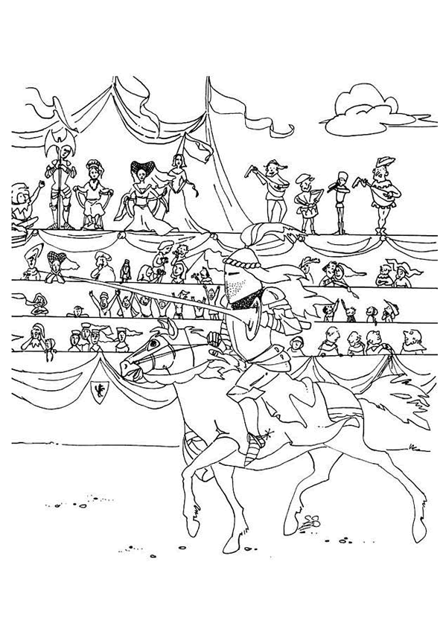
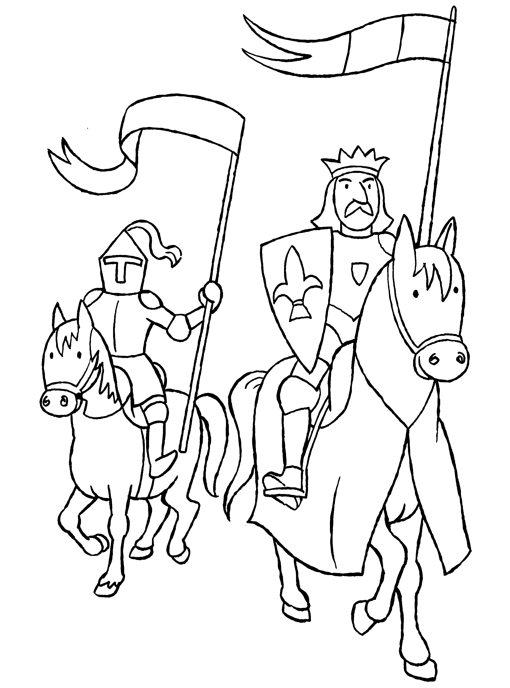 |  | 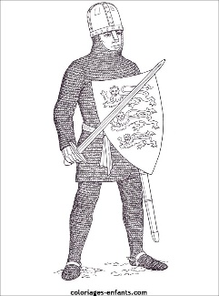 | 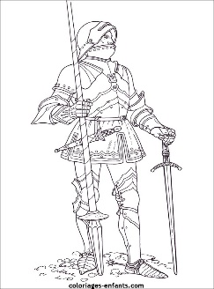 | 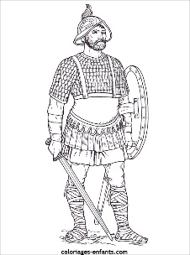

Français 2 Nom _________________________________________
Activité de Partenaire – Les Chevaliers (Partenaire B)
Partie A
You work at an art restoration workshop. Your partner sent you several paintings from his/her collection but you got them mixed up with someone else’s artwork. Ask your partner to describe each of his/her paintings and ask any necessary questions in order to identify which of the paintings in your workshop belong to your partner. Write the appropriate number (#1-#8) under each painting that your partner describes.
 | 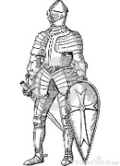
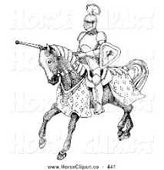
 | 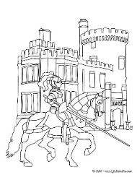 | 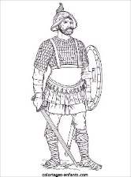 | 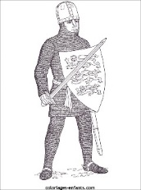
 |  | 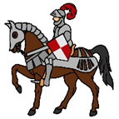 | 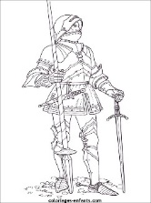

Partie B
Now it is your turn to play the role of the owner of the portraits. Describe each of the following portraits to your partner, who will ask you follow-up questions in order to identify which of the paintings in his/her workshop belong to you.

#1 | #2 | #3 | #4
#5 | #6 | #7 | #8

Here are some questions you can ask to help identify your partner’s portraits:

1. Le chevalier avait...
- une lance ?
- une épée ?
- un bouclier ?
- une bannière
2. Il montait à cheval?
3. Il portait…
- une cotte de mailles ?
- une armure de plates ?
- un heaume ?
- un casque ?
4. Il y avait... sur son bouclier/son casque?
- une plume
- une croix
- des fleurs de lys
5. Il attaquait… ?
- un dragon
6. Il joutait ?

