Français I Nom _____________________________________
Unit 4 IPA

Context: You’ve just graduated from high school and want to spend a year in France before starting college so you’ve decided to become an au pair. First, read the post from a family who is looking for an au pair and complete the comprehension guide. Then watch the French cartoon—you need to be familiar with what French children might watch on TV. Next, send a note to the parents who wrote the post telling them a little about yourself and your experience with children. Lastly, Anna will call you on the phone for a short interview.

Interpretive Reading

A. Key Word Recognition. Find the French words/phrases that best express the meanings of the following English words/phrases.

1. young ____________________________
2. A family____________________________
3. Activities____________________________
4. School____________________________
5. she likes____________________________
6. daughter____________________________
7. mother____________________________
8. she plays____________________________
9. movie theater____________________________

B. What is the main idea of this document? Answer in English.
______________________________________________________________________________________________________________________________________________________________________________________________________________________________________________________________________________________________________

C. Supporting Details.
1. Check each detail that is mentioned in the article (not all are included).
2. Fill in the information that is given for each detail you have checked. Write in English.
___Gabrielle’s age ___________________
___The grade that Gabrielle is in___________________
___What Gabrielle looks like __________________________________________________________________________
___What Gabrielle’s personality is like___________________________________________________________________
___When Gabrielle goes to school_____________________________________________________________________
___Gabrielle’s favorite subject________________________________________________________________________
___When she has free time/doesn’t go to school__________________________________________________________
___The activities that Gabrielle does (name as many as you can) _____________________________________________
__________________________________________________________________________________________________
___The language that Gabrielle is learning_____________________________
___Anna’s age___________________
___What Anna likes to do (name as many as you can) _____________________________________________
__________________________________________________________________________________________________
___Jerome’s age___________________
___What he likes (name as many as you can) _____________________________________________
__________________________________________________________________________________________________
___Who“R” is___________________________________
___Who“S” is ___________________________________
___The type of personality they’d like their au pair to have__________________________________________________
___The activities you can do in their town_______________________________________________________________
__________________________________________________________________________________________________

D. Guessing Meaning from Context.
Find the underlined words/phrases and write what you think they mean in English. The information in parenthesis tells you which paragraph the word appears in.
(All words found in the A notre sujet portion of the text.)
- Gabrielle adore aller jouer avec ses nombreux copains et copines du square voisin (1st par.) ________________
- Le père de Jérôme, R. bactériologiste en retraite, habite la moitié de l’année à Toulon.. (3rd par.) ________________
- Toute la famille habite un appartement de 150 m2 avec un jardin de 90m 2. (4th par.) ________________
- Le domicile est situé à 5 minutes de pied de la gare de Riom d’où partent de fréquents trains pour Clermont-Fernand ou pour Vichy (4th par.) ________________
E. Inference. Answer the following question(s) in English, giving us much information from the article as possible to support your response.
1. Why do you think this family wants to hire an “au pair?” __________________________________________________
__________________________________________________________________________________________________
2. Do you think this family will get many replies to their post? Why or why not? _________________________________
__________________________________________________________________________________________________
__________________________________________________________________________________________________

F. Comparing Cultural Perspectives. Answer the following questions in English.
The United States did not start an au pair program until 1989, while it has been popular in Europe since WWII. Why do you Americans might be less interested in having an au pair than a French family would be?
__________________________________________________________________________________________________
__________________________________________________________________________________________________
__________________________________________________________________________________________________
__________________________________________________________________________________________________

G. Would you like to work as an au pair for this family? Why or why not? Answer in French, and cite specific details from the post.
______________________________________________________________________________________________________________________________________________________________________________________________________________________________________________________________________________________________________

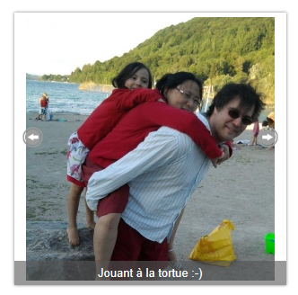
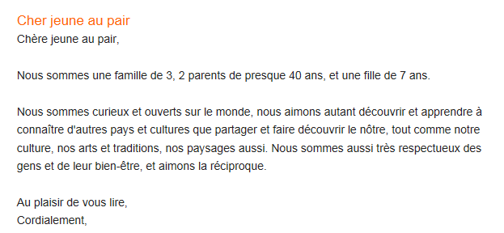
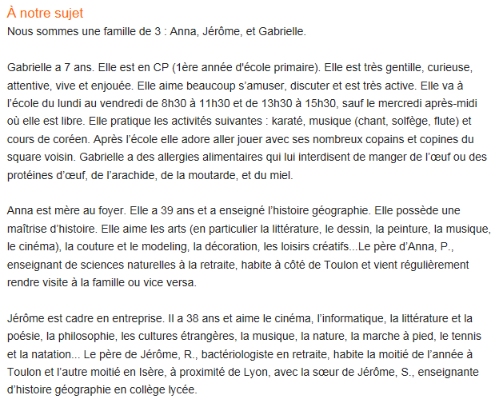
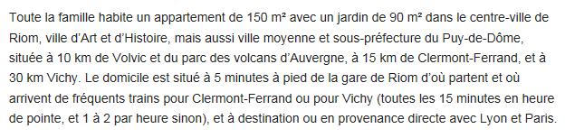
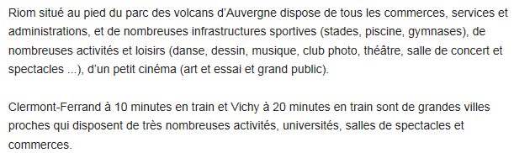
https://www.aupair-world.fr/aupair_detail?&a=2296059#letter_two

Interpretive Listening
Complete the quiz on Canvas.
Presentational Writing

You found Anna and Jerome’s post, and you’d like to live with them and take care of Gabrielle. Send them a note in which you tell them all about yourself so that they’ll choose you as their au pair. Tell them all about yourself (name, age, personality, likes/dislikes, etc.). Also include information about your own family and what you do to help out around the house so that they’ll know you have the right kind of experience.

Chers Anna et Jerome
____________________________________________________________________________________________________________________________________________________________________________________________________________________________________________________________________________________________________________________________________________________________________________________________________________________________________________________________________________________________________________________________________________________________________________________________________________
____________________________________________________________________________________________________________________________________________________________________________________________________________________________________________________________________________________________________________________________________________________________________________________________________________________________________________________________________________________________________________________________________________________________________________________________________________
______________________________________________________________________________________________________________________________________________________________________________________________________________________________________________________________________________________________________________________________________________________________________________________________________________________________________________________________________________________________________________________________________________________________________________________________________________________________________________________________________________________________________________
________________________________________________________________________________________________________________________________________________________________________________________________________________________________________________________________________________________________________________________________________________________________________________________________________________________________________________________________________________________________________________________________________________________________________________________________________________________________________________________________________________________________________________________________________________________________________________________________________________

Interpersonal Communication
Partner A: You are Anna or Jerome. Call your prospective au pair and try to find out a little more about him/her and his/her experience with children.
Partner B: When Ann or Jerome calls, answer his/her questions and ask some of your own to find out more about their family.

