Français I Nom _____________________________________________
Partenaire A

Imagine that you are a teenager who lives in Quebec and your family celebrates Noël. These pictures represent what you do to celebrate this holiday. (Note: Although these pictures represent typical Christmas activities, family traditions vary throughout Quebec and other Francophone regions.)
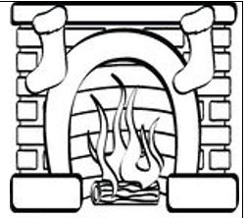 |  |  | 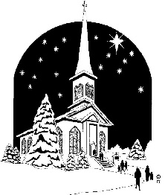 | 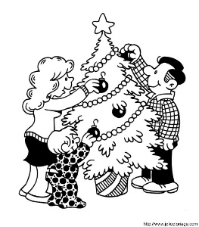
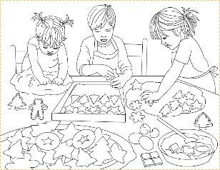 | 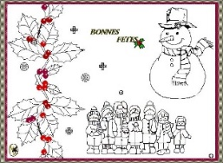 | 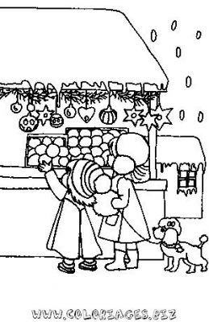

Interview your partner and then fill in the Venn Diagram comparing your Noel traditions with your partner’s.
Example:
Q: Tu manges des huitres?
A : Oui, je mange des huitres. (You will both write « Nous mangeons des huitres. » in the middle of the diagram.) OR
A: Non, je ne mange pas d’huitres. (You will write « Je mange des huitres. » on the left side of your diagram and your partner will write “Il/Elle mange des huitres.” on the right side of his/her diagram.)

Français I Nom _____________________________________________
Partenaire B

Imagine that you are a teenager who lives in Paris and your family celebrates Noël. These pictures represent what you do to celebrate this holiday. (Note: Although these pictures represent typical Christmas activities, family traditions vary throughout France and other Francophone regions.)

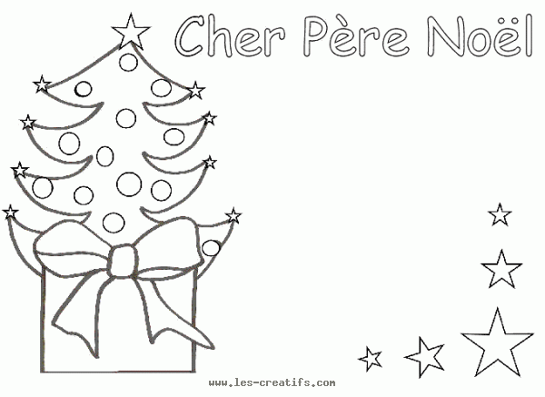 | 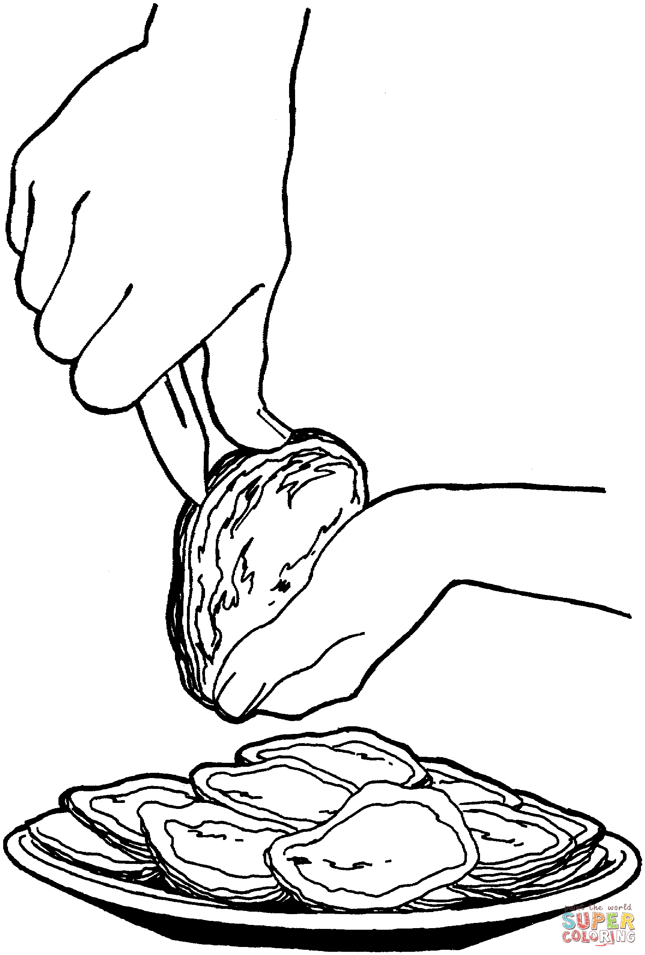 | 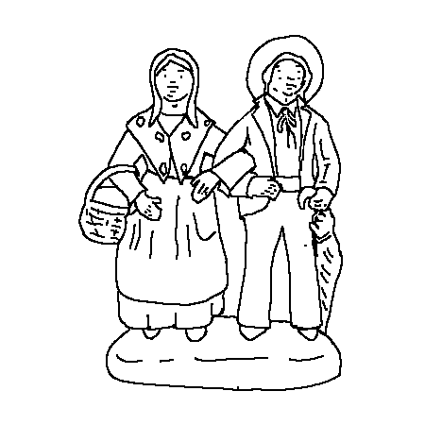 | 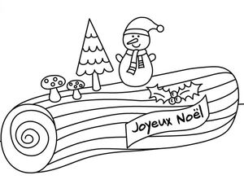
 |  |  |  | 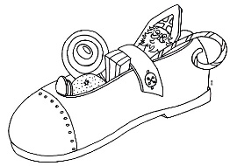

Interview your partner and then fill in the Venn Diagram comparing your Noel traditions with your partner’s.
Example:
Q: Tu manges des huitres?
A : Oui, je mange des huitres. (You will both write « Nous mangeons des huitres. » in the middle of the diagram.) OR
A: Non, je ne mange pas d’huitres. (You will write « Je mange des huitres. » on the left side of your diagram and your partner will write “Il/Elle mange des huitres.” on the right side of his/her diagram.)

