Français 1 Nom ______________________________________
Les Traditions de Noël – Partenaire A

You and your partner are both French people who celebrate Noël. You want to go shopping the week before, but you’re both very busy. Ask him/her what s/he is doing each day for each block of time and write a sentence in the appropriate square. Meanwhile s/he will be doing the same. After you have finished, suggest a day/time to go shopping, based on the block of time neither of you have filled in. « On fait du shopping …. ? »

Your Schedule Your Partner’s schedule
 | Matin/Après-midi | Soir | Matin/Après-midi | Soir
samedi | 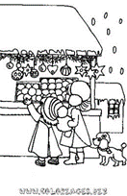 |  |  | Ex. Elle/Il écrit une lettre à Père Noel.
dimanche
lundi | 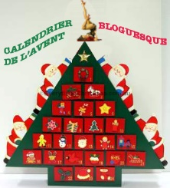 | 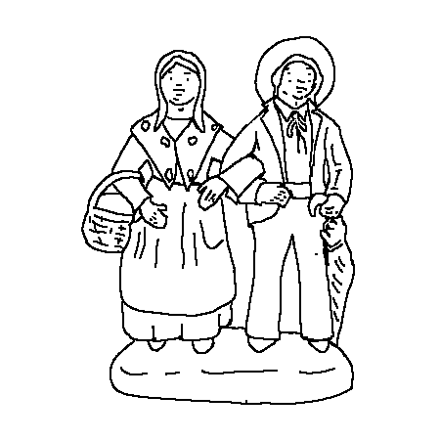
mardi |  | 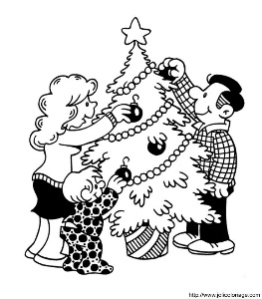
mercredi |  | 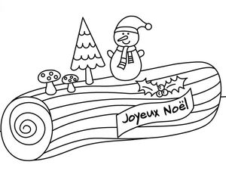
jeudi | 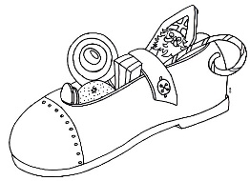
Vendredi

Français 1 Nom ______________________________________
Les Traditions de Noël – Partenaire B
You and your partner are both French people who celebrate Noël. You want to go shopping the week before, but you’re both very busy. Ask him/her what s/he is doing each day for each block of time and write a sentence in the appropriate square. Meanwhile s/he will be doing the same. After you have finished, suggest a day/time to go shopping, based on the block of time neither of you have filled in. « On fait du shopping …. ? »

Your Schedule Your Partner’s Schedule
 | Matin/Après-midi | Soir | Matin/Après-midi | Soir
samedi |  |  |  | Ex. Il/Elle echange des cadeaux.
dimanche |  | 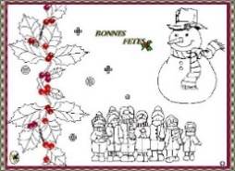
lundi
mardi
mercredi
jeudi
vendredi | 