Halloween Matching Activity #1: Partner A

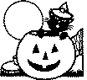 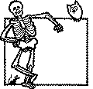 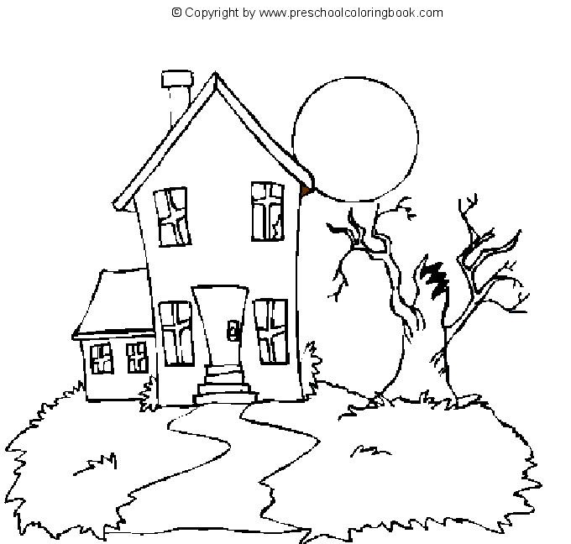 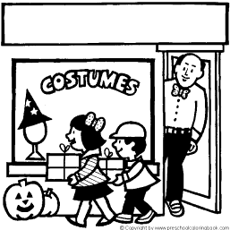

1. 2. 3. 4.

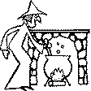 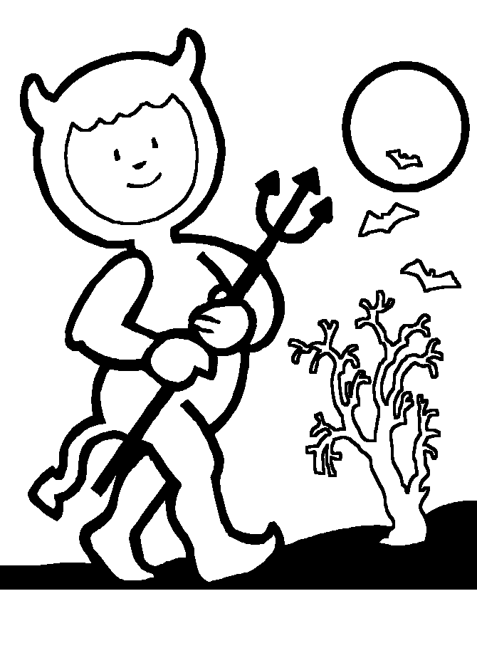 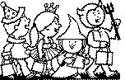 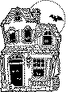[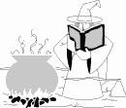](file:///\\HPFS_STAFF\Staff$\ShepardLi\holidays\Halloween\pages\hallw031.html)

5. 6. 7. 8. 9.

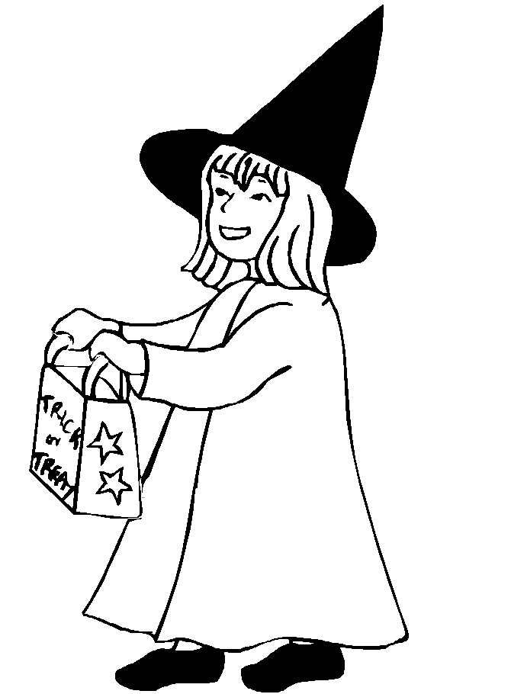 [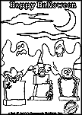](file:///\\HPFS_STAFF\assets\images\fun_stuff\holidays\halloween\coloring_book\color-grave.gif) [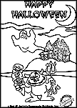](file:///\\HPFS_STAFF\assets\images\fun_stuff\holidays\halloween\coloring_book\color-imp-house.gif) 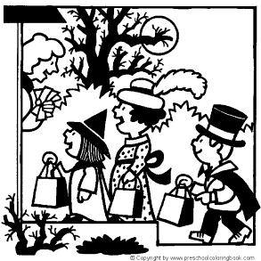 [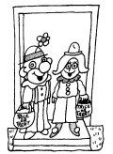](file:///\\HPFS_STAFF\Staff$\ShepardLi\holidays\Halloween\pages\halloween-7.html)

10. 11. 12. 13. 14.

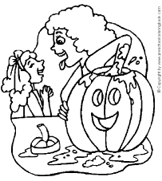 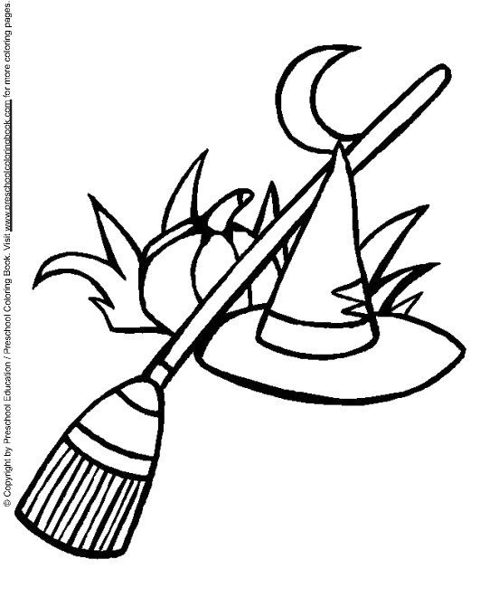 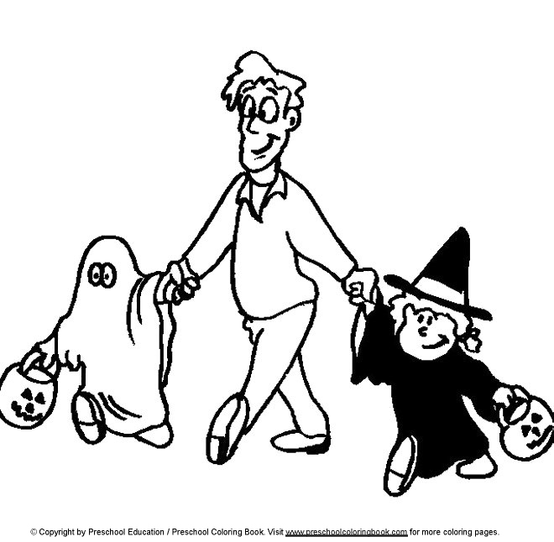 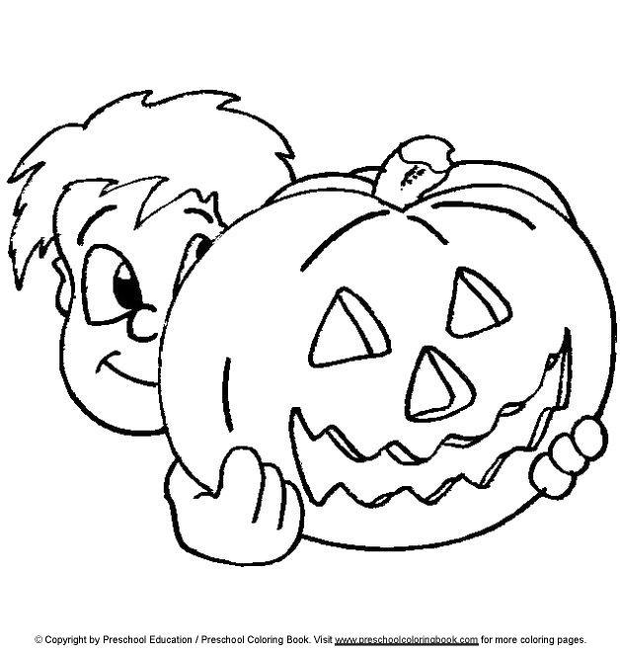

15. 16. 17. 18.

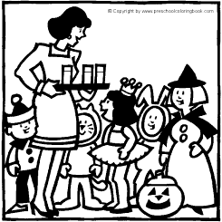 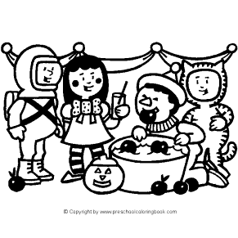 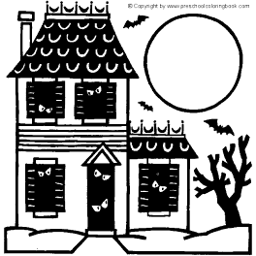 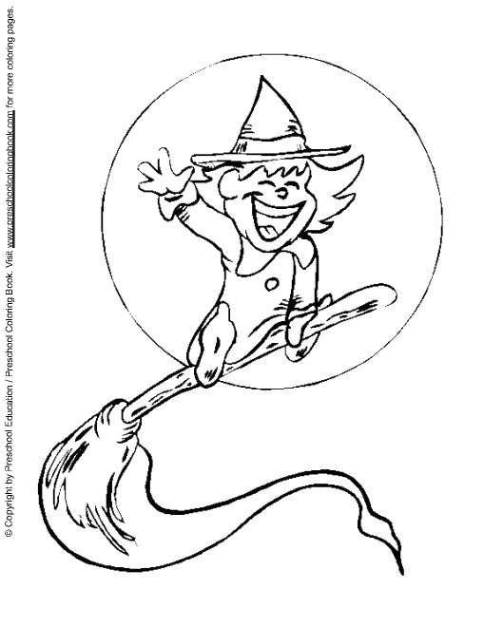

19. 20. 21. 22.

Halloween Matching Activity #1: Partner B

 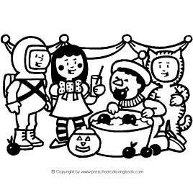 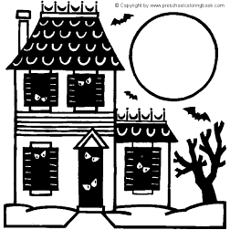 

a. b. c. d.

  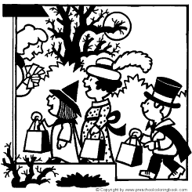 

e. f. g. h.

[](file:///\\HPFS_STAFF\assets\images\fun_stuff\holidays\halloween\coloring_book\color-grave.gif)  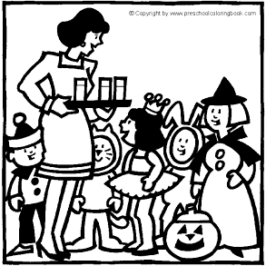 

i. j. k. l.

[](file:///\\HPFS_STAFF\Staff$\ShepardLi\holidays\Halloween\pages\halloween-7.html)

m. n. o. p. q.

[](file:///\\HPFS_STAFF\Staff$\ShepardLi\holidays\Halloween\pages\hallw031.html) [](file:///\\HPFS_STAFF\assets\images\fun_stuff\holidays\halloween\coloring_book\color-imp-house.gif)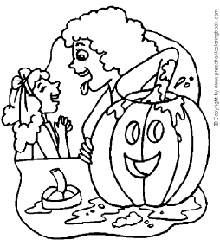

r. s. t. u. v.