Leçon 3: Comment Inviter et répondre
A. Read these Tweets and see if you can understand what the writer is asking his/her friend to do.

1.

2.

3. 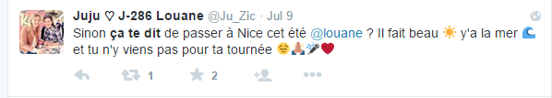

4. .
5.

6.

7.

8.
9.

10. 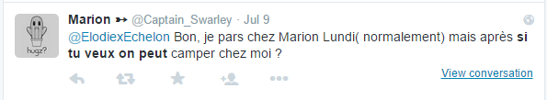

11.

12. 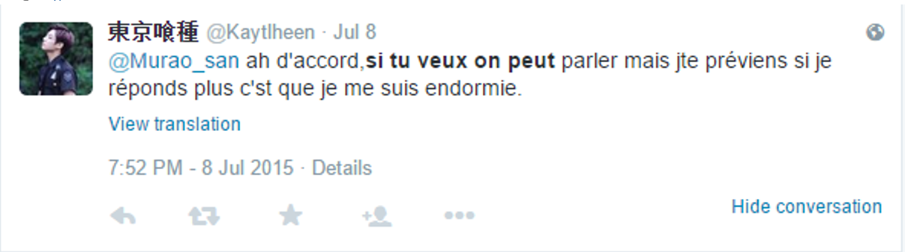

13. 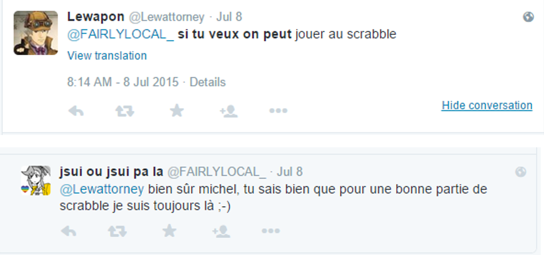

14.
15. 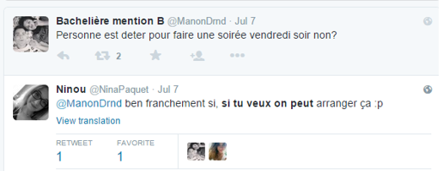

16. 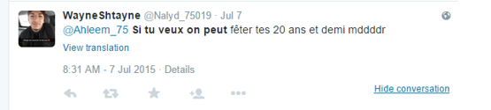
17.
18.
19.
20.

B. Write a Tweet to each member of your group, asking him/her to do something with you. Each Tweet should be at least 2 sentences. Write your Tweets in the forms on the left side below. Use the abbreviations on the handout (http://www.magicmaman.com/,le-langage-texto-de-a-a-z,332,1103560.asp )to make sure you stay under your limit of 140 characters.
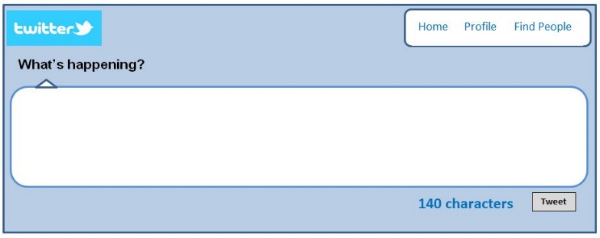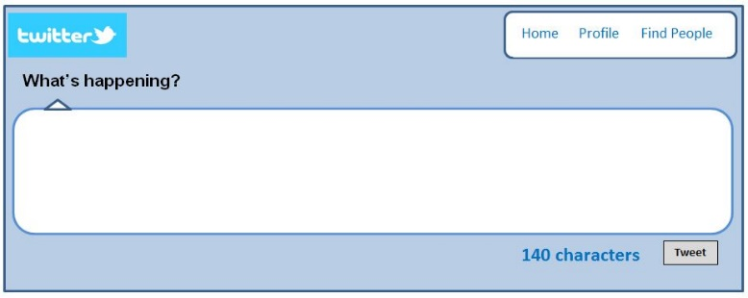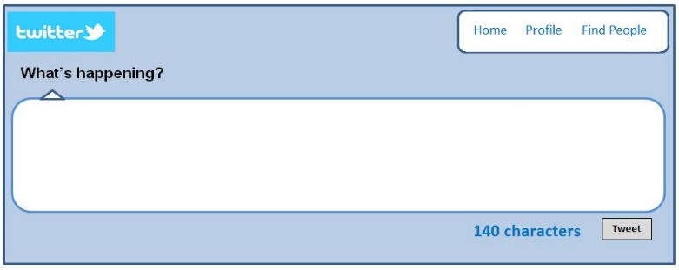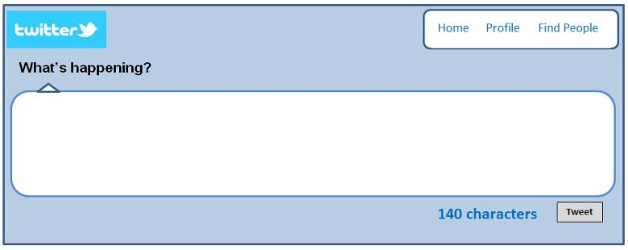
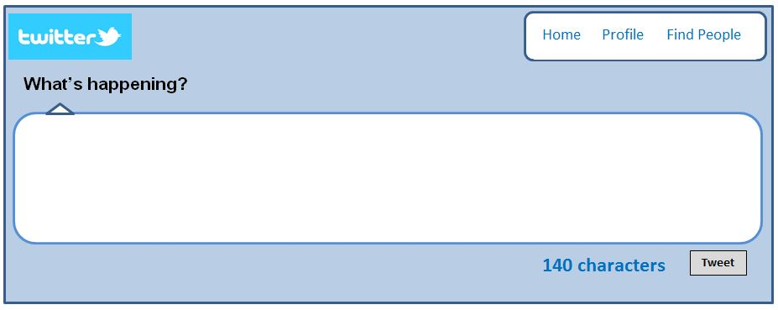

C. Now read each of these Tweets. What do you think each one means?

1. 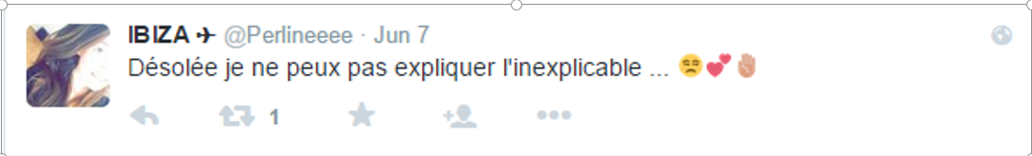

2.

3. 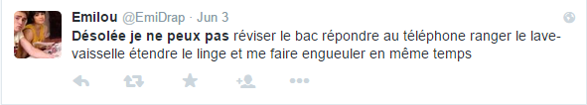

4. 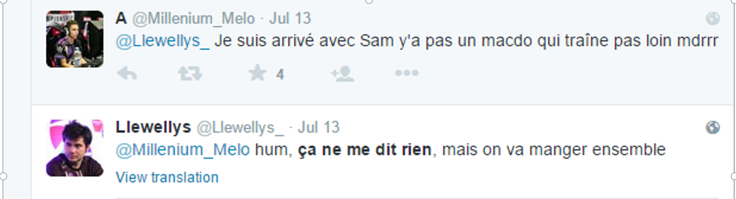

5. 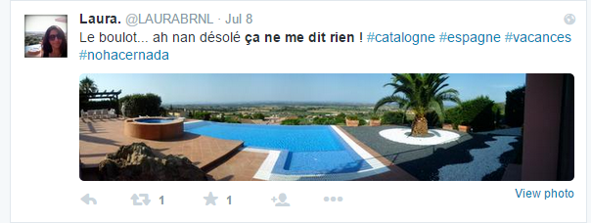

6. 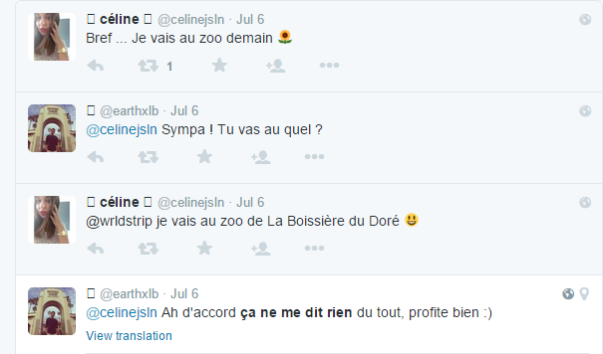

7. 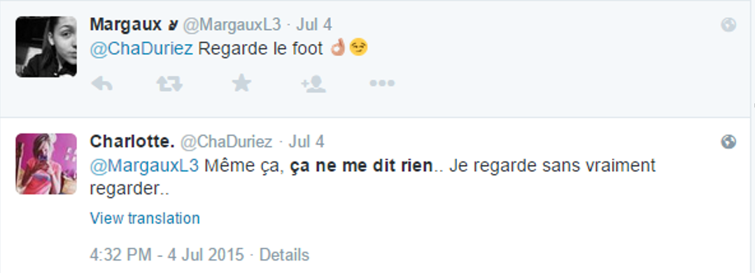

8. 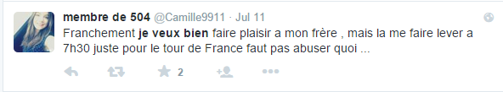

9. 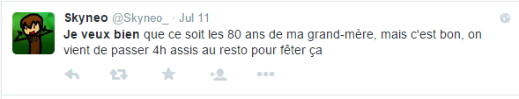
10.
D. Now, look at the Tweets that the members of your group have written to you and respond to each one (in the box to the right of it). You may agree to or refuse each activity to which you’ve been invited.

Communication Interpersonnelle
You and your partner are good friends who are spending the weekend together. Follow the directions below until the entire agenda has been filled in.
Partenaire A: Invite your partner to do something with you, using one of the expressions you learned in the Tweets.
- Idées: aller au cinéma, venir chez toi, jouer au foot, aller au parc, jouer à des jeux-vidéo, etc.
Partenaire B: Accept or reject your partner’s invitation, based on your own preferences. If you accept, ask a follow up questions about what, when, and where. If you reject the invitation, offer an invitation of your own.
- Où est-ce qu’on se retrouve?
- A quelle heure est-ce qu’on…
Partenaire A: If your partner invites you to do something, either accept or reject his/her invitation using one of the expressions you used from the Tweets. If you accept, ask a follow up questions about what, when, and where. If you reject the invitation, offer an invitation of your own.
 | Activité (avec quelques détails) | Lieu | Heure
Vendredi soir
Samedi matin
Samedi après-midi
Samedi soir
Dimanche matin

Présentation Ecrite
Create a series of Tweets in which you invite the new French foreign exchange student to hang out with you and your friend on Saturday. S/he will have lots of questions about the details, and you will answer them.
Note: Write your Tweets in the column on the left and the exchange student’s on the right.

