Francais I (Partner A)

La Chambre - Matching

You and your partner will take turns describing your pictures in order to fill in the corresponding number/letter.

|  |  |  |
| --- | --- | --- |
| http://www.clipart-box.com/zoom/bedroom120212.jpg | http://www.clipartpal.com/_thumbs/bedroom_home_181709_tnb.png | http://www.clker.com/cliparts/0/h/v/h/1/R/bedroom-hi.png |
| 1. | 2. | 3. |
| http://comps.canstockphoto.com/can-stock-photo_csp13470670.jpg | https://encrypted-tbn2.gstatic.com/images?q=tbn:ANd9GcQVelzjDbbYQ1NwjVolBsfXV3w5rK9Q62K7LNxU64-eBtF5fnAF | https://encrypted-tbn3.gstatic.com/images?q=tbn:ANd9GcRF54LZ1UNxusZtlXLH0DzbWV9dAsYWk2Wo4X6sOhxIH0v4I_bH |
| 4. | 5. | 6. |
| http://sr.photos3.fotosearch.com/bthumb/CSP/CSP664/k6642407.jpg | http://thumbs.gograph.com/gg3998485.jpg | http://comps.gograph.com/smal-bedroom_gg60704625.jpg |
| 7. | 8. | 9. |
| http://thumbs.dreamstime.com/x/bedroom-17385321.jpg | http://sr.photos3.fotosearch.com/bthumb/CSP/CSP528/k5282427.jpg | http://sr.photos3.fotosearch.com/bthumb/CSP/CSP991/k11763867.jpg |
| 10. | 11. | 12. |

Francais I (Partner B)

La Chambre - Matching

You and your partner will take turns describing your pictures in order to fill in the corresponding number/letter.

|  |  |  |
| --- | --- | --- |
| http://sr.photos3.fotosearch.com/bthumb/CSP/CSP528/k5282427.jpg | http://www.clipartpal.com/_thumbs/bedroom_home_181709_tnb.png | http://thumbs.dreamstime.com/x/bedroom-17385321.jpg |
| a. | b. | c. |
| http://www.clker.com/cliparts/0/h/v/h/1/R/bedroom-hi.png | https://encrypted-tbn2.gstatic.com/images?q=tbn:ANd9GcQVelzjDbbYQ1NwjVolBsfXV3w5rK9Q62K7LNxU64-eBtF5fnAF | http://sr.photos3.fotosearch.com/bthumb/CSP/CSP991/k11763867.jpg |
| d. | e. | f. |
| http://sr.photos3.fotosearch.com/bthumb/CSP/CSP664/k6642407.jpg | http://thumbs.gograph.com/gg3998485.jpg | http://comps.gograph.com/smal-bedroom_gg60704625.jpg |
| g. | h. | i. |
| http://www.clipart-box.com/zoom/bedroom120212.jpg | http://comps.canstockphoto.com/can-stock-photo_csp13470670.jpg | https://encrypted-tbn3.gstatic.com/images?q=tbn:ANd9GcRF54LZ1UNxusZtlXLH0DzbWV9dAsYWk2Wo4X6sOhxIH0v4I_bH |
| j. | k. | l. |

Partenaire A: Même/Différent (La Cuisine)

|  |  |
| --- | --- |
| dglxasset[1] 1. | dglxasset[2] 2. |
| dglxasset[4]3. | dglxasset[2] 4. |
| dglxasset[1] 5. | dglxasset[3] 6. |
| dglxasset[3] 7. | dglxasset[4] 8. |
| dglxasset[1] 9. | dglxasset[1] 10 |
| dglxasset[1] 11. | dglxasset[2] 12 |

Partenaire B: Même/Différent (La Cuisine)

|  |  |
| --- | --- |
| dglxasset[1] 1. | dglxasset[2] 2. |
| dglxasset[5] 3. | dglxasset[5] 4. |
| dglxasset[1] 5. | k2976363 6. |
| dglxasset[2] 7. | dglxasset[2] 8. |
| dglxasset[2] 9. | MC900352437[1] 10. |
| dglxasset[1] 11. | dglxasset[2]12. |

Pair Matching Activity (Le Salon) Partenaire A

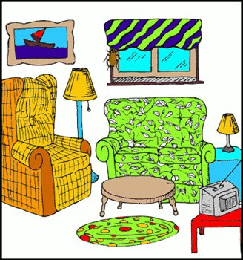 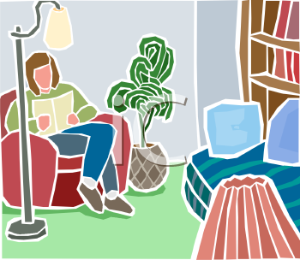 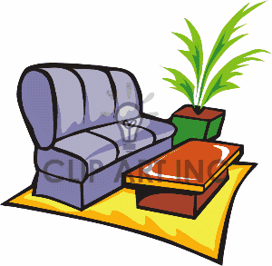 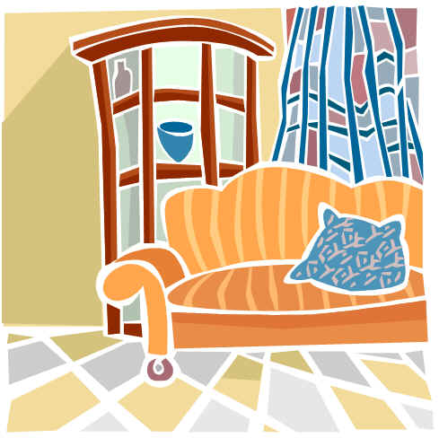

1. 2. 3. 4.

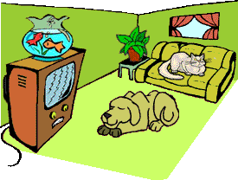 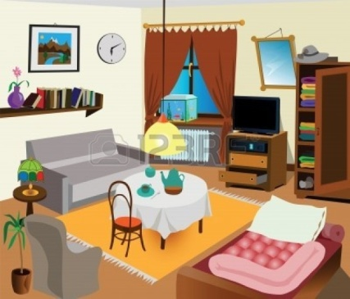 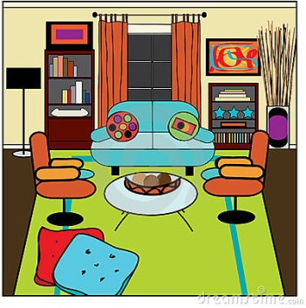

5. 6. 7.

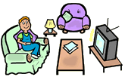  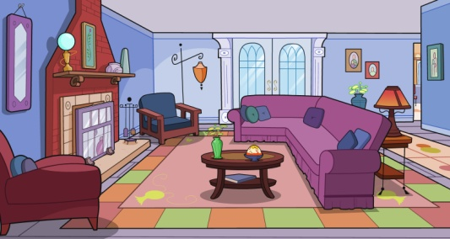

8. 9. 10.

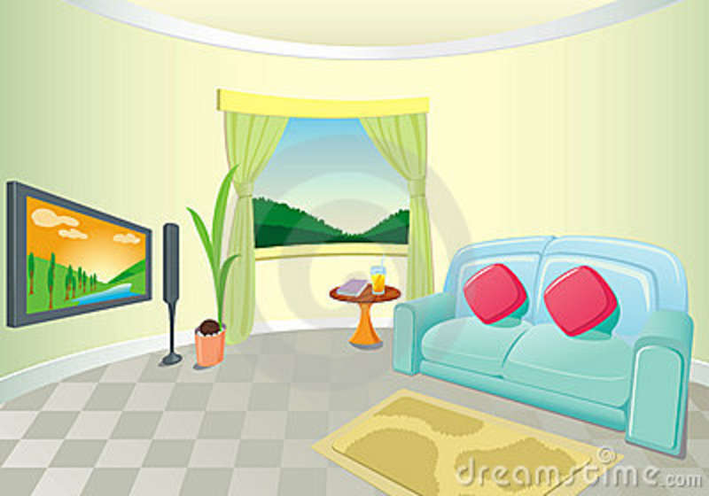 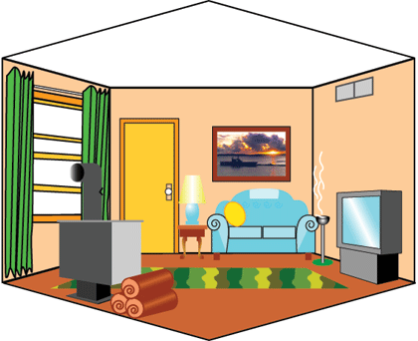 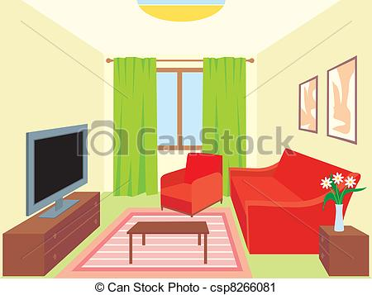

11. 12. 13.

C:\Users\shepardli\AppData\Local\Microsoft\Windows\Temporary Internet Files\Content.IE5\73J7DWWB\MC900059362[1].wmf C:\Users\shepardli\AppData\Local\Microsoft\Windows\Temporary Internet Files\Content.IE5\L4BS7WB2\MC900036425[1].wmf 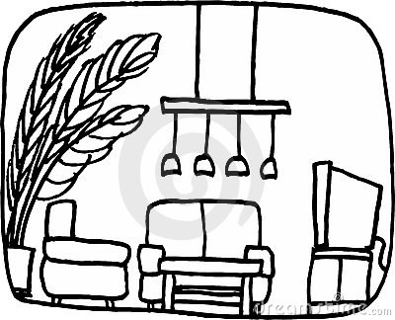

14. 15. 16.

Pair Matching Activity (Le Salon) Partenaire B



a. b. c. d.

 

e. f. g. h.

C:\Users\shepardli\AppData\Local\Microsoft\Windows\Temporary Internet Files\Content.IE5\L4BS7WB2\MC900036425[1].wmf

i. j. k. l.

C:\Users\shepardli\AppData\Local\Microsoft\Windows\Temporary Internet Files\Content.IE5\73J7DWWB\MC900059362[1].wmf

m. n. o.



p.

Pair Matching Activity (La Maison) Partenaire A

MC900391412[1] 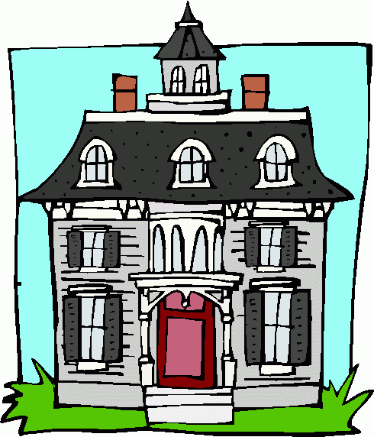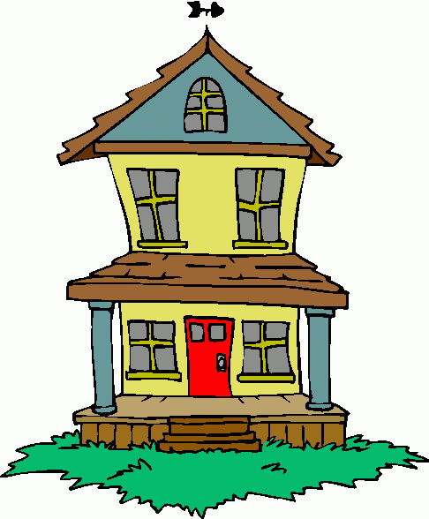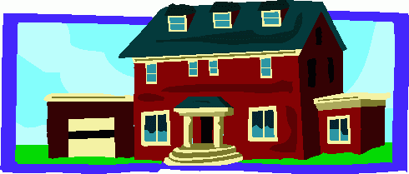

1. 2. 3 4.

  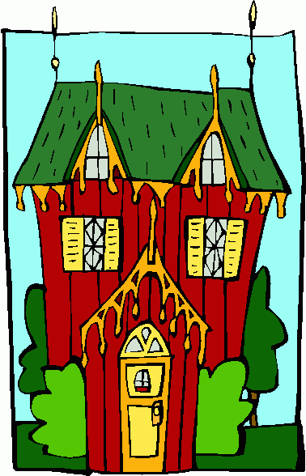 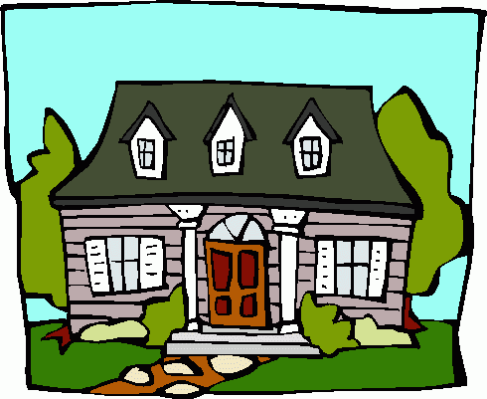

5. 6. 7. 8.

MC900389392[1]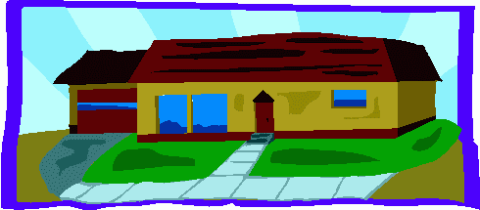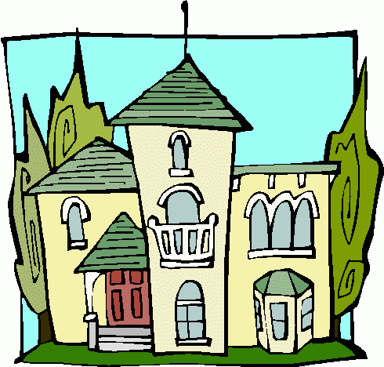

9. 10. 11. 12.

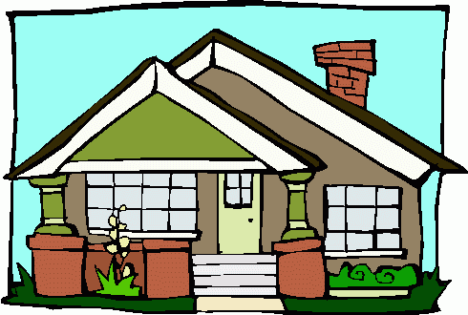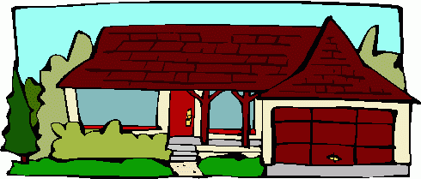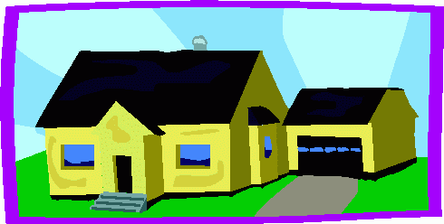 

13. 14. 15. 16. 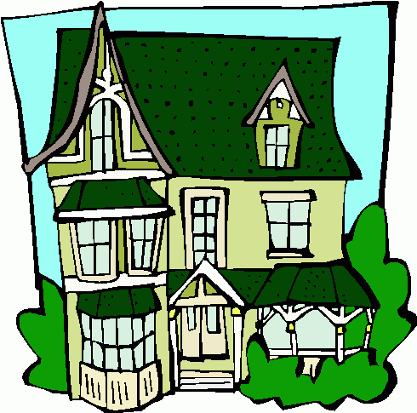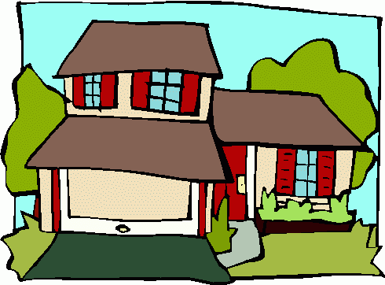 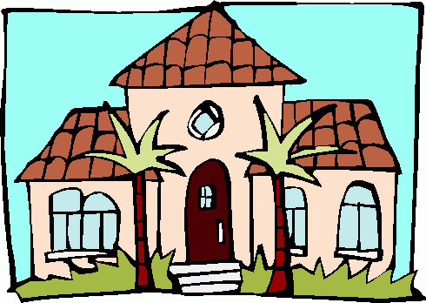

17. 18. 19. 20.

Pair Matching Activity (La Maison) Partenaire B

MC900389392[1]

A. B. C. D.

 MC900391412[1] 

E. F. G. H.

 

I. J. K. L.

 

M. N. O. P.

   

Q. R. S. T.

Même/Différent (La Salle de Bain) Partenaire A

|  |  |  |  |
| --- | --- | --- | --- |
| http://sr.photos3.fotosearch.com/bthumb/IMZ/IMZ203/nri0115.jpg1. | Happy Toilet2. | C:\Users\shepardli\AppData\Local\Microsoft\Windows\Temporary Internet Files\Content.IE5\8U13HPX4\MC900232153[1].wmf 3. | C:\Users\shepardli\AppData\Local\Microsoft\Windows\Temporary Internet Files\Content.IE5\J4QVXZ6A\MC900215471[1].wmf4. |
| Claw Foot Bath Tub5. | Sink with Running Water6. | Man Thinking on Toilet7. | http://cliparts.co/cliparts/6Tp/oXR/6TpoXR46c.jpg8. |
| http://www.totalpma.org/wp-content/uploads/2014/03/Bathroom-clip-art.gif.jpg 9. | C:\Users\shepardli\AppData\Local\Microsoft\Windows\Temporary Internet Files\Content.IE5\L4BS7WB2\MC900022697[1].wmf 10. | https://encrypted-tbn0.gstatic.com/images?q=tbn:ANd9GcTlR-1T_Pdsl0hgKRQaVyRsvGpNjfJ73bEb6WUmTlPzxTW-K1BarQ11. | http://images.clipartpanda.com/dentist-tools-clipart-TN_girl_brushing_teeth_1030.jpg12. |
| 13.http://whningli.com/wp-content/uploads/2015/02/school-bathroom-clipart-5-design-ideas-bathroom-design.png | 14. http://www.picturesof.net/_images_300/Bathroom_Sink_with_a_Leaky_Faucet_Royalty_Free_Clipart_Picture_090323-021503-278042.jpg | C:\Users\shepardli\AppData\Local\Microsoft\Windows\Temporary Internet Files\Content.IE5\J4QVXZ6A\MC900040100[1].wmf15. | Woman Relaxing in a Bubble Bath16. |

Même/Différent (La Salle de Bain) Partenaire B

|  |  |  |  |
| --- | --- | --- | --- |
| Man Cleaning Shower 1. | Toilet2. | C:\Users\shepardli\AppData\Local\Microsoft\Windows\Temporary Internet Files\Content.IE5\8U13HPX4\MC900232153[1].wmf3. | Claw Foot Bath Tub4. |
| 5.Poodle Taking a Bath in a Clawfoot Tub | Sink with Running Water6. | Embarrassed Elephant on Toilet7. | Claw Foot Bath Tub8. |
| http://www.totalpma.org/wp-content/uploads/2014/03/Bathroom-clip-art.gif.jpg9. | 10. http://images.clipartpanda.com/imposition-clipart-gg61214524.jpg | 11. https://encrypted-tbn0.gstatic.com/images?q=tbn:ANd9GcTlR-1T_Pdsl0hgKRQaVyRsvGpNjfJ73bEb6WUmTlPzxTW-K1BarQ | 12. http://thumbs.dreamstime.com/x/girl-brushing-teeth-bathroom-14022558.jpg |
| 13.http://whningli.com/wp-content/uploads/2015/02/school-bathroom-clipart-5-design-ideas-bathroom-design.png | http://www.picturesof.net/_images_300/Bathroom_Sink_with_a_Leaky_Faucet_Royalty_Free_Clipart_Picture_090323-021503-278042.jpg14. | http://www.skodn.com/wp-content/uploads/bathroom-clipart-agmmfun1.jpg  15 | 16.http://whningli.com/wp-content/uploads/2015/02/bathroom-clipart-black-and-white-7-design-ideas-bathroom-design.jpg |