Français 2 Nom _________________________________________
Castle Unit IPA

Interpretive Reading

I. Key Word Recognition. Find the French words/phrases that best express the meanings of the following English
words/phrases

- King ___________________________
- War___________________________
- Sons ___________________________
- Great discoveries_________________________
- Printing press___________________________
- Era/time period__________________________
- kingdom
- Castle___________________________
- To hunt___________________________
- Royal power___________________________
- Rooms___________________________
- Staircases___________________________
- Feasts___________________________
- Lords___________________________
- Bed ___________________________
- Keep___________________________
- Walls _________________________
- Curtains _______________________
- Noise __________________________
- Guests __________________________

5 | Identifies 18-20 key words appropriately with context of the text.
4 | Identifies 13-17 key words appropriately within context of the text.
3 | Identifies 9-12 key words appropriately within the context of the text.
2 | Identifies 5-8 key words appropriately within the context of the text.
1 | Identifies fewer than 4 key words appropriately within the context of the text.

II. Main Idea. What is this book about?
____________________________________________________________________________________________________________________________________________________________________________________________________
5 | Identifies the complete main idea(s) of the text.
4 | Identifies the key parts of the main idea(s) of the text but misses some elements.
3 | Identifies some part of the main idea(s) of the text.
2 | Identifies a minor idea from the text.
1 | No response
__________________________________________________________________________________________________

III. Supporting Details. Check each detail that is given in the article. (You will not check every detail.) Then fill in the information that is given for each detail. Write in English. Read the main body and then the extra information on the sides for each page in order to find the details in order.
pp. 1,2
____ 1. The age at which Francois I became king __________________________________
____ 2. What Francois and his enemy fought over__________________________________
____ 3. The location of Francois I’s greatest victory__________________________________
____ 4. What Francois I did in order to get his freedom after being imprisoned by Charles V ____________________
___________________________________________________________________________________________
____ 5. The salamander’s magic power (according to legend) ________________________________________________
____ 6. Where Gutenberg was from__________________________________
____ 7. How books were made before the invention of the printing press ______________________________________
____ 8. What Copernicus discovered ___________________________________________________________________
____ 9. What people believed before Copernicus _________________________________________________________
____ 10. The number of days that Francois I spent traveling__________________________________
____ 11. The reason they slept along the way ____________________________________________________________
pp. 3/4
____ 12. The reason Francois came to Chambord __________________________________________________________
____ 13. The length of time it took to build Chambord__________________________________
____ 14. The number of workers it took to build Chambord__________________________________
____ 15. The reason that the staircase in Chambord is magical _______________________________________________
___________________________________________________________________________________________
____ 16. Where members of the court slept at Chambord __________________________________________________
____ 17. The reason you could see the castle from such a long distance when it was built _________________________
___________________________________________________________________________________________
____ 18. The reason that Chambord is so big _____________________________________________________________
____ 19. The reason we know the number of fireplaces ____________________________________________________
____ 20. What the author suggests that the reader count__________________________________
pp. 5/6
____ 21. The types of people that traveled with Francois I ___________________________________________________
____ 22. What Francois did when he stopped along the way _________________________________________________
___________________________________________________________________________________________
____ 23. The reasons that tapestries were put up __________________________________________________________
____ 24. The groups of people that lived in Chambord when the king wasn’t there _______________________________
____ 25. The animals that were used for hunting__________________________________
____ 26. The type of artwork that the author suggests the reader look for ______________________________________
____ 27. Who Eleonore d’Autriche was __________________________________________________________________
____ 28. When Francois I met Eleonore d’Autriche for the first time ___________________________________________
____ 29. The types of people that Marguerite de Navarre invited to Chambord __________________________________
____ 30. The advantages of canopy beds _________________________________________________________________
___________________________________________________________________________________________

5 | Identifies all supporting details in the text and accurately provides information from the text to explain these details.
4 | Identifies the majority of supporting details in the text and provides information from the text to explain some of these details.
3 | Identifies some supporting details in the text and may provide limited information from the text to explain these details. Or identifies the majority of the supporting details but is unable to provide information from the text to explain these details.
2 | Identifies some supporting detail but is unable to provide information from the text to support them.
1 | No response
5 | Identifies all supporting details in the text and accurately provides information from the text to explain these details.

IV. Guessing Meaning from Context. Find the underlined words/phrases and write what you think they mean in English.
The information in parentheses will tell you where to find the sentences.

- On dit qu’il a dormi dans 728 lieux différents (p. 2, right marg.) ___________________________________
- Leonard a sans doute donne des conseils d’architecture à François (p.4, body) _____________________________
- On le connait surtout pour « La Joconde » (p. 3, left marg.) _________________________________________
- Il emmène avec lui sa famille, ses amis, ses serviteurs (p. 5, body) _____________________________
- On dispose ensuite les meubles dans chaque logis. (p. 6 body) __________________________________
- Toute cette installation est provisoire car quand le roi n’y est pas, le château est vide. (p. 6, body) _______________________
- Elle écrit des contes. (p. 5, caption below picture)________________________________
- C’est un lit avec un “ciel” de tissu accroché au plafond ______________________________

5 | Accurately infers meaning of 6-8 unfamiliar words and phrases in the text.
4 | Infers meaning of 4-5 unfamiliar words and phrases in the text. Inferences are plausible although some may not be accurate.
3 | Infers meaning of 1-3 unfamiliar words and phrases in the text. Inferences are plausible although some may not be accurate.
2 | Is unable to infer the correct meaning of any of the words or phrases.
1 | No response

V. Inference. Answer the following question in English. Give lots of information from the article to support your answer.
1. Where do you think this book was sold? Why do you think so?
________________________________________________________________________________________________________________________________________________________________________________________________________________________________________________________________________________________________________________________________________________________________________________________________________
5 | Infers and interprets the text’s meaning in a highly plausible manner.
4 | Infers and interprets the text’s meaning in a partially complete and/or partially plausible manner.
3 | Inferences and interpretations of the text’s meaning are largely incomplete or not plausible.
2 | Inference is incomplete and not plausible
1 | No response.

VI. Comparing Cultural Perspectives. Answer the following question in English.
French tourists can visit Chambord and other castles in the Loire Valley. What types of historical residences can Americans visit? How are these tourist sites similar or different than visiting a Loire Valley castle?

______________________________________________________________________________________________________________________________________________________________________________________________________________________________________________________________________________________________________
______________________________________________________________________________________________________________________________________________________________________________________________________________________________________________________________________________________________________

5 | Identifies cultural perspectives/norms accurately. Provides a detailed connection of cultural products/practices to perspectives.
4 | Identifies some cultural perspectives/norms accurately. Connects cultural products/practices to perspectives.
3 | Identification of cultural perspectives/norms is mostly superficial or lacking. And/or connection of cultural practices/products to perspectives is superficial or lacking.
2 | Unable to identify a pertinent cultural perspective/norm.
1 | No response.

Raw Score _______________/30 Converted Score __________________/10

Conversion Table
Points | Final Score
27-30 | 11
24-26 | 10
21-23 | 9
18-20 | 8
15-17 | 7
12-14 | 6
11/below | 5

Interpretive Listening
http://www.youtube.com/watch?v=Pk_7n1BCSSg
Watch approximately the first 10 minutes and give the following information in English.

1. The reason the two hosts are arguing at the beginning of the video _________________________________________
2. The time period when the French kings moved to the Loire Valley _________________________________________
3. One of the enemies they were fleeing from _________________________________________
4. Two kings that lived in Amboise _________________________________________
5. The king at the time period that is being reenacted at Amboise _______________________________________
6. The time period that the Renaissance began in France _________________________________________
7. The time period when it ended _________________________________________
8. The king who married Anne de Bretagne, adding Brittany (Bretagne) to France ________________________________
9. The century that Chinon and Loches were built_________________________________________
10. A castle that was renovated during the Renaisssance _________________________________________
11. Two castles that were built during the Renaissance_________________________________________
12. The Italian city where the Renaissance began_________________________________________
13. The time period it began there _________________________________________
(No questions between 4:35 and 7:20)
14. The owner of Villandry (role, not name) _________________________________________
15. Three vegetables grown at Villandry ________________________________________________________________
16. The reason tapestries were put on the walls _________________________________________
17. The bad news does the host share as he’s leaning out the window _________________________________________
18. The king that Anne de Bretagne married after Charles VIII died? _________________________________________
19. The number/gender of children they had _________________________________________
20. Francois’ age when he came to Amboise? _________________________________________
21. The people who came with him _________________________________________
No questions after 10:19

Français 2 Nom _________________________________________
Castle Unit IPA

Interpersonal Speaking
You and a partner will have 3 minutes to discuss what you know about Francois I in order to fill out the following graphic organizer with notes about Francois I. As a result of your discussion you should each end up with the same information.
Sa Famille:
________________________________________________________________________________________________________________________________________________________________________________________________________________________________________________________________________________________________________________________________________________
Ses Intérêts:
________________________________________________________________________________________________________________________________________________________________________________________________________________________________________________________________________________________________________________________________________________________________________________

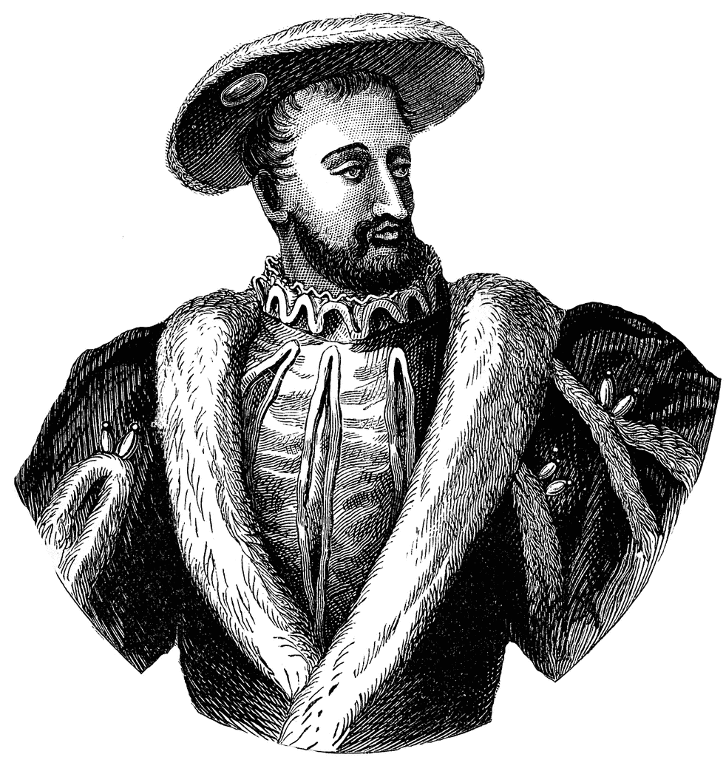
Son Château
________________________________________________________________________________________________________________________________________________________________________________________________________________________________________________________________________________________________________________________________________________________________________________________________________________________________________________________________________________________________________________________________________________________________________________________________________________________________________________________________________________________________________________________________________________________________________________________________________________________________________________________________________________________________

Interpersonal Rubric
11
9/10 | - You contributed actively to the conversation by suggesting several facts, responding appropriately to your partner’s comments and asking follow up questions you didn’t understand his/her ideas.  - You used the appropriate vocabulary and structures to talk about what Francois I’s life was like and made only minor errors that did not impede comprehension.  - Several accurate facts were recorded for each section in both graphic organizers  - You spoke fluently with excellent pronunciation.
8 | - You contributed adequately to the conversation by making a few suggestions, responding to your partner’s statements and asking some follow up questions to clarify meaning.  - You made minor errors in vocabulary or structures which occasionally interfered with comprehension somewhat  - A few accurate facts were recorded in each section on both graphic organizers.  - You spoke with some hesitation and a slight accent.
7 | - You suggested only a few facts and/or did not respond to your partner’s suggestions. You attempted to ask follow up questions to clarify meaning.  - Your errors in vocabulary and structures sometimes made it difficult for your partner to understand your ideas  - A few accurate facts were included in each section on both graphic organizers  - You spoke with considerable hesitation and a strong accent.
6 | - Your contribution was limited to reading sentences directly from the article and/or writing down your partner’s statements. You were not able to respond to your partner’s statements in a meaningful way or to ask questions to clarify misunderstandings.  - You made significant errors in vocabulary or structures which often made it difficult for your partner to understand your ideas.  - At least one accurate fact was included in both graphic organizers.  - You paused for long periods of time and many significant pronunciation errors.
5 | You did not meet the requirements for this task.

Français 2 Nom _________________________________________
Castle Unit IPA

Presentational Writing
Imagine that you are Francois I and you didn’t really die at the age of 53. Instead, you were kidnapped by Charles V (again) and have been living in Italy for the past 30 years. You feel that your life is coming to an end and you want to leave a written memoir for your descendants. Write the first chapter of your memoir, in which you talk about what your life was like when you were king. Your chapter should be at least 200 words long and should include the following information:
- Who you lived with
- Where you lived
- What your castle was like
- How you spent your time

Write on loose-leaf (Don’t forget to skip lines) and staple your paper to this one before placing it in the tray at the end of the period.

