Français 3 Nom _______________________________________
La Saint-Valentin
A. Key Word Recognition. Find the French words/phrases that best express the meanings of the following English words/phrases.
1. numbers _____________________________
2.will find_____________________________
3. will celebrate_____________________________
4. will spend_____________________________
5. the survey_____________________________
6. have broken up _____________________________
B. What is the main idea of this infographic? Answer in English.
____________________________________________________________________________________________________________________________________________________________________________________________________

C. Supporting Details.
1. Check each detail that is mentioned in the article (not all are included).
2. Fill in the information that is given for each detail you have checked. Write in English.
___ The number of people included in the survey _____________________________
___ The percentage of people in the area around Paris who will celebrate Valentine’s Day ______________________
___ The amount of money that the average man will spend on Valentine’s Day ____________________________
___ The percentage of French people who plan on buying a Valentine’s gift for their sweetheart ___________________
___ The total amount of money that French people will spend on Valentine’s Day ____________________
___ The most popular Valentine’s gift ___________________________
___ The percentage of people who will go away for the weekend to celebrate Valentine’s Day ________________
___ The percentage of people who will relax at home for Valentine’s Day ___________________
___ The percentage of French couples who will celebrate Valentine’s Day with their children __________________
___ The percentage of French couples who won’t celebrate Valentine’s Day ____________________
___ The percentage of French couples who got engaged on Valentine’s Day ____________________
___ The percentage of single people who say they hate Valentine’s Day ______________________
___ The proportion of single people who will declare their love to someone on Valentine’s Day ___________________
___ The percentage of single people who are going to go to a party for Valentine’s day __________________________
___ The percentage of single people who are going to stay home with their cats on Valentine’s Day _________________
___ The percentage of single people who are going to go to bed early on Valentine’s Day ____________________

D. Guessing Meaning from Context. Find the underlined words/phrases and write what you think they mean in English.

1. Nous avons décidé de sonder 2,326 Français et de fouiller un peu dans les festivités amoureuses des Valentins et Valentines de France __________________________________
2. 71% des couples de la région qui prevoient de célébrer la Saint Valentin cette année. _____________________________
3. Les valentins les plus radins de France _____________________________
4. L’an dernier, plus de la moitie des cadeaux lingerie achetés par les hommes étaient de la mauvaise taille_____________________________
5. Un quart des célibataires profiteront de la Saint Valentin pour déclarer leur flamme à quelqu’un _____________________________
E. Comparing Cultural Perspectives. Answer the following question in English.

How do French and American perspectives on Valentine’s Day compare? Support your ideas with lots of examples from the infographic.
____________________________________________________________________________________________________________________________________________________________________________________________________
____________________________________________________________________________________________________________________________________________________________________________________________________
____________________________________________________________________________________________________________________________________________________________________________________________________

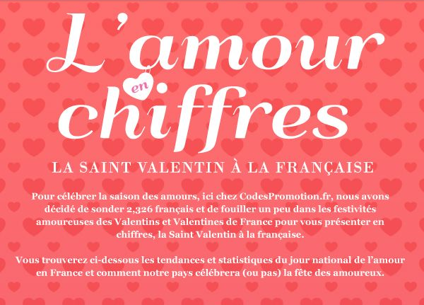
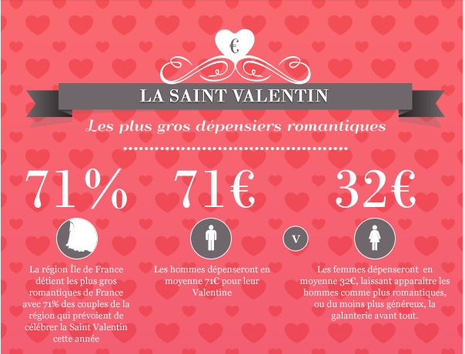

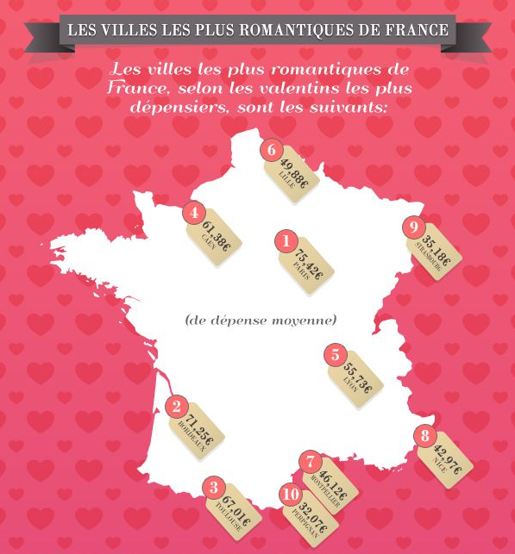
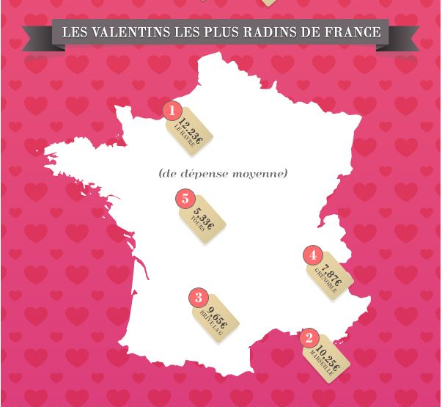

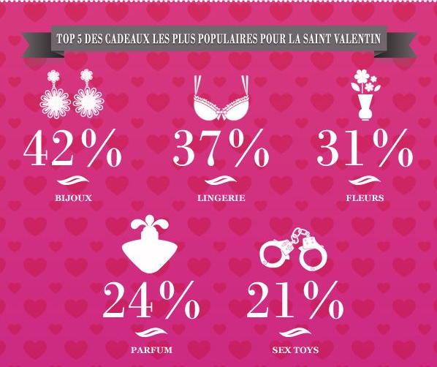
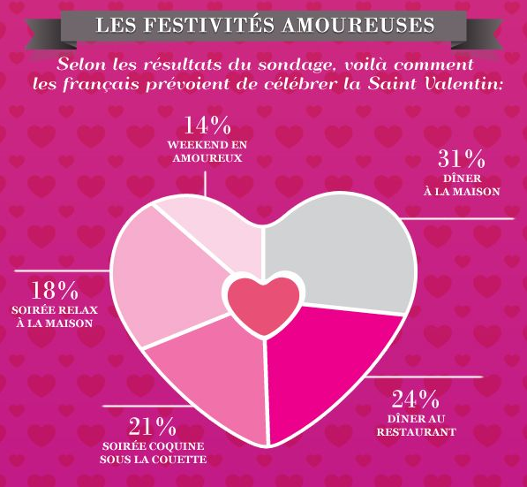

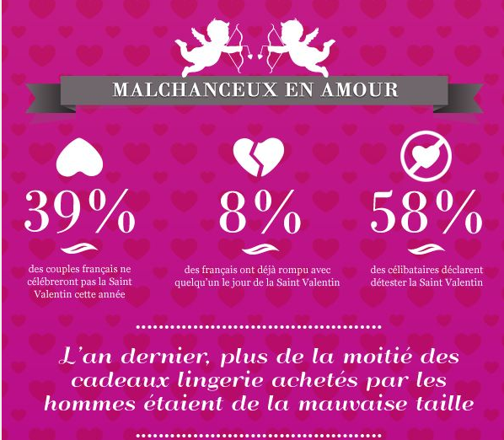
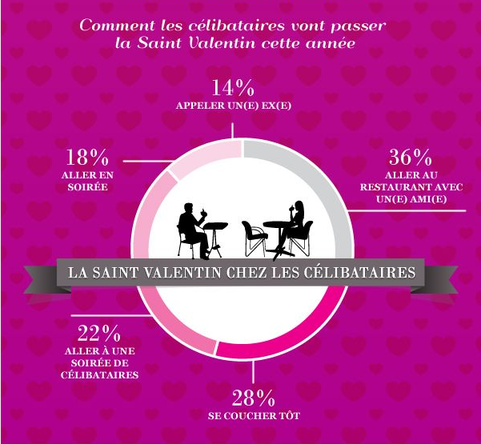
http://www.codespromotion.fr/blog/la-saint-valentin-dechiffree-rien-que-pour-vous

