Francais 1
La Saint-Valentin Nom_______________________________________

A. Key Word Recognition. Find the French words/phrases that best express the meanings of the following English words/phrases.

1. meal _______________________________
2. flowers_______________________________
3. clothing_______________________________
4. to celebrate_______________________________
5. men_______________________________
6. women_______________________________
7. gifts_______________________________
8. today_______________________________

B. What is the main idea of this infographic? Answer in English.
____________________________________________________________________________________________________________________________________________________________________________________________________

C. Supporting Details.
1. Check each detail that is mentioned in the article (not all are included).
2. Fill in the information that is given for each detail you have checked. Write in English.
___ The percentage of French people who give flowers for Valentine’s Day. ______________
___ The percentage of French people who give perfume for Valentine’s Day. ______________
___ The percentage of French people who give candy for Valentine’s Day. ______________
___ The percentage of French people who give jewelry for Valentine’s Day. ______________
___ The percentage of French people who go out/to a show for Valentine’s Day. ______________
___ The percentage of French people who think that Valentine’s Day is too commercialized. ______________
___ The percentage of French people who think that Valentine’s Day is a chance to let family members know you love them. ______________
___ The percentage of French people who think that Valentine’s Day is a chance to give gifts to someone you love. ______________
___ The percentage of French people who think that Valentine’s Day is the best day to propose. ______________
___ The percentage of French people who think that Valentine’s Day is a tradition that’s important to keep. __________
___ The percentage of French people who think that Valentine’s Day is a chance to exchange sweet words. ___________
___ The percentage of French people who think that Valentine’s Day is the most important day of the year. __________
___ The average amount of money spent by a French person for Valentine’s Day. ______________

D. Comparing Cultural Perspectives. Answer the following question in English.

Compare the way that Valentine’s Day is celebrated in France and the U.S., based on what you learned in the infographic.
____________________________________________________________________________________________________________________________________________________________________________________________________
____________________________________________________________________________________________________________________________________________________________________________________________________
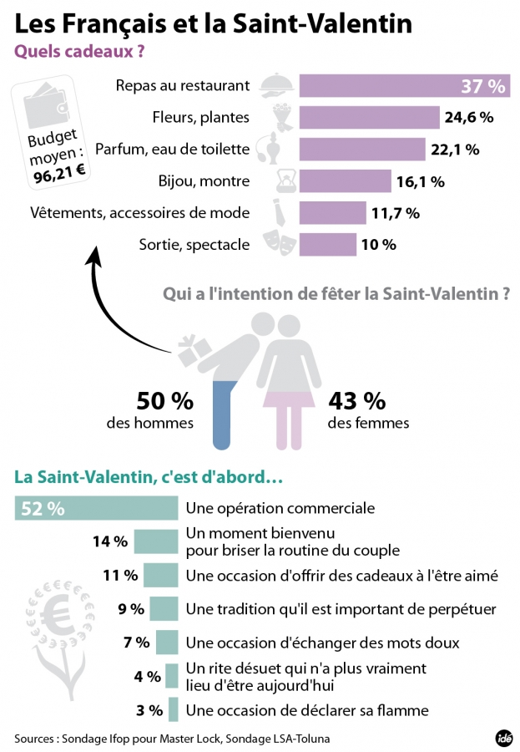
http://www.francebleu.fr/infos/saint-valentin/infographie-la-saint-valentin-et-vous-1277690

