Français 2 – Partenaire A Nom _______________________________

You work at a photo processing company and you mixed up some picture files that came in. Call your partner and ask her/him questions about what s/he DID during his/her vacation so that you can find out which pictures are his/hers. Circle the pictures that your partner took so you can make a photo calendar for him/her.

Here are some questions you might want to ask:

* Est-ce que vous avez vu … ?
* Avec qui est-ce que vous … ?
* Vous avez mis… ?
* Il y avait… ?

     

   

 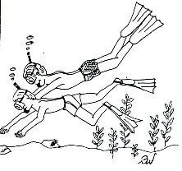   

     

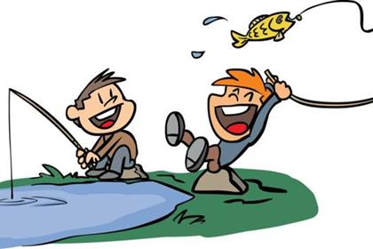   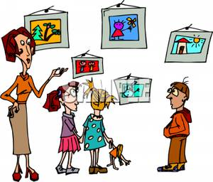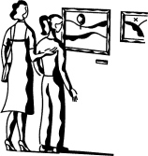 

Français 2 – Partenaire B Nom _____________________________

You have decided to make your parent(s) a photo calendar featuring pictures of your trip to Martinique. Unfortunately, the calendar website got your files mixed up with someone else’s. Describe what you did on your trip so that the employee can identify which pictures are yours. The employee may ask you the following questions:

* Est-ce que vous avez vu … ?
* Avec qui est-ce que vous … ?
* Vous avez mis… ?
* Il y avait… ?

Here are the pictures that you took on your trip. For each picture, you should tell your partner what you did, and then answer his/her questions.

  