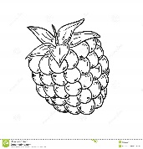  1. | 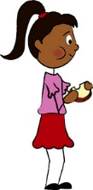  2. | 3. | 4. | 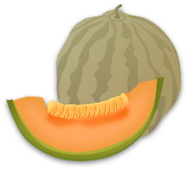  5.
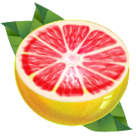  6. | 7. | 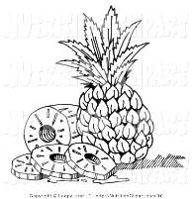  8. | 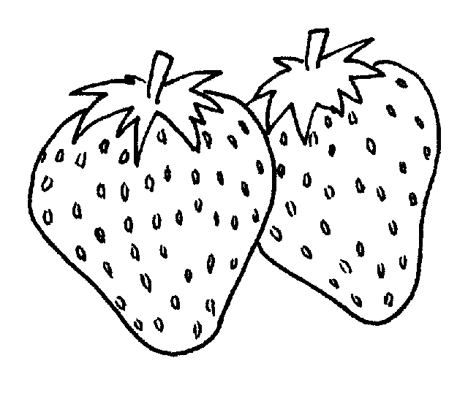  9. | 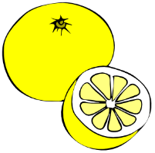  10.
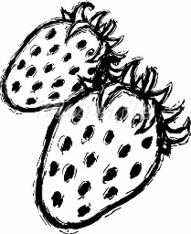  11. | 12. | 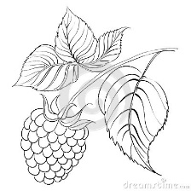  13. | 14. | 15.
16. | 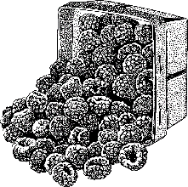  17. | 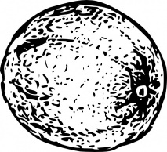  18. | 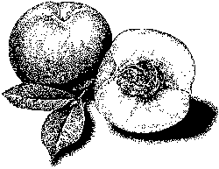  19. | 20.

Directions:
1. Place a book or binder between you and your partner so that you can’t see each other’s papers.
2. On a separate sheet of paper, make a column #1-#20.
3. Partner A will begin by describing one of his/her pictures.
4. Partner B will listen and ask questions when needed. Then s/he will tell Partner A the letter of the picture which corresponds to the description.
5. Both partners will write this letter next to the corresponding number.
6. Next it will be Partner B’s turn to describe a picture.
7. Continue until both partners have filled in a letter next to each number.

Note:
1. Make sure to use the correct article in your descriptions.
- If there is 1 item, start your description with, “Il y a un/une…”
- If there is part of an item, say “Il y a du/de la/de l’…”
- If there are more than one of an item, say “Il y a des…”
2. Here are a couple of new words that might help you:
Une feuille – leaf une tranche – a slice

Partenaire A

a. | b. | c. | d. | e.
f. | g. | h. | i. | j.
k. | l. | m. | n. | o.
p. | q. | r. | s. | t.

Directions:
1. Place a book or binder between you and your partner so that you can’t see each other’s papers.
2. On a separate sheet of paper, make a column #1-#20.
3. Partner A will begin by describing one of his/her pictures.
4. Partner B will listen and ask questions when needed. Then s/he will tell Partner A the letter of the picture which corresponds to the description.
5. Both partners will write this letter next to the corresponding number.
6. Next it will be Partner B’s turn to describe a picture.
7. Continue until both partners have filled in a letter next to each number.

Note:
1. Make sure to use the correct article in your descriptions.
- If there is 1 item, start your description with, “Il y a un/une…”
- If there is part of an item, say “Il y a du/de la/de l’…”
- If there are more than one of an item, say “Il y a des…”
2. Here are a couple of new words that might help you:
Une feuille – leaf une tranche – a slice

Partenaire B

