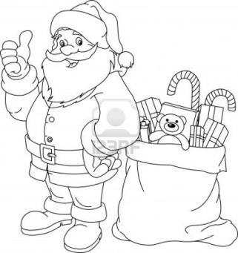 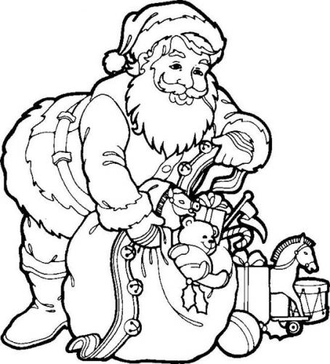 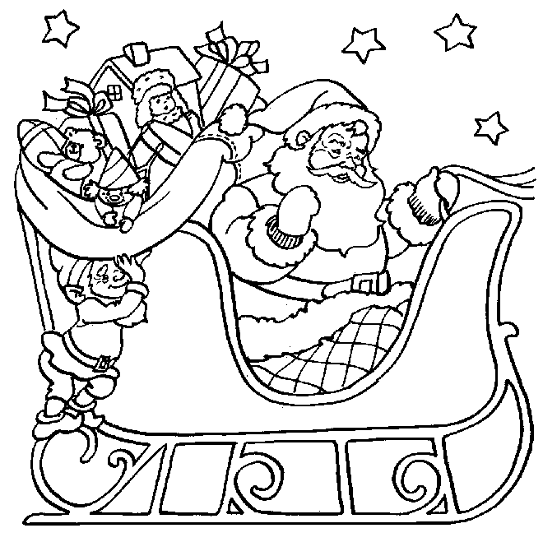 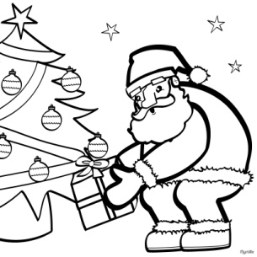

1. 2. 3. 4.

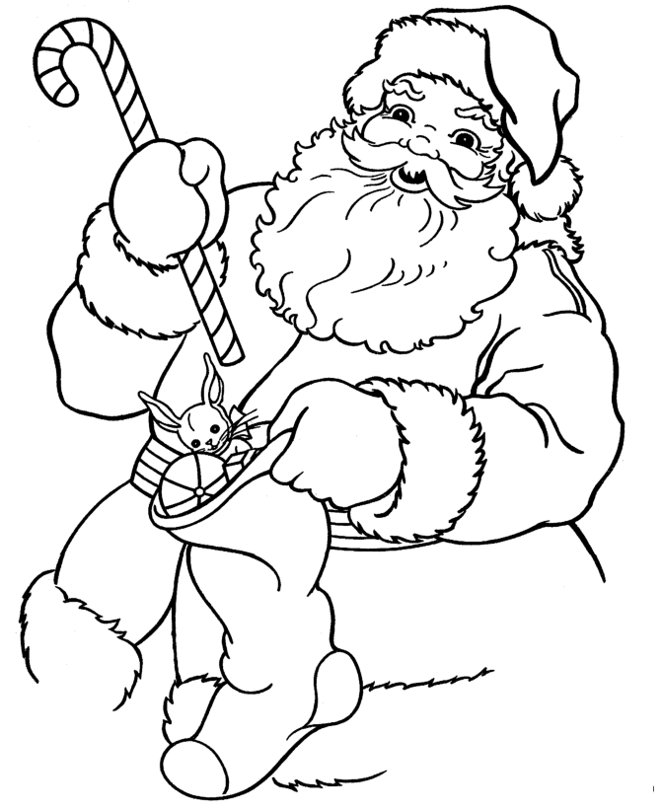 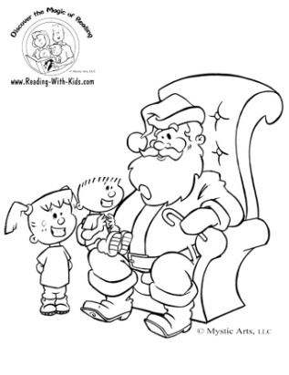 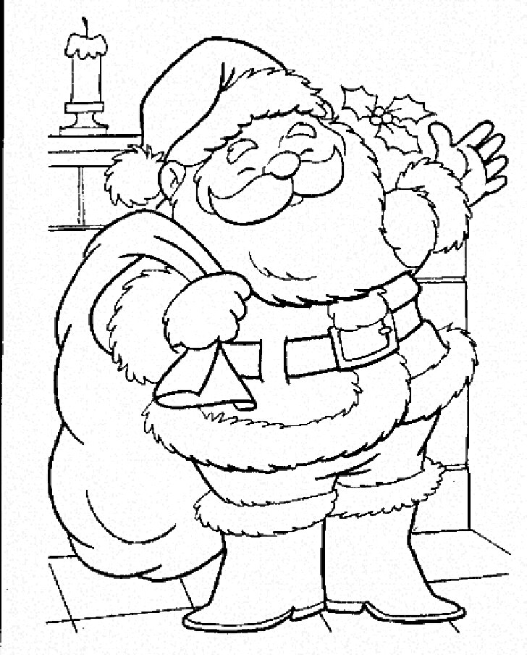 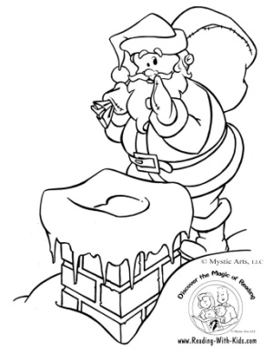

5. 6. 7. 8.

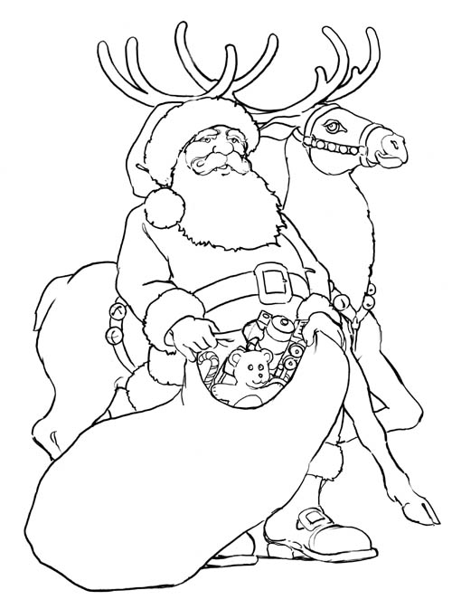 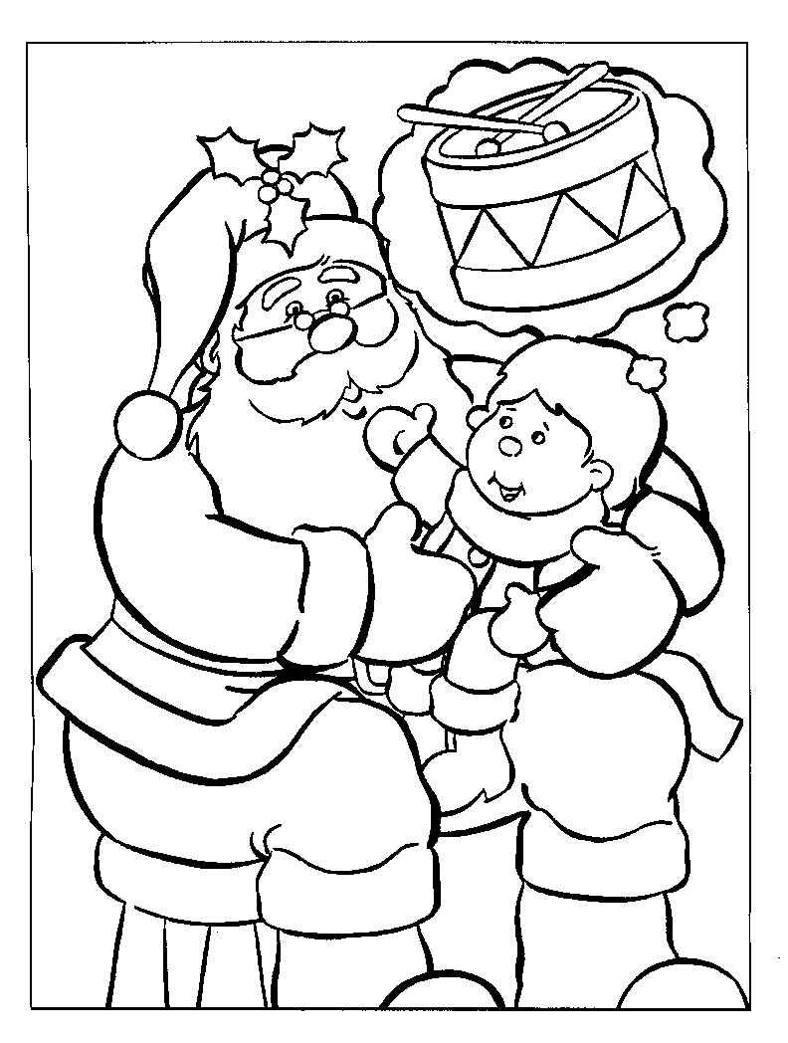 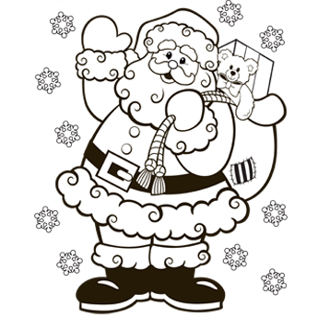 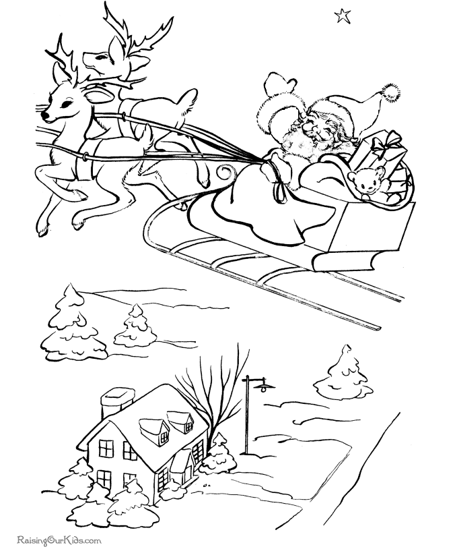

9. 10. 11. 12.

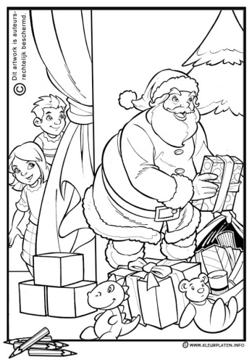 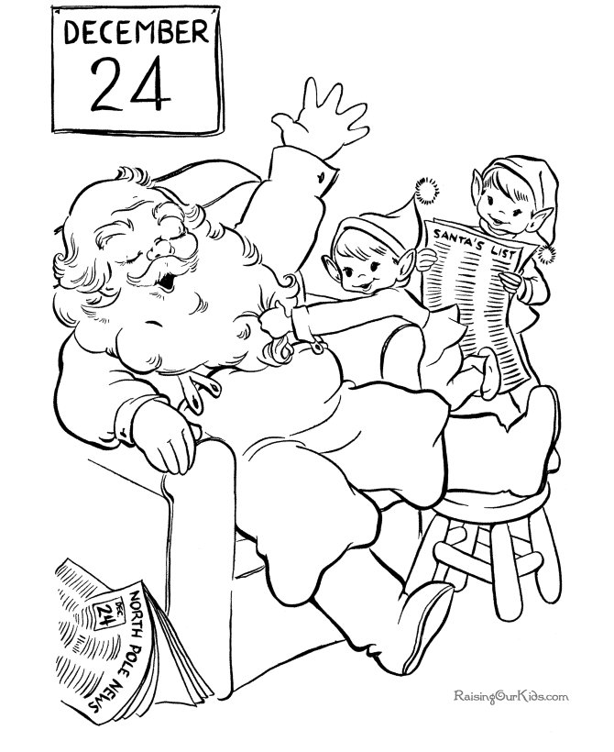 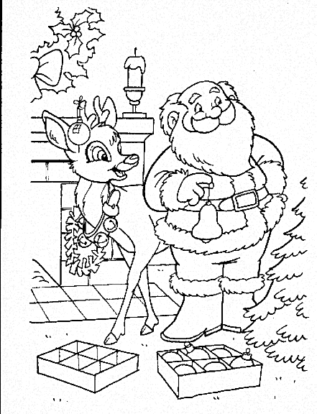 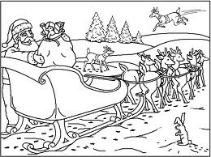

13. 14. 15. 16.

Partenaire A



A. B. C. D.

 

F. G. H. I.

 

J. K. L. M.

 

N. O. P. Q.

Partenaire B

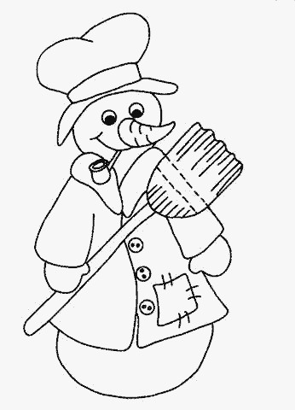 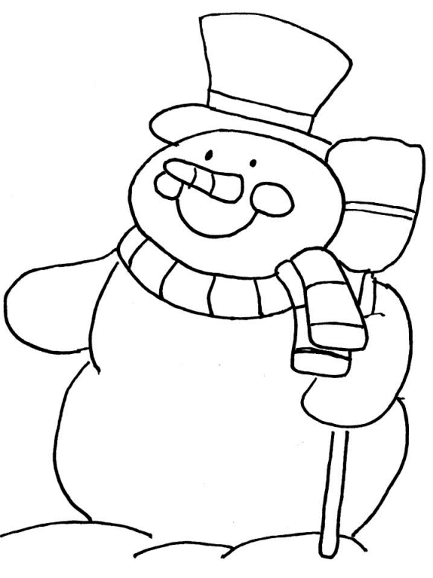 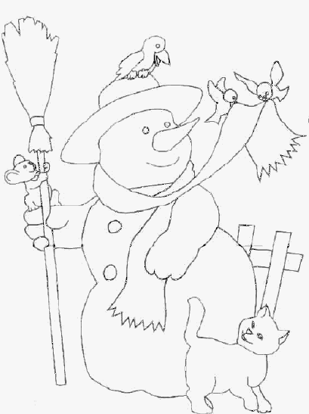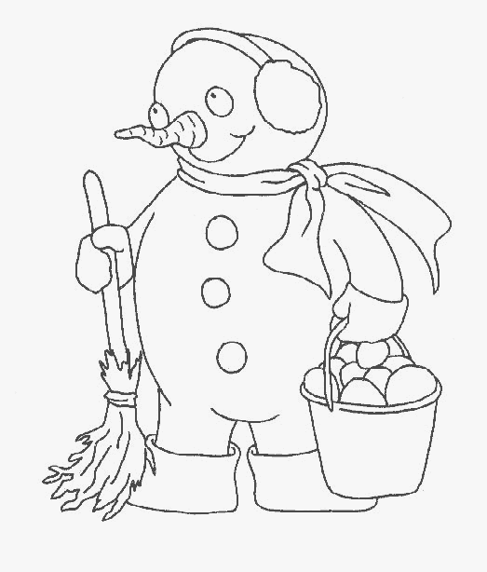

1. 2. 3. 4.

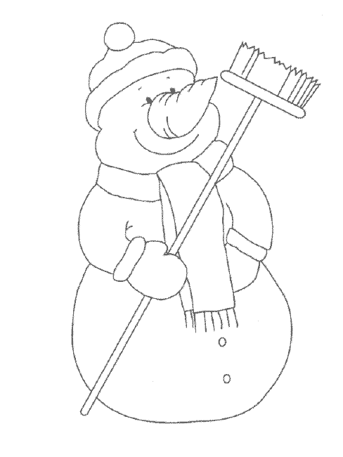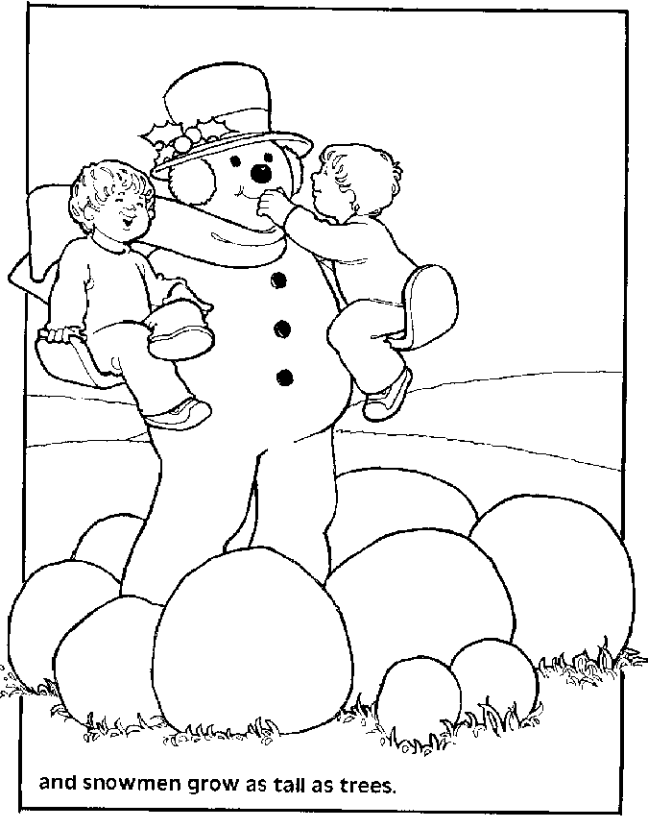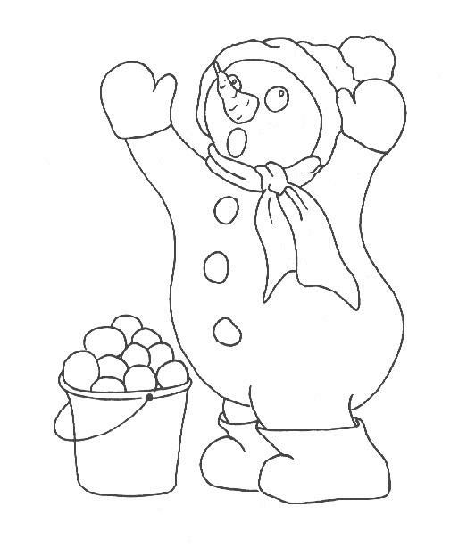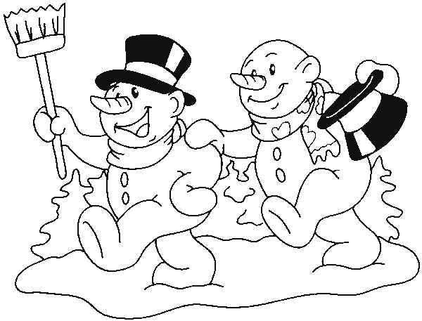

5. 6. 7. 8.

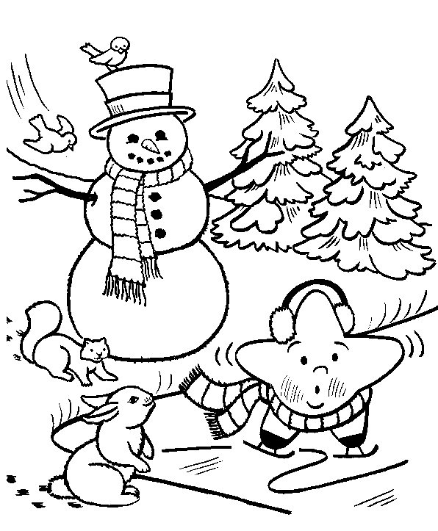 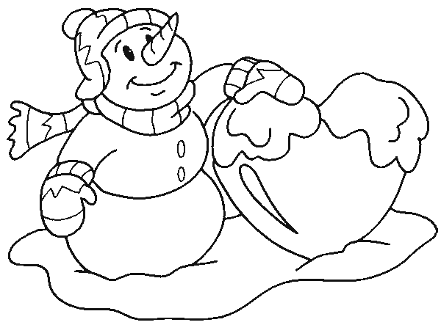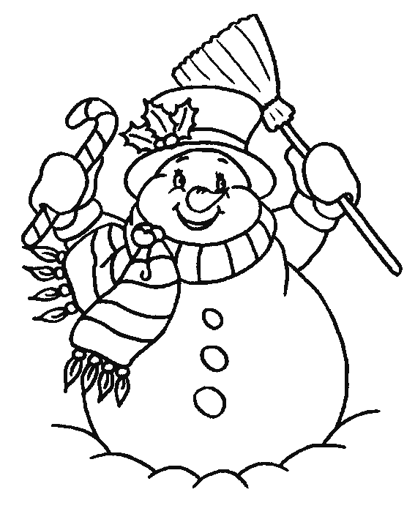

9. 10. 11.

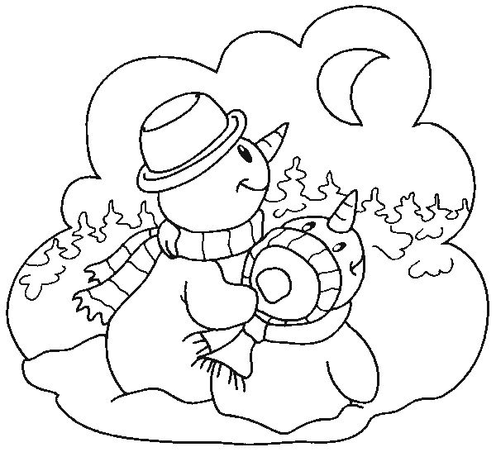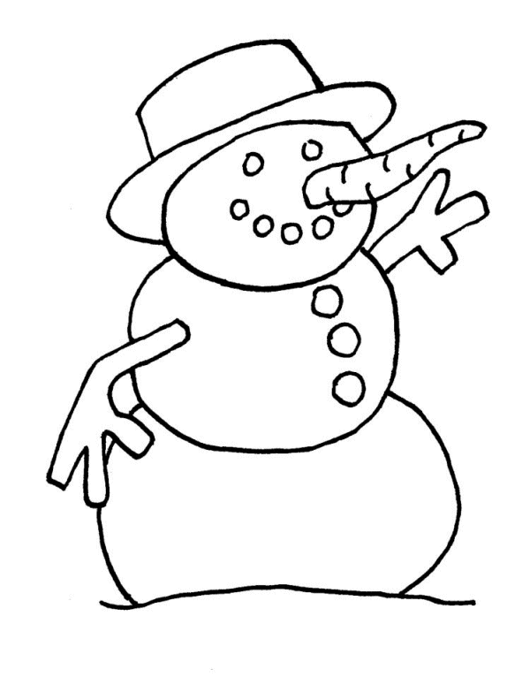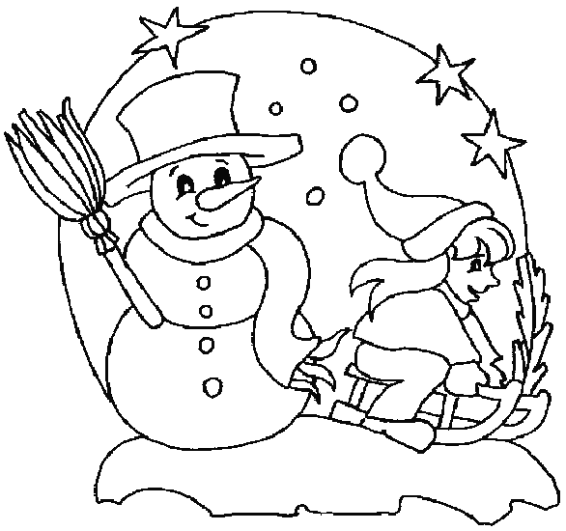

12. 13. 14.

Partenaire A

 

A. B. C. D.



E. F. G. H.

  

I. J. K. L.



M. N.

Partenaire B

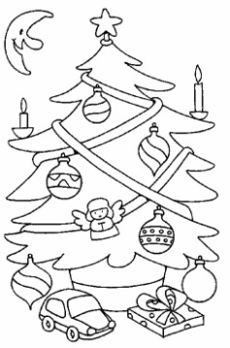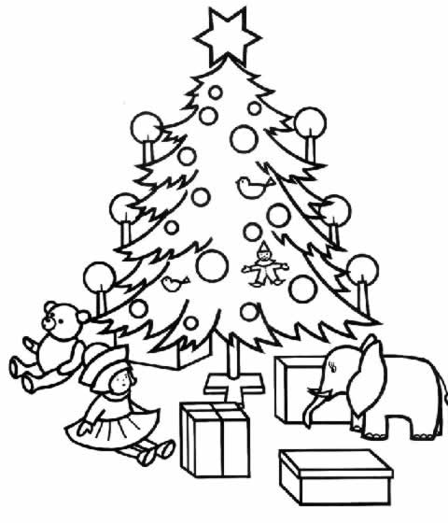 [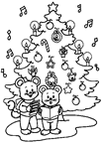](http://www.mescoloriages.com/noel/coloriages,sapins,sapins1/7_gif.gif.shtml) 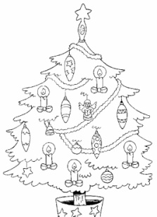 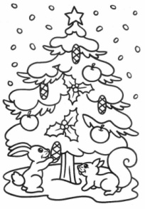

1. 2. 3. 4. 5.

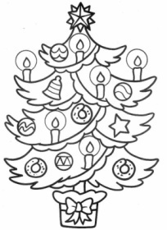 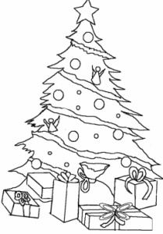 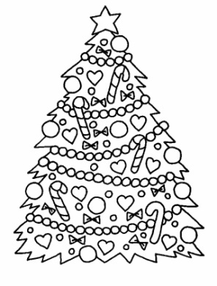 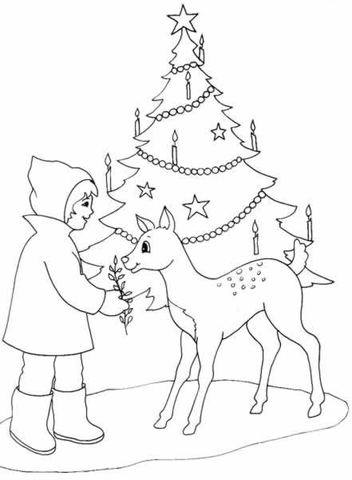 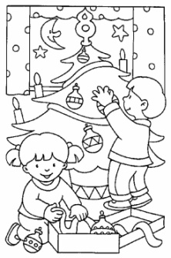

6. 7. 8. 9. 10.

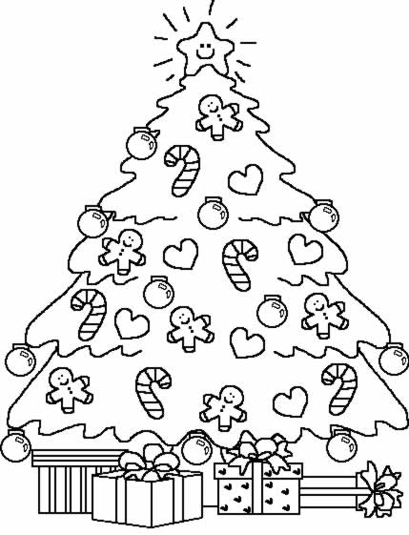 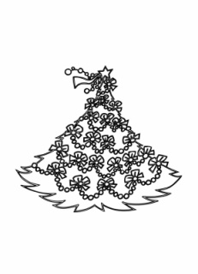 [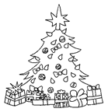](http://www.mescoloriages.com/noel/coloriages,sapins,sapins1/6_gif.gif.shtml)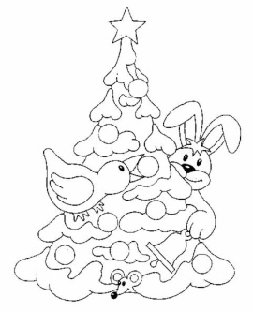 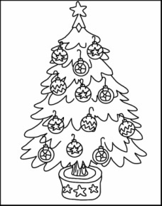

11. 12. 13. 14. 15.

[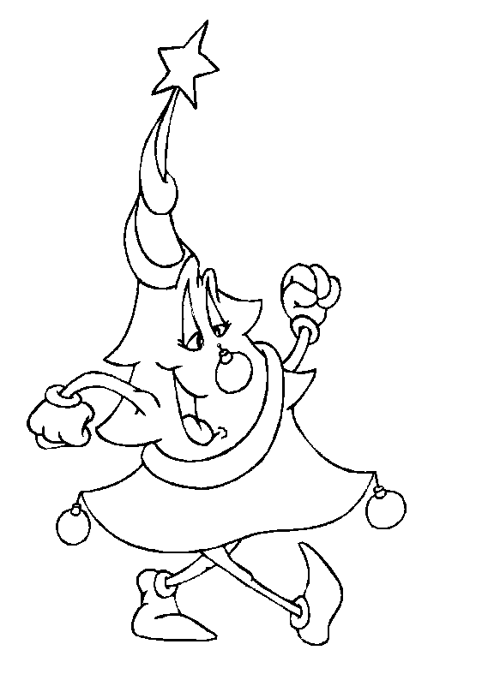](http://www.mescoloriages.com/imprimer.php?img=/coloriages/noel/sapins/sapins1/images/21_gif.gif)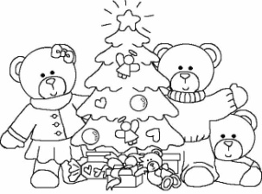 [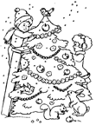](http://www.mescoloriages.com/noel/coloriages,sapins,sapins1/10_gif.gif.shtml) [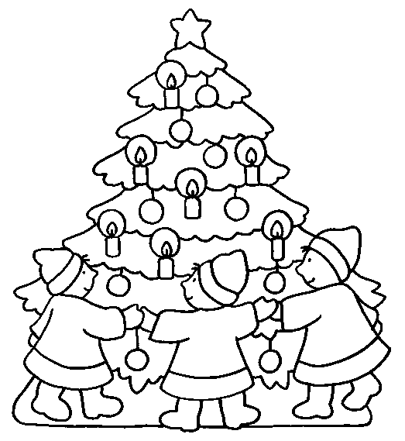](http://www.mescoloriages.com/imprimer.php?img=/coloriages/noel/sapins/sapins1/images/24_gif.gif) [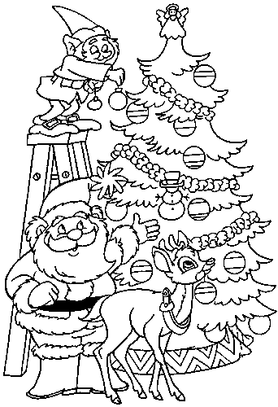](http://www.mescoloriages.com/imprimer.php?img=/coloriages/noel/sapins/sapins1/images/12_gif.gif)

16. 17. 18. 19. 20.

Partenaire A

   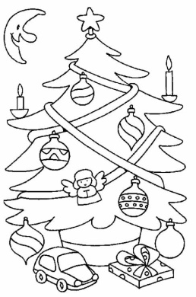

A. B. C. D. E.

   

F. G. H. I. J.

[](http://www.mescoloriages.com/imprimer.php?img=/coloriages/noel/sapins/sapins1/images/24_gif.gif)   [](http://www.mescoloriages.com/imprimer.php?img=/coloriages/noel/sapins/sapins1/images/12_gif.gif) [](http://www.mescoloriages.com/noel/coloriages,sapins,sapins1/6_gif.gif.shtml)

K. L. M. N. O.

[](http://www.mescoloriages.com/noel/coloriages,sapins,sapins1/7_gif.gif.shtml)   [](http://www.mescoloriages.com/noel/coloriages,sapins,sapins1/10_gif.gif.shtml) [](http://www.mescoloriages.com/imprimer.php?img=/coloriages/noel/sapins/sapins1/images/21_gif.gif)

P. Q. R. S. T. Partenaire B