Français I Nom _________________________
Noel IPA
Interpretive Listening

Watch the video and answer the questions in English.
Trotro fait de la luge (http://www.youtube.com/watch?v=_Ol1uMeLVCc )

1. What does Trotro think is beautiful? ________________________________
2. Trotro says, “Je vais essayer d’attraper un flocon de neige.” What do you think a flocon de neige is ?
___________________________
3. Why does Trotro decide to make a snowball? ________________________________________________
4. Trotro says that the snow is “doux comme du coton.” What do you think doux means? ______________
5. What else does he say about his snowball, before he throws it? ____________________________________
6. Trotro says, « Pour se réchauffer, il faut mettre ses mouffles. » What are mouffles ? ____________________
7. What does Trotro tell his teddy bear they are going to do next? _______________________________________
8. Trotro says, “C’est rigolo de marcher dans la neige.” What does he think it is fun to do? _________________________
9. What does Trotro ask his teddy bear before putting him in his pocket? _______________________________________
10. What does Lili ask Trotro if she can do? _______________________________________________________________
11. What does he ask her to help him do? ________________________________________________________________
12. What is the first thing Trotro says when they get to the top of the hill? ______________________________________
11. What does Lili say they can do next? _________________________________________________________________
12. Trotro asks Lili if she’s afraid to go fast. What is her response? ____________________________________________
13. What do you think Trotro will do differently the next time he goes sledding? Support your answer with information from the video. _____________________________________________________________________________________
__________________________________________________________________________________________________

Interpersonal Communication

Directions:
1. You and your partner each have 8 pictures showing Noel celebrations. Take turns describing the pictures in order to decide whether you have the same picture (même) or a different (different) picture for each number.
2. Make sure to use complete sentences and to be as descriptive as possible. Include information about what the people in the picture are doing rather than just naming things that you see.
3. Ask your partner lots of questions so that you’re confident about your answers!
4. Write D for différent or M for même for each picture below.

1. ___ 2. ___ 3. ___ 4. ___ 5. ___ 6. ___ 7. ___ 8. ___

Partenaire A
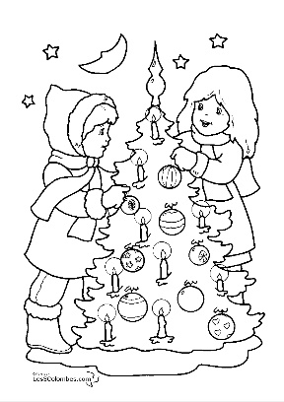 | 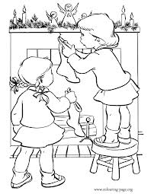 | 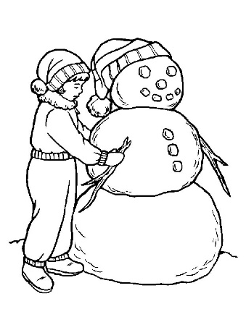 | 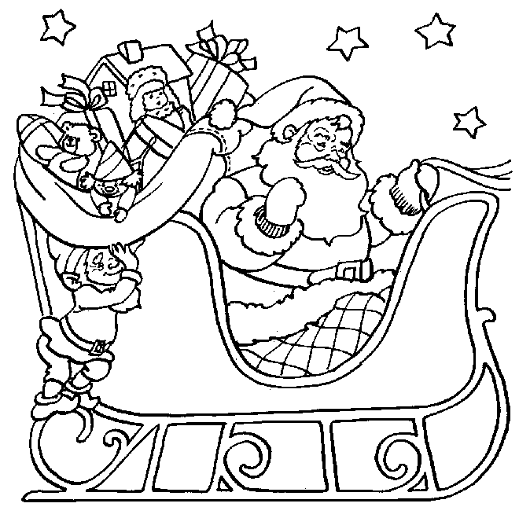
1. | 2. | 3. | 4.
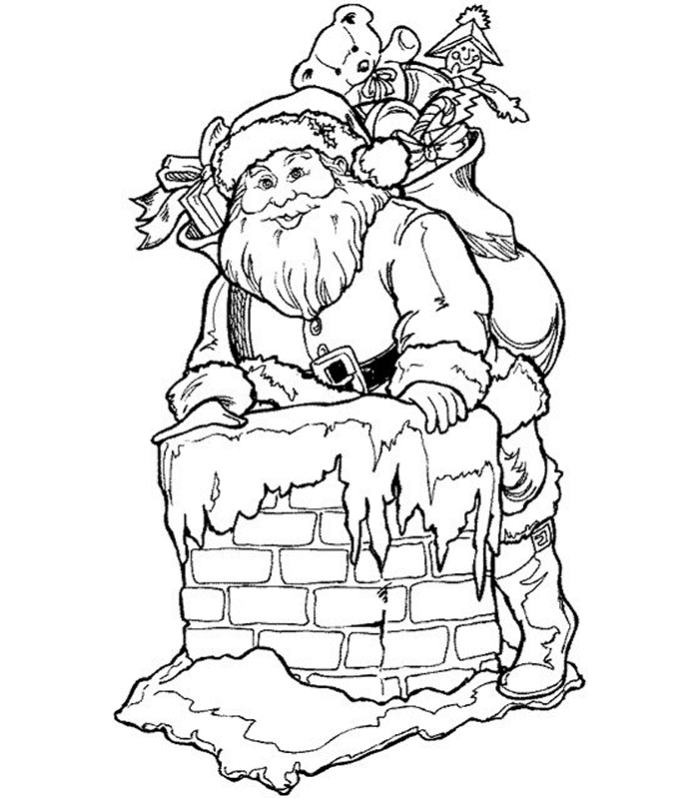 | 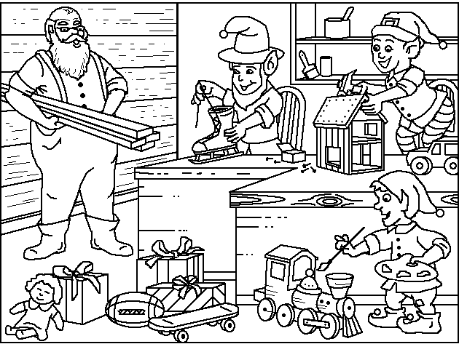 | 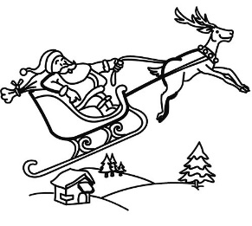 | 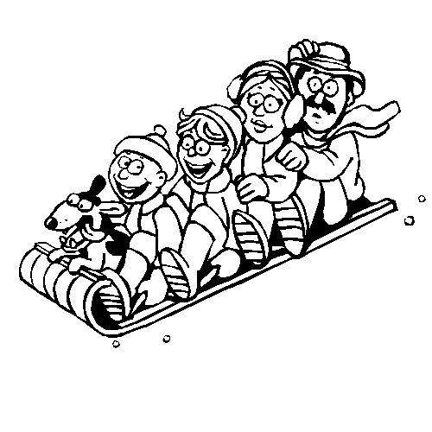
5. | 6. | 7. | 8.

Partenaire B
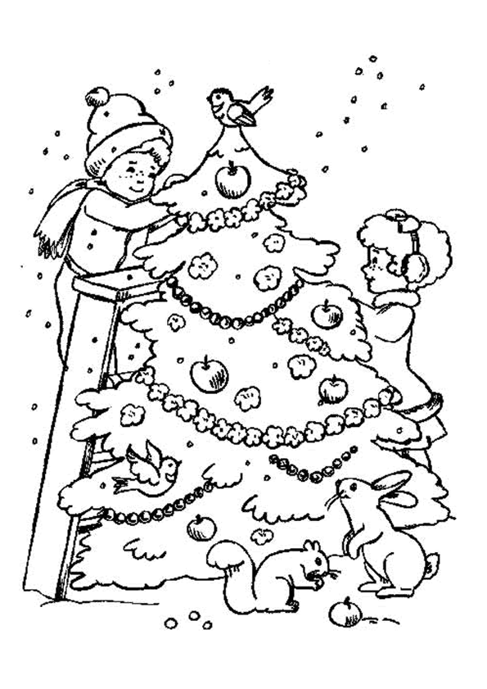 |  | 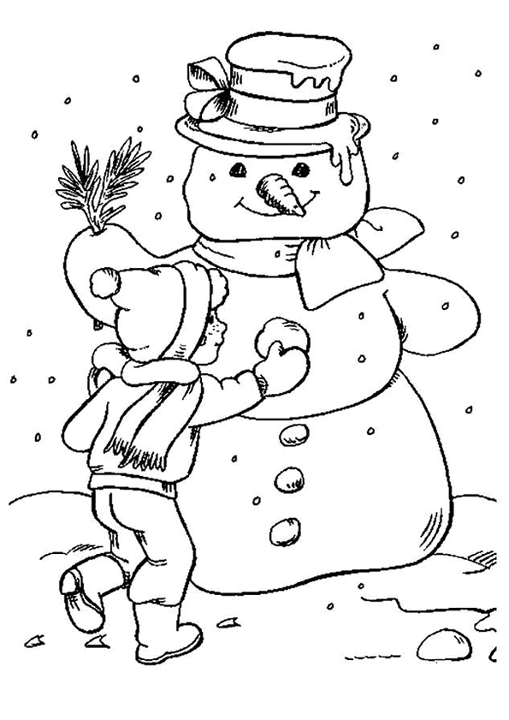 | 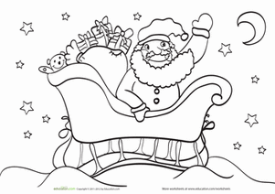
1. | 2. | 3. | 4.
 |  | 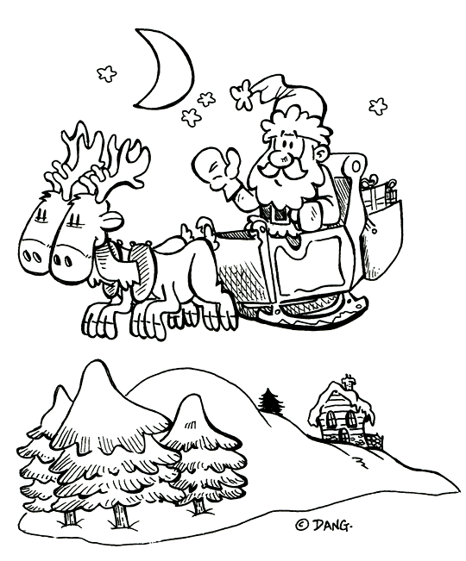
5. | 6. | 7. | 8.

Presentational Writing
Imagine that you are spending a year in Chamonix, France as an exchange student. Your parents are curious about how the holidays are celebrated there. Write an e-mail (on loose-leaf) in which you include the following information:
- How French people decorate their homes for Christmas
- What people do on Christmas Eve and Christmas Day
- What imaginary characters are associated with Christmas in France.
- What people do outside in the winter (Chamonix is in the Alps.)
- Use words like et, mais, ou, aussi, and parce que to organize your e-mail.
- Your e-mail should be at least 150 words long.

Interpretive Reading
(http://www.fete-enfants.com/noel-enfants/noel-en-europe.htm)
A. Key Word Recognition. Find the French words/phrases that best express the meanings of the following English words/phrases.

- Santa comes____________________________
- They (people) celebrate __________________
- They (people) eat _______________________
- A donkey ______________________________
- A Christmas tree ________________________
- The Wise Men__________________________
- Toys __________________________________
- Stocking _______________________________
- Shoes _________________________________
- In the north ____________________________
- Easter ________________________________
B. What is the main idea of this article? Answer in English.
____________________________________________________________________________________________________________________________________________________________________________________________________
C. Supporting details
1. Check each detail that is mentioned in the article (not all are included).
2. Fill in the information that is given for each detail you have checked. Write in English.
France
___How Santa travels __________________________________________________________________
___Where he leaves gifts _______________________________________________________________
___How people decorate their trees_______________________________________________________
___What people eat ___________________________________________________________________
England
___Who brings gifts___________________________________________________________________
___Where he puts them___________________________________________________________________
___What people eat___________________________________________________________________
Spain
___How Santa travels___________________________________________________________________
___Where the gifts are placed___________________________________________________________________
___What people eat___________________________________________________________________
Belgium
___Who brings gifts___________________________________________________________________
___When people eat their holiday meal________________________________________________________________
___What people eat___________________________________________________________________
Germany
___The Christmas tradition that comes from Germany_____________________________________________________
___When this tradition began___________________________________________________________________
___Who brings the gifts___________________________________________________________________
___How he travels__________________________________________________________________
___What people eat __________________________________________________________________
Italy
___Who brings the gifts__________________________________________________________________
___When the gifts are given__________________________________________________________________
___What people eat__________________________________________________________________
Greece
___Who brings the gifts__________________________________________________________________
___When the gifts are brought__________________________________________________________________
___What people eat __________________________________________________________________
___What children do __________________________________________________________________
D. Guessing meaning from context.
Find the underlined words/phrases and write what you think they mean in English. The information in parenthesis tells you which section the word appears in.
- On ne fête pas Noël de la même façon dans tous les pays. (intro) __________________________________
- il n'y a pas de Noël sans dinde (England) __________________________________
- On fête la naissance de Jésus-Christ. (Spain) __________________________________
- La fête de Noël dure 3 jours, du 24 au 26 décembre (Italy) __________________________________
E. Inference
Answer the following questions in English, giving as much information as possible to support your response.
1. Why do you think that holiday gifts are exchanged on several different dates? ________________________________
____________________________________________________________________________________________________________________________________________________________________________________
2. Which country would you most like to visit during the holidays? Why? ________________________________
____________________________________________________________________________________________________________________________________________________________________________________
F. Comparing Cultural Perspectives. Answer the following questions in English.
1. Which countries most influenced American holiday celebrations? In what way? Why do you think this is so?
____________________________________________________________________________________________________________________________________________________________________________________________________________________________________________________________________________________________________________________________________________________________________________________________________________________________________________________________________________________________________________________________________________________________________________________________________________

