#1 : First I introduced this vocabulary with a powerpoint containing the same images on this handout.
Français 3 Nom _____________________________________________
Les Campeurs - Vocabulaire
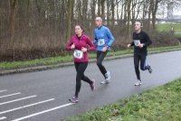 |  | 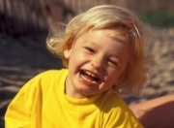 | 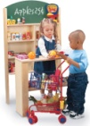 | 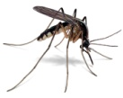 | 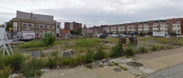
courir | pleuvoir | rigoler | faire semblant | une moustique | un terrain vague
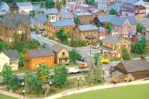 | 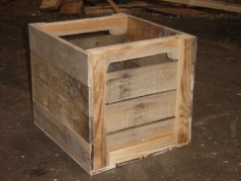 |  | 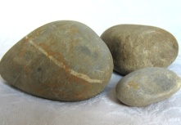 | 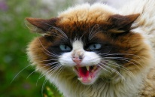
un quartier | une caisse | une boite (à conserve) | une pierre | un chat fâché | chouette
 | 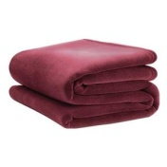 | 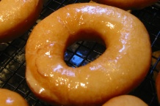 |  | 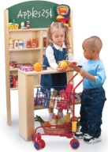
une roue | une couverture  pliée | un trou | une tâche | faire semblant | conduire
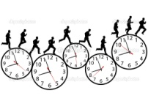 |  | 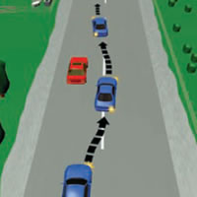 | 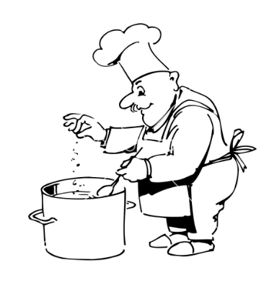 | 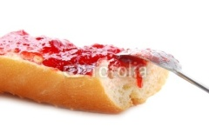 | 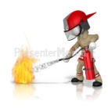
pressé | le toit | doubler | cuire | une tartine | éteindre
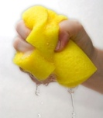 | 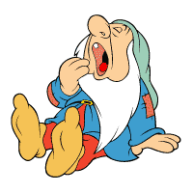 | 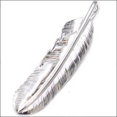 | 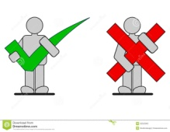 | 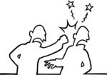 | 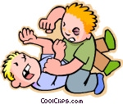
serrer | avoir sommeil | une plume | avoir raison/avoir tort | donner un coup de poing | se battre
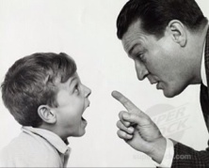 | 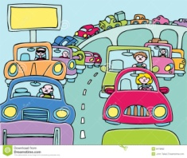
gronder | un embouteillage

#2 Next I had the students complete this interpretive task over the first part of the story.
« Les campeurs »
Part 1 : Pages 34-37 Nom ___________________________

A. Key Word Recognition. Find the French words/phrases that best express the meanings of the following English words/phrases.

- to go camping ____________________________
- awesome/cool____________________________
- a pretty spot____________________________
- a fire____________________________
- to fish____________________________
- the country(side) ____________________________
- empty lot____________________________
- old boxes ____________________________
- a blanket____________________________
- lots of holes____________________________

B. Summarize what happens in the first part of the story in English.
______________________________________________________________________________________________________________________________________________________________________________________________________________________________________________________________________________________________________________________________
C. Supporting Details.
1. Check each detail that is mentioned in the article (not all are included).
2. Fill in the information that is given for each detail you have checked. Write in English.
___ The reason Clotaire makes the other boys laugh ______________________________________________________________
__________________________________________________________________________________________________________
___ Where Joachim went camping ______________________________________________________________________________
___ What you do when you go camping, according to Joachim________________________________________________________
__________________________________________________________________________________________________________
__________________________________________________________________________________________________________
___ The reason Maixent says he can’t go camping__________________________________________________________________
__________________________________________________________________________________________________________
___ The fib that Joachim suggests Maixent tell his parents________________________________________________________
_____________________________________________________________________________________________________________ Things you can find at the empty lot________________________________________________________
__________________________________________________________________________________________________________
___ The reason they don’t play in the car in the empty lot________________________________________________________
_____________________________________________________________________________________________________________ What Joachim brought with him ________________________________________________________
__________________________________________________________________________________________________________
___ The reason he brought this item ________________________________________________________
__________________________________________________________________________________________________________
___ What Joachim told the boys they had to do________________________________________________________
__________________________________________________________________________________________________________
___ The reason Geoffroy doesn’t agree with Joachim________________________________________________________
__________________________________________________________________________________________________________
___ The reason the other boys will get there before Geoffroy (according to Joachim) ___________________________________
__________________________________________________________________________________________________________
___ The reason Joachim thinks he should get to drive ________________________________________________________
__________________________________________________________________________________________________________
___ The reason Geoffroy thinks he should get to drive ________________________________________________________
__________________________________________________________________________________________________________
___ The reason the other boys told Geoffroy not to make a fuss_______________________________________________________
__________________________________________________________________________________________________________D. Inference. Answer the following question in English, giving us much information from the article as possible to support your response.
1. What do you think will happen in the second part of the story? Write 3 things and explain, based on the text, why you think they will happen.
__________________________________________________________________________________________________________
____________________________________________________________________________________________________________________________________________________________________________________________________________________
__________________________________________________________________________________________________________
____________________________________________________________________________________________________________________________________________________________________________________________________________________
E. Find the underlined words/phrases and write what you think they mean in English. The information in parenthesis tells you which page and paragraph the word appears on.
- “quand il se met à pleuvoir” (p. 34, 3rd par.)_______________________________
- « Surtout s’il y a une rivière. » (p. 34 4th par.)_______________________________
- “mon papa allait me prêter sa tente (p. 36, 7th. par.) _______________________________
- « qui va conduire ? » (top of p. 37) _______________________________
- « on était pressés d’arriver » (p. 37, 5th par.) _______________________________
F. Cultural Comparison. Answer the following questions in English.

1. What kind of make-believe games did you play when you were little? How were they the same or different than Nicolas and his friends? Why do you think this is?
__________________________________________________________________________________________________________
____________________________________________________________________________________________________________________________________________________________________________________________________________________
__________________________________________________________________________________________________________
____________________________________________________________________________________________________________________________________________________________________________________________________________________

#3 : Next I had the students discuss these questions in small groups, filling in either the first or second column, based on their own inferences. We then discussed them as a class.

Français 3 Nom _______________________________________
« Les Campeurs »
Discutez en groupes et remplissez en français.

 | Je pense que c’est vrai parce que… | Je pense que c’est faux parce que…
1. Clotaire a déjà fait du camping.
2. Joachim fait souvent du camping.
3. C’est la première fois que les garçons sont allés au terrain vague.
4. Nicolas s’attendait à camper sur une vraie tente. (s’attendre à= to expect)
5. Joachim avait demandé à son père de prendre la vraie tente.
6. Geoffroy veut conduire.
7. Le père de Joachim est un bon conducteur.
8. Rufus aime faire semblant.

#4: Next I had the students complete this interpretive assessment for the second part of the story. This was their IPA Interpretive Reading grade for this mini-unit.
Les Campeurs – Partie 2 Name _______________________________________
A. Key Word Recognition. Find the French words/phrases that best express the meanings of the following English words/phrases.

1. French bread with jelly ____________________
2. crazy____________________
3. dumb____________________
4. canned goods____________________
5. to bury____________________
6. to be sleepy____________________
7. to punch____________________
8. to fight____________________
9. to stomp on____________________
10. a traffic jam____________________

5 | Identifies all key words appropriately with context of the text.
4 | Identifies majority of key words appropriately within context of the text.
3 | Identifies half of key words appropriately within the context of the text.
2 | Identifies less than half of key words appropriately within the context of the text.
1 | No response

B. Summarize what happens in the second part of the story. Write in English.
______________________________________________________________________________________________________________________________________________________________________________________________________________________________________________________________________________________________________

5 | Identifies the complete main idea(s) of the text.
4 | Identifies the key parts of the main idea(s) of the text but misses some elements.
3 | Identifies some part of the main idea(s) of the text.
2 | Identifies a minor idea from the text.
1 | No response

C. Supporting Details.
1. Check each detail that is mentioned in the story (not all are included).
2. Fill in the information that is given for each detail you have checked. Write in English.
___ Two things Joachim told Geoffroy and Clotaire to do ____________________________________________________
__________________________________________________________________________________________________
___ How they built a tent_____________________________________________________________________________
__________________________________________________________________________________________________
___ How they made a fire_____________________________________________________________________________
__________________________________________________________________________________________________
___ What the boys ate________________________________________________________________________________
__________________________________________________________________________________________________
___ Two things Joachim told the other boys to do after they were done eating__________________________________
__________________________________________________________________________________________________
___ What it was like inside the tent_____________________________________________________________________
__________________________________________________________________________________________________
___ The reason they didn’t sleep_______________________________________________________________________
__________________________________________________________________________________________________
___ Where they went swimming______________________________________________________________________
__________________________________________________________________________________________________
___ The reason Joachim calls Eudes and “imbecile.” ____________________________________________________
__________________________________________________________________________________________________
___ How the boys got stuck in the tent__________________________________________________________________
__________________________________________________________________________________________________
___ The reason Alceste wanted to go home_______________________________________________________________
__________________________________________________________________________________________________
___ The reason they got home late (according to Nicolas) ___________________________________________________
__________________________________________________________________________________________________

5 | Identifies all supporting details in the text and accurately provides information from the text to explain these details.
4 | Identifies the majority of supporting details in the text and provides information from the text to explain some of these details.
3 | Identifies some supporting details in the text and may provide limited information from the text to explain these details. Or identifies the majority of the supporting details but is unable to provide information from the text to explain these details.
2 | Identifies some supporting detail but is unable to provide information from the text to support them.
1 | No response

E. Guessing Meaning from Context. Find the underlined words/phrases and write what you think they mean in English. The information in parenthesis tells you which paragraph the word appears in.
1. « allumer du feu pour cuire le déjeuner »(p. 38 2nd para.) _____________________
2. “on a mis la couverture par-dessus.” (p. 38 3rd para.) _______________________
3. “ Il faut éteindre le feu” (p. 39, 1st para.) _______________________-
4. « Si j’avais apporté mes plumes… on aurait pu jouer aux Indiens » (p. 39 7th para.) _______________
5. « Même si nos papas et nos mamans nous ont grondés » (p.41, 4th para.) ______________________
5 | Infers meaning of unfamiliar words and phrases in the text. Inferences are accurate.
4 | Infers meaning of unfamiliar words and phrases in the text. Most of the inferences are plausible although some may not be accurate.
3 | Inferences of meaning of unfamiliar words and phrases are largely inaccurate or lacking.
2 | Is unable to infer the correct meaning of any of the words or phrases.
1 | No response

F. Inference. Answer the following question(s) in English, giving us much information from the article as possible to support your response.
1. What do you think will happen the next time Joachim suggests they go camping? Will the boys want to go again? Why or why not?
______________________________________________________________________________________________________________________________________________________________________________________________________________________________________________________________________________________________________

5 | Infers and interprets the text’s meaning in a highly plausible manner.
4 | Infers and interprets the text’s meaning in a partially complete and/or partially plausible manner.
3 | Inferences and interpretations of the text’s meaning are largely incomplete or not plausible.
2 | Inference is incomplete and not plausible
1 | No response.

H. Comparing Cultural Perspectives. Answer the following questions in English.
1. Based on this story, do you think French parents are more or less strict than American parents? Why do you think this might be?
______________________________________________________________________________________________________________________________________________________________________________________________________________________________________________________________________________________________________
2. Write 3 things that happened in this story that probably wouldn’t have happened if they story took place today.
______________________________________________________________________________________________________________________________________________________________________________________________________________________________________________________________________________________________________

5 | Identifies cultural perspectives/norms accurately. Provides a detailed connection of cultural products/practices to perspectives.
4 | Identifies some cultural perspectives/norms accurately. Connects cultural products/practices to perspectives.
3 | Identification of cultural perspectives/norms is mostly superficial or lacking. And/or connection of cultural practices/products to perspectives is superficial or lacking.
2 | Unable to identify a pertinent cultural perspective/norm.
1 | No response.

Raw Score ______________/40

Converted Score ___________/10

Conversion Table
39-40 = 11
36-38 = 10
32-35 = 9
28-31 = 8
24-27 = 7
16-23 = 6
15 or below = 5

#5: After the students finished reading the story, they wrote a rough draft of the Presentational Writing portion of the IPA. Here’s the prompt and the feedback form that I gave them.
Presentation Ecrite
Imagine that you are Nicolas and you’re writing a note to your Grandma to ask her to give you a tent for your birthday. In your letter you will explain why you need a tent, based on the camping trip that you took on Thursday. Your letter should be written on loose-leaf (skip lines) and should include the following:
- abundant information from the story, as well as creative details
- correct use of past tenses
- a variety of object pronouns
- at least 150 words

When you are finished, staple your paper to this one and place it in the tray.

 | You did a good job: | You could improve by: | Comments:
Content | ___Responding thoroughly | ___ Adding detail  ___ Being more creative
Organization | ___Organizing your response | ___Improving transitions (T)  ___ Adding an introduction (Intro)  ___ Adding conclusion (Conc.)  ___ Organizing sentences more logically
Accuracy | ___ You correctly used level-appropriate structures and vocabulary. | ___ Conjugating verbs correctly (C)  ___ Making correct agreement between nouns and articles/adjectives. (A)  ___ Using the correct word order (WO)  ___ Choosing the correct words and spelling them correctly. (WW, SP)  ___ Other:

#6: This is the prompt I used for the Interpersonal task for the IPA.

Les Campeurs Mini-IPA Nom ____________________________________________
Communication Interpersonnelle

You will have most of the class period to practice these role plays. At the end of the period, Madame will call you up for a grade. Make sure to practice both roles, as you will not know who you partner will be or which role you will play until you are called up.

Partner A: You are Nicolas and your partner is Joachim. Joachim will ask if you want to go camping again this week. Based on what happened last week, you don’t really want to go. When Joachim tries to persuade you, remind him of the various things that happened last time.

Partner B: You are Joachim and you want Nicolas to go camping with you again this week. He doesn’t want to go. Do your best to persuade him by reminding him how much fun you had, and/or telling him how it will be different this time.

Commentaire _____________________________________________________________________________________
__________________________________________________________________________________________________
__________________________________________________________________________________________________
__________________________________________________________________________________________________
__________________________________________________________________________________________________
__________________________________________________________________________________________________
Score | Indicators
10+ | You exceeded expectations on this task.
9/10 | You thoroughly addressed the prompt, continued your conversation for the entire time, and included all the required information without being prompted.  You ensured a flow in the conversation by responding appropriately to your partner’s comments and asking relevant questions to prompt his/her responses.  You used a varied vocabulary, and level-appropriate grammatical structures to express your meaning.  You spoke fluently with excellent pronunciation.
8 | You adequately addressed the prompt and continued your conversation for most of the allotted time, with only occasional, brief lapses.  You were able to respond appropriately to most of your partner’s comments and you attempted to ask questions when conversation lagged.  You used the correct structures and vocabulary to express your meaning most of the time; minor errors did not significantly impede comprehension.  Your may have spoken with a minor accent and occasional pauses.
7 | You were able to address most of the prompt, although at times you may have relied heavily on your partner’s questions to prompt your responses.  You may have had difficulty responding to your partner’s comments or asking questions of your own, creating a lack of flow and/or long silences in your conversation.  You made errors in grammar and/or vocabulary which sometimes interfered with comprehension.  You may have spoken with a strong accent and significant pauses.
6 | You were able to make several statements related to the prompt although you may have required considerable prompting.  Your inability to respond to your partner’s comments or ask questions of your own resulted in a very choppy, incomplete conversation with significant periods of silence.  Errors in grammar and vocabulary significantly impeded comprehension or resulted in an incomplete response.  You may have made significant pronunciation errors and/or spoken with considerable hesitation.
5 | You did not participate adequately in the conversation OR  Your contribution was incomprehensible due to errors in grammar, vocabulary or pronunciation.

#7: This was the Interpretive Listening task
http://www.youtube.com/watch?v=u_2D3u4zlCA Nom _____________________________________
Les Campeurs
Note: This is the first of several videos you will watch about Nicolas and his friends. Make sure that you can identify who each character is:
- Boy wearing a red sweater vest - Nicolas
- Boy wearing a yellow shirt w/crooked black stripe – Clotaire (He isn’t very smart.)
- Boy with a band-aid on his nose – Eudes (He’s a bully.)
- Boy wearing a suit – Geoffroy (He’s rich.)
- Boy wearing glasses – Agnan (He’s the teacher’s pet.)
- Chubby boy – Alceste (He likes to eat.)
- Girl – Louisette
Directions:
1. Watch the video and write “T” if the statement is true and “F“ if it false. (The video is very different from the story.)
2. Add a supporting detail for the true sentences and rewrite the false sentences so that they are correct.
3. Your details should reflect information that you hear and not just what you see.

Questions:
_____ 1. Nicolas invites Louisette to go camping. __________________________________________________________
_____ 2. Louisette offers to bring a snack. ___________________________________________________________
_____ 3. Nicolas suggests they meet at the empty lot. _____________________________________________________
_____ 4. Louisette’s mother asks Louisette if Nicolas is her love. _____________________________________________
_____ 5. Louisette’s mother makes a suggestion for how Louisette can figure out whether Nicolas loves her.
__________________________________________________________________________________________________
_____ 6. Louisette isn’t very happy to see Nicolas’ friends. __________________________________________________
_____ 7. Louisette asks Nicolas if he loves her. ___________________________________________________________
_____ 8. Alceste says they better hurry to the empty lot. ____________________________________________________
_____ 9. Eudes races Louisette to the car. ___________________________________________________________
_____10. Clotaire wants to go camping in the woods.
____ _______________________________________________________________________________________
_____11. Alceste wants to go camping on the beach. _______________________________________________________
_____12. Alceste refuses to eat the crushed cookies. _______________________________________________________
_____13. Louisette plays along with the boys when they pretend to be Indians.
__________________________________________________________________________________________
_____14. The kids decide to “attack” the toy store. _______________________________________________________
_____15. Nicolas and Louisette both buy a snack. __________________________________________________________
_____16. Agnan asks the boys if he can share their snacks. __________________________________________________
_____17. Agnan goes home because the other boys won’t let him play. _______________________________________
_____18. The boys pretend that Agnan is a bear. ______________________________________________________
_____19. Agnan tells the other boys that they can’t attack him. _____________________________________________
_____20. Geoffroy’s dad comes to pick him up. __________________________________________________________
_____21. Alceste decides to go home. ___________________________________________________________________
_____22. Nicolas asks Louisette if he can drive. ___________________________________________________________
_____23. Nicolas tells Louisette that they’ll be married when she grows up. ____________________________________
_____24. Louisette finally asks Nicolas “the question.” ______________________________________________________

