I. Infographic Activities
Le Phénomène des Selfies Nom ______________________________________________
A. Avant de lire
Discutez les questions suivantes dans vos groupes et prenez des notes.
 | #1 : | #2 : | #3 : | #4
1. Vous prenez souvent des selfies ?
2. Si oui, où est-ce que vous les prenez ? Si non, pourquoi pas ?
3. Est-ce que vous retouchez vos selfies ?
Si oui, pourquoi ?
Si non, pourquoi pas ?
4. Si vous retouchez vos selfies, quelles parties de votre corps est-ce que vous changez ? Pourquoi ?
5. Où est-ce que vous partagez vos selfies ?
6. Où est-ce que vous capturez vos selfies ?
7. Pourquoi est-ce que vous prenez des selfies ?
8. Qu’est-ce que vous pensez des personnes qui prennent beaucoup de selfies ?

B. Trouvez les réponses dans l’infographie
- le pourcentage de jeunes (18-24 ans) qui ont pris un selfie __________________________________
- le pourcentage de vieux qui ont pris un selfie __________________________________
- le pourcentage d’hommes qui ont pris un selfie __________________________________
- le pourcentage de femmes qui ont pris un selfie__________________________________
- le pourcentage de filles qui ont pris un selfie coquin__________________________________
- le pourcentage d’hommes qui ont pris un selfie coquin__________________________________
- le pourcentage de personnes qui prennent des selfies qui ont pris un selfie coquin_____________
- le pourcentage de ces personnes qui ont regretté de l’avoir fait__________________________________
- les parties du corps qu’on édite avant de poster les selfies__________________________________________
- le pourcentage d’hommes qui retouchent tous leurs selfies__________________________________
- le pourcentage de femmes qui retouchent tous leurs selfies__________________________________
- le réseau social le plus populaire pour partager les selfies__________________________________
- Où on capture les selfies_______________________________________________________________________
- __________________________________________________________________________________________
- les raisons qu’on prend un selfie____________________________________________________________
__________________________________________________________________________________________
- les caractéristiques des personnes qui prennent souvent des selfies __________________________________
- __________________________________________________________________________________________

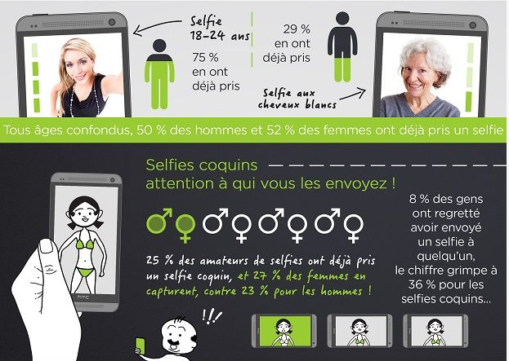
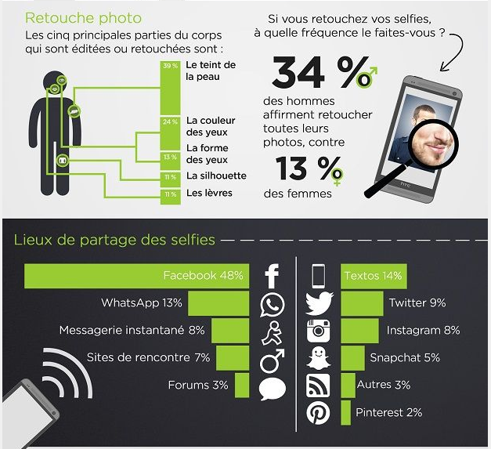

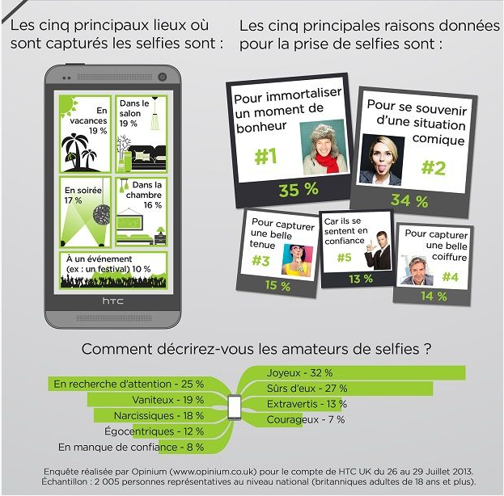

II. Listening #1
Français 4/5 Nom ________________________________________________
http://www.youtube.com/watch?v=ZpxvqAuoAOk Watch the video and respond in English.

1. What is the definition of a selfie? _____________________________________________________________________
__________________________________________________________________________________________________
2. Why is this phenomenon so well known? ______________________________________________________________
__________________________________________________________________________________________________
3. Why shouldn’t you take a selfie in the restroom? _______________________________________________________
__________________________________________________________________________________________________
4. Where are good places to take a selfie? ______________________________________________________________
__________________________________________________________________________________________________
5. Why shouldn’t you take selfies too close up?____________________________________________________________
__________________________________________________________________________________________________
6. Why shouldn’t you take a selfie that looks like you’re asleep? _____________________________________________
__________________________________________________________________________________________________
7. What should you watch out for when taking a selfie with a flash? __________________________________________
__________________________________________________________________________________________________
III. Article #1
Français 4/5
15 Astuces pour reussir un selfie Name _______________________________________
http://www.lexpress.fr/styles/vip/15-astuces-pour-reussir-un-selfie-l-autoportrait-avec-smartphone_1284447.html
A. What is the main idea of this article? Answer in English.
____________________________________________________________________________________________________________________________________________________________________________________________________

B. Supporting Details.
1. Check each detail that is mentioned in the article (not all are included).
2. Fill in the information that is given for each detail you have checked. Write in English.
___ The definition of a selfie___________________________________________________________________________
__________________________________________________________________________________________________
___ The reason you should turn off your flash_____________________________________________________________
__________________________________________________________________________________________________
___ What you should do to make the best of the available lighting __________________________________________
__________________________________________________________________________________________________
___ The reason natural light is better than artificial light_________________________________________________
__________________________________________________________________________________________________
___ The reason you shouldn’t take a selfie from too high up _____________________________________________
__________________________________________________________________________________________________
___ The reason you shouldn’t take a selfie from too far away _____________________________________________
__________________________________________________________________________________________________
___ The reason you shouldn’t take a selfie from too low ____________________________________________________
__________________________________________________________________________________________________
___ The advantage of taking a selfie (in terms of wardrobe) _____________________________________________
__________________________________________________________________________________________________
___ What you should do before taking a selfie in the bathroom _____________________________________________
__________________________________________________________________________________________________
___ A suggestion for taking interesting selfies when wearing sunglasses_____________________________________
__________________________________________________________________________________________________
___ The types of faces that should be avoided_____________________________________________________________
__________________________________________________________________________________________________
___ The reason you shouldn’t use the other side of your phone for taking selfies _______________________________
__________________________________________________________________________________________________
___ The reason you shouldn’t zoom in too close __________________________________________________________
__________________________________________________________________________________________________
___ A description of how to hold your arm when taking a selfie _____________________________________________
__________________________________________________________________________________________________
___ The reason you shouldn’t pretend to be sleeping in a selfie _____________________________________________
__________________________________________________________________________________________________
___ The reason you shouldn’t point out your faults in the caption of your selfie _______________________________
__________________________________________________________________________________________________
___ The reason you shouldn’t take too many selfies_______________________________________________________
__________________________________________________________________________________________________

C. Guessing Meaning from Context. Find the underlined words/phrases and write what you think they mean in English. The information in parenthesis tells you which paragraph the word appears in.
1. vous contournerez les yeux rouges et le teint blafard (#3) ________________________
2. Mais cela ne vous empêche pas de profiter de la lumière naturelle… (#4) ______________________
3. l’objectif doit être dans votre ligne de mire (#5) ______________________
4. Vérifiez votre tenue (#6) _______________________
5. Faites attention à l’arrière-plan (#7) __________________________
6. devant la coiffeuse de votre salle de bain (#8) __________________________
7. une difficulté supplémentaire à gérer (#9) _____________________________

D. Author’s Perspective. Check the perspective or point of view you think the author adopted as s/he wrote this article and justify your answer with information from the text.

___ Taking selfies is a result of the narcissism in our culture
___ You should always try to look your best in your selfies
___ Silly selfies are the best selfies
Justification from text: ______________________________________________________________________________
_________________________________________________________________________________________________
E. Comparing Cultural Perspectives. Answer the following questions in English.
1. Do you think selfies are as popular in France as they are in the United States? Why or why not?

____________________________________________________________________________________________________________________________________________________________________________________________________
IV. Selfie Presentation

Présentation sur un selfie Nom _______________________________________________
Directions :
1. Find the Selfie Presentation on your shared Google Drive.
2. Add a slide and insert a picture of a selfie. It can be a selfie that you’ve taken, or an appropriate one that you find online.
3. Prepare to discuss the selfie you added for about 1 minute. If you are using your own selfie, tell where you took it, when you took it, whom you shared it with, how you shared it, whether you edited it, and what you like/don’t like about it. If you shared someone else’s selfie, talk about why you selected it, what you think of it, etc.
4. Your presentation will be on Thursday (Oct. 2) and will be graded according to the following rubric:

Score | Indicators
10+ | You exceeded the stated expectations for this assignment.  You used complex structures and varied vocabulary with no errors.  You spoke fluently with excellent pronunciation.
9/10 | You thoroughly addressed the prompt with accurate, relevant and interesting detail.  Your presentation was well-organized with smooth transitions.  You were able to speak without relying on written notes.  You used level-appropriate structures and varied vocabulary to express your meaning with few errors.  You spoke fluently with excellent pronunciation.
8 | You adequately addressed the prompt; most information was accurate and relevant.  Your presentation was logically organized.  You glanced at your visual aid/notecards, but only occasionally.  You used level-appropriate structures and vocabulary with only minor errors which did not impede comprehension.  You may have spoken with a slight accent and occasional pauses.
7 | Your presentation fell slightly short of stated expectations due to a lack of adequate, pertinent detail.  Your presentation occasionally lacked adequate transitions between ideas.  You paused to check the script on your visual aid or notes.  You relied on simple structures and repetitive vocabulary, or made errors which occasionally interfered with comprehension.  You may have spoken with considerable accent and/or frequent pauses.
6 | Your presentation fell significantly short of stated expectations.  Your presentation lacked organization; you jumped around between ideas rather than presenting your information in a logical order.  You read directly from your visual aid or notes.  You made errors in grammar and/or vocabulary which significantly impeded comprehension.  You may have spoken with significant pronunciation errors or long pauses.
5 | Your presentation did not meet stated expectations in terms of content, organization, vocabulary/grammatical structures, and pronunciation.

Commentaire:

V. Article #2
Français 4/5 Nom __________________________
Lisez l’article et choisissez la meilleure réponse à chaque question.
http://www.terrafemina.com/societe/societe/articles/34181-selfies-une-mode-dangereuse-pour-les-adolescentes-.html
___ 1. A qui est-ce que cet article est destiné?
a. aux adolescents
b. aux chefs des réseaux sociaux
c. A ceux qui sont responsables pour les adolescents (parents, professeurs, etc.)
___ Dans le deuxième paragraphe, l’auteur écrit « depuis que ce néologisme anglophone a été élu mot de l’année 2013… » Quelle est la définition de néologisme ?
a. un insulte
b. un nouveau mot
c. un mot étranger
___ 2. Selon l’article, qu’est-ce que c’est qu’une « Lolita numérique ? »
a. Une jeune fille qui cherche un copain a l’Internet
b. Une jeune fille qui envoie des photos coquines aux inconnus.
c. Une jeune fille qui poste des selfies sur les réseaux sociaux
___ 3. Quelle est l’attitude de Yann Leroux vis-à-vis la prolifération des selfies ?
a. Il pense que les selfies permettent aux adolescents de trouver l’affirmation. b. Il pense que les selfies sont le résultat du narcissime des ados.
c. Il pense que c’est un phénomène dangereux, surtout pour les filles.
___ 4. Selon Thalmann, quelle est la différence entre les filles et les garçons en ce qui concerne les réseaux sociaux?
a. Les filles passent plus de temps sur les réseaux sociaux parce qu’ils sont plus verbales.
b. Les garçons préfèrent les réseaux sociaux parce qu’ils sont plus visuels.
c. Les garçons préfèrent les réseaux sociaux parce qu’ils peuvent y exprimer leurs émotions plus facilement.
___ 5. Dans le 4e paragraphe, l’auteur cite Thalmann en disant que ces « selfies ne sont pas anodins. » Lequel des mots suivants est un synonyme de anodins ?
a. importants
b. innocents
c. dangereux
___ 6. Selon Thalmann, pourquoi est-ce que les filles sont plus susceptibles que les garçons aux risques inhérents dans le phénomène des selfies ?
a. Les filles ont une tendance de se critiquer.
b. Les filles sont plus souvent exploitées par des inconnus.
c. Les filles publient plus de selfies sur les réseaux sociaux.
___ 7. Est-ce que les trois psychologues sont d’accord vis-à-vis l’effet des selfies sur l’estime de soi des adolescents ?
a. Oui, tous les trois croient tous que les filles sont plus vulnérables.
b. Non, Barthe-Liberge et Leroux constatent que les garçons sont aussi vulnérables que les filles.
c. Non, Barthe-Liberge pense que les garçons sont plus vulnérables que les filles.
___ 8. Selon Leroux, quel est le rapport entre les selfies et la sexualité ?
a. Il croit que les selfies encourage la sexualisation des jeunes filles.
b. Il croit que la publicité est aussi responsable que les réseaux sociaux en soulignant la sexualité.
c. Il croit que les stars sont plus responsable que le media pour l’hyper sexualisation des jeunes.
___ 9. Selon l’article, quel est le rôle des adultes en protégeant les jeunes des dangers des selfies.
a. Ils doivent interdire aux jeunes de publier les selfies.
b. Ils doivent leur expliquer les dangers des selfies.
c. Ils doivent encourager les jeunes à réfléchir et à prendre de bonnes décisions.
___10. Quel est le but de cet article ?
a. D’expliquer le développement de la popularité des selfies.
b. D’expliquer le rôle entre le narcissisme adolescent et les selfies.
c. D’expliquer les risques psychologiques qui peuvent résulter des selfies.

VI. Composition

Français 4/5 Nom __________________________
Réponse écrite

Imaginez que votre petite sœur de 15 ans a commencé à publier beaucoup de selfies. Ecrivez-lui un message (200-300 mots) dans lequel vous la persuadez de faire bien attention aux dangers de cette pratique. Utilisez des détails spécifiques de l’article (sans copier des locutions exactes).

10/11 | Thorough and effective treatment of topic, including supporting details and relevant references to all sources  Fully understandable, with ease and clarity of expression; occasional errors do not impede comprehensibility  Varied and appropriate vocabulary and idiomatic expressions  Control of time frames; accuracy and variety in grammar, syntax, and usage, with few errors  Organized essay; effective use of transitional elements or cohesive devices.  Variety of simple and compound sentences, and some complex sentences
9 | Effective treatment of topic, including some supporting details and mostly relevant references to all sources  Fully understandable, with some errors, which do not impede comprehensibility  Generally appropriate vocabulary, including some idiomatic expressions  Accurate use of present time and mostly accurate use of other time frames; general control of grammar, syntax, and usage  Organized essay; some effective use of transitional elements or cohesive devices  Simple, compound, and a few complex sentences
8 | Competent treatment of topic, including a few supporting details and references to all sources  Generally understandable, with errors that may impede comprehensibility  Sufficient vocabulary, including a few idiomatic expressions  Mostly accurate use of present time and some accuracy in other time frames; some control of grammar, syntax, and usage  Some organization; limited use of transitional elements or cohesive devices  Simple and a few compound sentences
7 | Inadequate treatment of topic, consisting mostly of statements with no development; references to sources may be inaccurate; may not refer to all sources  Partially understandable, with errors that force interpretation and cause confusion for the reader  Limited vocabulary and idiomatic expressions  Some accuracy in present time and little or no accuracy in other time frames; limited control of grammar, syntax, and usage  Inadequate organization; ineffective use of transitional elements or cohesive devices  Simple sentences and phrases
6 | Little or no treatment of topic; may consist mostly of repetition of sources or may not refer to any sources  Barely understandable, with frequent or significant errors that impede comprehensibility  Very few vocabulary resources  Little or no control of grammar, syntax, usage, and time frames  Little or no organization; absence of transitional elements and cohesive devices  Simple sentences or fragments
5 | Mere restatement of language from the prompt  Clearly does not respond to the prompt; completely irrelevant to the topic  « Je ne sais pas, » « Je ne comprends pas : or equivalent  Not in the language of the exam

VII. Videos
http://www.youtube.com/watch?v=DcBFucN-qiw
- Explain the tradition regarding this bridge. _____________________________________________________
________________________________________________________________________________________
- When did it start? _______________________
- Why did the Mexican couple want to do it? _____________________________________________________
- About how many locks are there? _____________________________________________________
- How much weight is on each part of the bridge? ___________________________________________________
- What does Julie describe? (Give as much detail as possible.) ___________________________________________________________________________________________
- What languages are the stickers in? ______________________________________________________________
- What will the next step be, if people don’t follow the rules on the stickers? ______________________________
___________________________________________________________________________________________
http://www.youtube.com/watch?v=nuNfpmPSf2I
1. Where did they launch this campaign? ________________________________________________________
2. Describe the tradition. _______________________________________________________
3. When did part of the bridge collapse? _________________________________________________________________
4. What does the French man (black shirt) think of the new idea?_____________________________________________
5. Why didn’t the authorities want to make the locks illegal at this time? __________________________________________________________________________________________________

