Français I Nom ___________________________________________
Unité 2: Les Fournitures Scolaires

I. Office Supply Website : http://www.top-office.com/fournitures-scolaires.html
A. Using your computer, Ipad, or handouts find the following words and write what you think they mean in English.
http://www.top-office.com/fournitures-scolaires/cartable-sac-a-dos.html

1. un sac à dos ________________________
2. un cartable________________________
3. une fille________________________
4. un garçon________________________

http://www.top-office.com/fournitures-scolaires/ecriture-correction.html

5. un effaceur________________________
6. un taille-crayon________________________
7. un surligneur________________________
8. un crayon________________________
9. orange________________________
10. jaune ________________________
11. rose________________________
12. bleu________________________
13. noir________________________
14. un stylo________________________
15. des craies________________________
16. un flacon correcteur________________________
17. une gomme________________________

http://www.top-office.com/fournitures-scolaires/classement-archivage-protection.html

18. un classeur________________________
19. violet________________________
20. rouge________________________
21. vert________________________

http://www.top-office.com/fournitures-scolaires/colle-adhesifs.html

22. un bâton de colle________________________
23. du ruban adhésif________________________

http://www.top-office.com/fournitures-scolaires/geometrie-tracage.html

24. une règle________________________
25. un équerre ________________________
26. un rapporteur________________________
27. un compas________________________

http://www.top-office.com/fournitures-scolaires/decoupage-perforation.html

28. des ciseaux ________________________
29. une perforatrice________________________

http://www.top-office.com/fournitures-scolaires/trousse.html
30. une trousse________________________
http://www.top-office.com/fournitures-scolaires/calculatrice.html
31. une calculatrice________________________
http://www.top-office.com/fournitures-scolaires/attache-fixation.html

32. une agrafeuse________________________
33. un aimant______________________
34. des trombones_______________________
35. un bracelet caoutchouc_______________

http://www.top-office.com/papeterie/cahiers-carnets-bloc-notes.html

36. un cahier _______________________
37. un carnet _______________________

http://www.top-office.com/papeterie/feuilles-copies-papier.html

38. une feuille de papier ___________________

Answer the following questions comparing French and American school supplies.

1. What is the system of measurement used to describe French school supplies? __________________
2. Name at least one brand name from the website that is also common in the U.S. ________________
3. Name at least one brand name from the website that you’ve never seen before. _________________
4. What is the abbreviation that is used in place of a dollar sign in France? _______________
5. What does this abbreviation stand for? ________________________
6. Which of the items on the list have you never purchased? _______________________ (French word)
- Why not? ________________________________
B. In the activity below, you are going to ask your partner whether s/he has various items in his/her backpack.
This is the question you will ask: Tu as… (Do you have…?)
Sample Questions
- Tu as un crayon? (Do you have a pencil ?)
- Tu as une gomme? (Do you have an eraser ?)
- Tu as des trombones? (Do you have any paper clips?)

This is how you will answer your partner’s questions: Oui, j’ai… (Yes, I have…) OR
Non, je n’ai pas de…. (No, I don’t have a/any…)
Sample Responses:
- Oui, j’ai un crayon. (Yes, I have a pencil.)
- Oui, j’ai une gomme. (Yes, I have an eraser.)
- Oui, j’ai des trombones. (Yes, I have some paper clips)
- Non, je n’ai pas de crayon. (No, I don’t have a pencil.)
- Non, je n’ai pas de gomme. (No, I don’t have an eraser.)
- Non, je n’ai pas de trombone. (No, I don’t have any paper clips.)

Partner Activity
Partner A:
1. Ask your partner whether s/he has each of the following items.
2. If s/he does have the item, circle it.
3. If s/he doesn’t have the item, draw an X through it.
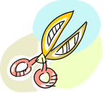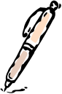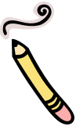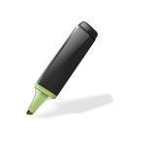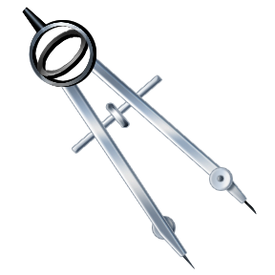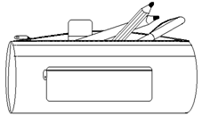

Partner B:
1. Ask your partner whether s/he has each of the following items.
2. If s/he does have the item, circle it.
3. If s/he doesn’t have the item, draw an X through it.
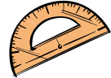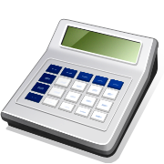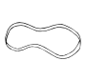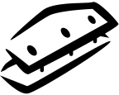

C. Practice saying whether your partner has/doesn’t have each item, in case Madame asks you to present. These are the phrases that you will use to talk about what your partner has/doesn’t have.
- Il a un/une/des… (He has a/some…) Il n’a pas de… (He doesn’t have a/any…)
- Elle a un/une/des… (She has a/some) Elle n’a pas de… (She doesn’t have a/any…)

D. Make a list of 10 items that you have in your back pack. Write in French. Don’t forget to use un, une or des in front of each word.

1. ________________________________
2. ________________________________
3. ________________________________
4. ________________________________
5. ________________________________
6. ________________________________
7. ________________________________
8. ________________________________
9. ________________________________
10. ________________________________

II. Video: https://www.youtube.com/watch?v=JET4cy1XL3g
A. Watch the video and complete the following activities.
1. The first time that you listen, check each item that the girl mentions.
2. The second time you listen, add any details you hear, such as the brand, color, or size. You can write the details in French or English. (You will not list a detail for every item.)

___ un agenda Détail: ______________________________
___ un équerre Détail: ______________________________
___ un rapporteur Détail: ______________________________
___ un compas Détail: ______________________________
___ des ciseaux Détail: ______________________________
___ une agrafeuse Détail: ______________________________
___ une règle Détail: ______________________________
___ une tube de colle Détail: ______________________________
___ des effaceurs Détail: ______________________________
___ des crayons Détail: ______________________________
___ un taille crayon Détail: ______________________________
___ une gomme Détail: ______________________________
___ un surligneur Détail: ______________________________
___ une souris Détail: ______________________________
___ des crayons de couleurs Détail: ______________________________
___ une calculatrice Détail: ______________________________
___ un cahier Détail: ______________________________
___ un classeur Détail: ______________________________

B. Discuss the school supplies that you have in your backpack with your partner and fill in the following table.
1. If you have an item but your partner does not, write the name of the item in the first column.
2. If you both have the item, write the name of the item in the second column (We have…).
3. If your partner has the item but you do not, write the name of the item in the third column.
- Don’t forget to write the un/une/des in front of the item.
- If you’ve forgot how to say “Do you have a/some…” look at the examples at the top of page 2.
J’ai… | Nous avons… | Elle/Il a…
C. Write 10 sentences comparing the school supplies in your backpack to the school supplies in your partner’s backpack. Use the following new words/phrases in your sentences:
- mais (but)
- et (and)
- aussi (too)
- non plus (neither)
Examples:
1. J’ai un cahier mais elle n’a pas de cahier.
2. J’ai un cahier et elle a un cahier aussi.
3. Elle n’a pas de cahier et je n’ai pas de cahier non plus.

Sentences :

- _________________________________________________________________________________
- _________________________________________________________________________________
- _________________________________________________________________________________
- _________________________________________________________________________________
- _________________________________________________________________________________
- _________________________________________________________________________________
- _________________________________________________________________________________
- _________________________________________________________________________________
- _________________________________________________________________________________
- _________________________________________________________________________________

III.
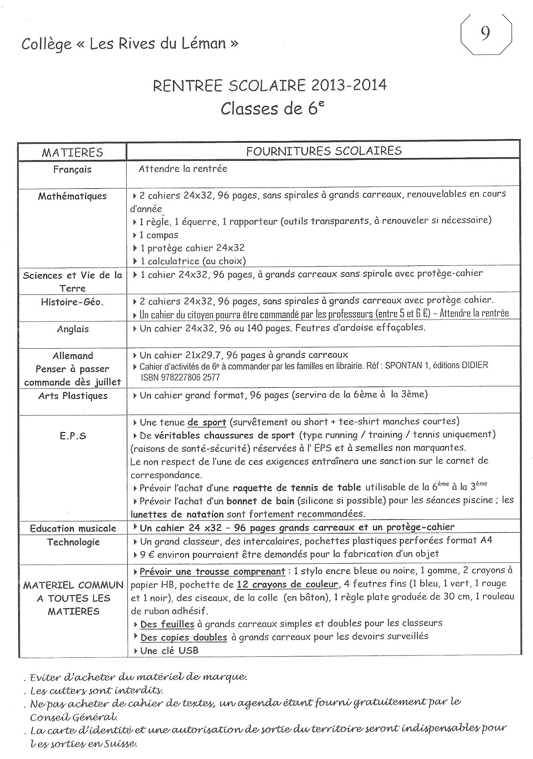

A. Read the text (III) and answer the following questions.
1. What is this document? ___________________________________________________________________
2. For whom was it written? _________________________________________________________________
3. Name 7 different things that are needed for math class __________________________________________
_____________________________________________________________________________________
_____________________________________________________________________________________
4. How much is social studies workbook? ______________________________________________________
5. For what class do you need a dry-erase marker? _______________________________________________
7. What do the students wear for gym class? ____________________________________________________
8. Name at least one sport that they play in gym class. ____________________________________________
9. Name 9 items that students should have in their pencil cases for all of their classes.
________________________________________________________________________________________________________________________________________________________________________________________________________________________________________________________________________
10. What color pens are suggested? _________________________________
11. What color felt-tip markers do students need? ________________________________________________
12. What will the students do with the sheets of paper? __________________________________________
13. What do you think une clé USB is? ____________________________________
B. Talk to your partner about what you need for each of the following classes and fill in the table below.
Here are some words/phrases that will help you:
- pour (for)
- On a besoin de/d’ (we/you need)
- On n’a pas besoin de/d’ (we/you don’t need)
- aussi (also)
Sample sentences:
A : Pour les maths, on a besoin d’une calculatrice.
B : Oui, on a besoin d’un cahier aussi.
A : On a besoin d’un classeur pour les maths ?
B : Non, on n’a pas besoin d’un classeur.

Fill in the table in French. Don’t forget to include either un/une or a number for each item.
Matière | Fournitures Scolaires
Anglais
Français
Maths
EPS
Sciences
C. Write 10 sentences comparing what you need for various classes to what the students at this school need.
Sample sentences:
1. Pour les maths, j’ai besoin d’une calculatrice, mais je n’ai pas besoin d’un compas.
2. Pour les sciences, je n’ai pas besoin d’un protège-cahier, mais j’ai besoin de lunettes de sécurité.
3. Moi aussi, j’ai besoin d’un cahier pour le français.
Sentences :

- _________________________________________________________________________________
- _________________________________________________________________________________
- _________________________________________________________________________________
- _________________________________________________________________________________
- _________________________________________________________________________________
- _________________________________________________________________________________
- _________________________________________________________________________________
- _________________________________________________________________________________
- _________________________________________________________________________________
10. _________________________________________________________________________________

IV. https://www.youtube.com/watch?v=cDpSl5WUGvA
A. Listen to the video and complete the following activities:
1. Choose each school supply item that the speaker mentions.
2. Add an additional detail (color, size, number, etc.) when possible. You may write in French or English.

___ un taille-crayon Détail: ______________________________
___ des crayons Détail: ______________________________
___ une trousse Détail: ______________________________
___ des effaceurs Détail: ______________________________
___ des gommes Détail: ______________________________
___ des surligneurs Détail: ______________________________
___ des stylos Détail: ______________________________
___ des ciseaux Détail: ______________________________
___ une calculatrice Détail: ______________________________
___ un compas Détail: ______________________________
___ des colles scotch Détail: ______________________________
___ un agenda Détail: ______________________________
___ des feuilles de papier Détail: ______________________________
___ des cahiers Détail: ______________________________
___ un classeur Détail: ______________________________
B. You and your partner will practice the following role play. Make sure to practice both roles, as you will not know in advance which role you will play (or who your partner will be).
Role Play #1
Partner A
1. You are a teenager who wants a lot of new school supplies. Tell your parent (Partner B) that you want the following items:
Note: Je voudrais = I would like
2. If your parent agrees that you need an item, circle it.
3. If your parent reminds you that you already have an item, draw an X through it.

Partner B:
1. You are the parent and you can’t afford to keep buy new school supplies for your son/daughter.
2. Circle 10 items above that you are willing to buy for your son/daughter.
3. When s/he asks for various items, reply accordingly:
- If you are willing to buy the item (circled items), you will reply: Tu as raison, tu as besoin d’un/une/de..(You’re right, you need a/some…)
- If you’re not willing to buy the item (uncircled items), you’ll reply: Non, tu n’as pas besoin d’un/une/de…(No, you don’t need a/some…)
Role Play #2: Follow the directions for Role Play #1, but switch roles.

C. Imagine that you are the mother (see Role Play #1 or #2) and write out your shopping list for the school supplies that you need to buy for your son/daughter. Don’t forget to write un/une/des in front of the item you have circled.

1. ________________________________
2. ________________________________
3. ________________________________
4. ________________________________
5. ________________________________
6. ________________________________
7. ________________________________
8. ________________________________
9. ________________________________
10. _______________________________

