Français 1 – Station de Conversation

You and your partner each have a paper with 12 pictures that you took while spending December with a host family. (Partner A was in Quebec and Partner B was in France). Take turns discussing your pictures, using the following phrases to start, continue and end your conversation for each picture.

To start a conversation:
- Qui est-ce?................................................... Who is this?
- Qu’est-ce que c’est? ………………………….…….. What is this?
- Qu’est-ce qu’il (or elle) fait ?....................... What is he (or she) doing?

To respond:
- C’est mon père/ma mère/ma sœur/mon frère/etc.…………………….
- Il/elle…………
  - décore………….is decorating
  - ouvre……………is opening
  - mange………… is eating
  - fait……………… is making
  - regarde………. is looking at
  - accroche…….. is hanging
  - écrit……………. is writing
  - envoie………… is sending
  - offre…………… is offering
  - chante……….. is singing
  - met…………… is putting
- En France/Au Canada, on……………. In France/In Canada, they…
  - décore…………. decorate
  - ouvre…………… open
  - mange………… eat
  - fait……………… make
  - accroche…….. hang
  - écrit……………. write
  - envoie………… send
  - offre…………… offer
  - chante……….. sing

To give an opinion :
- C’est intéressant……………… That’s interesting.
- C’est bizarre……………………..That’s weird.
- C’est amusant/rigolo………. That’s fun.

To compare cultures :
- On fait la même chose en France/au Canada………………… They do the same thing in France/Canada.

Partenaire A
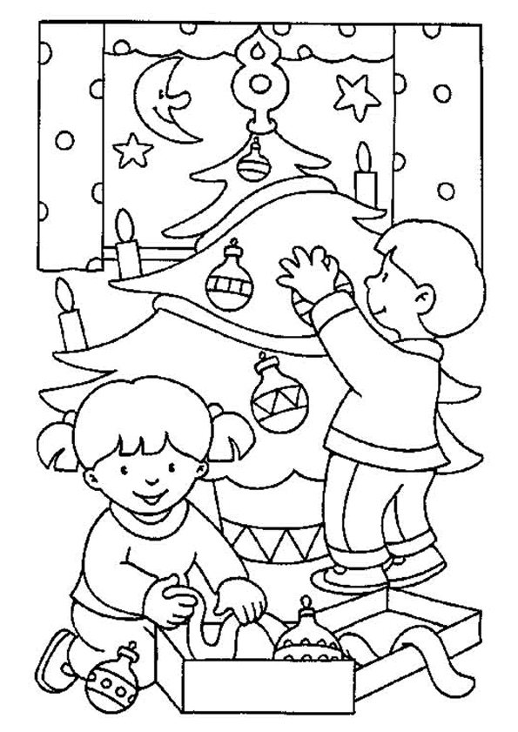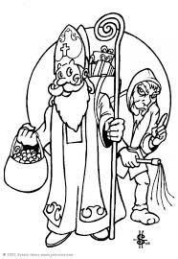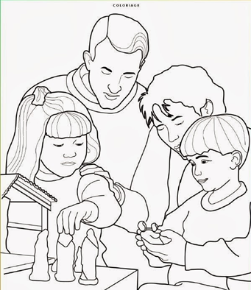

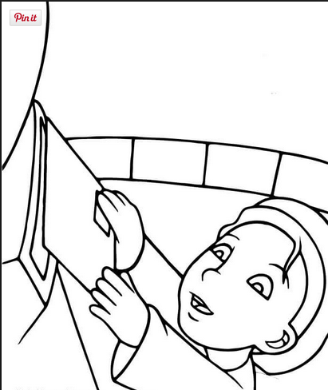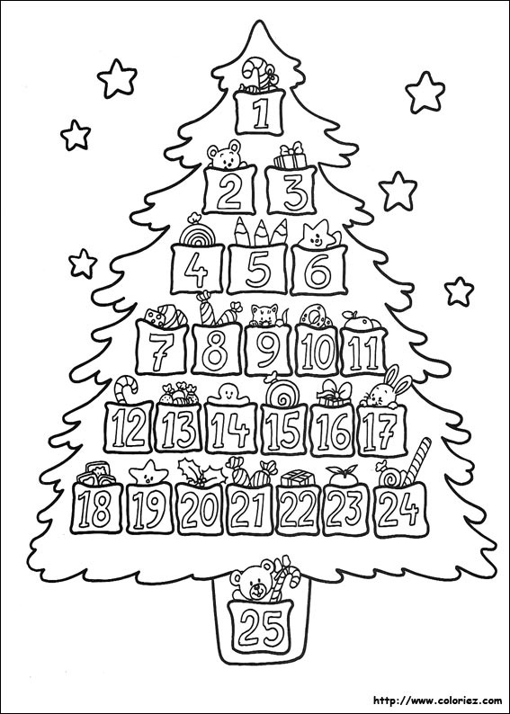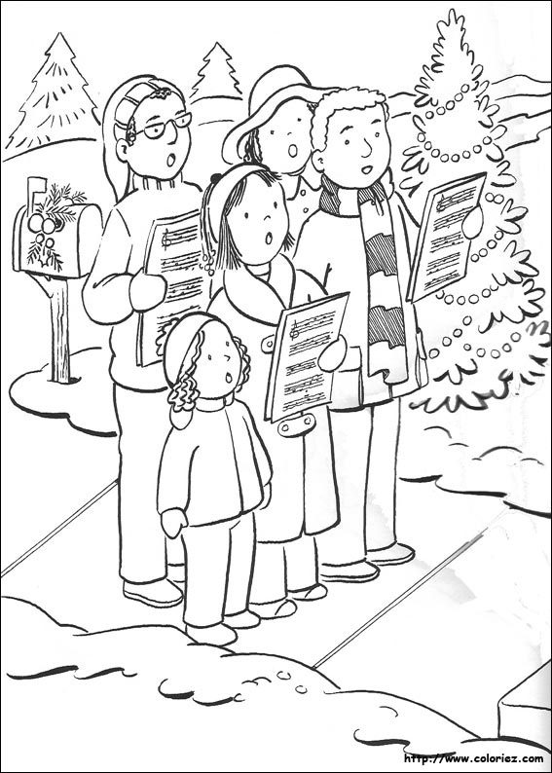

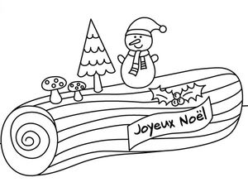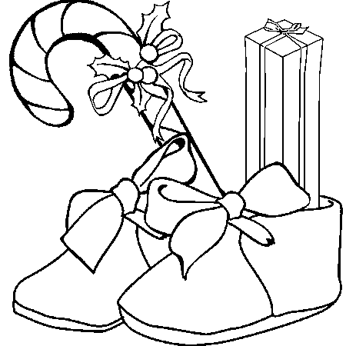
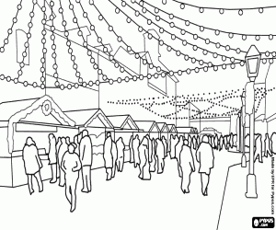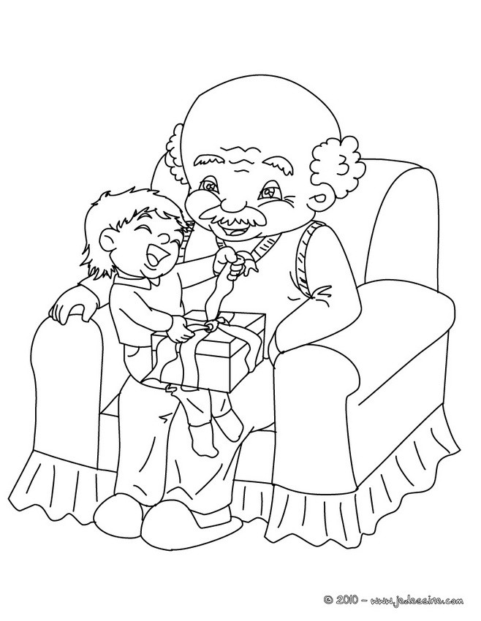

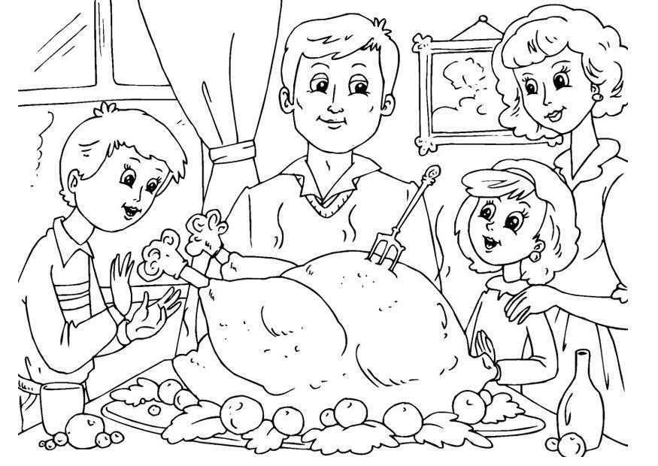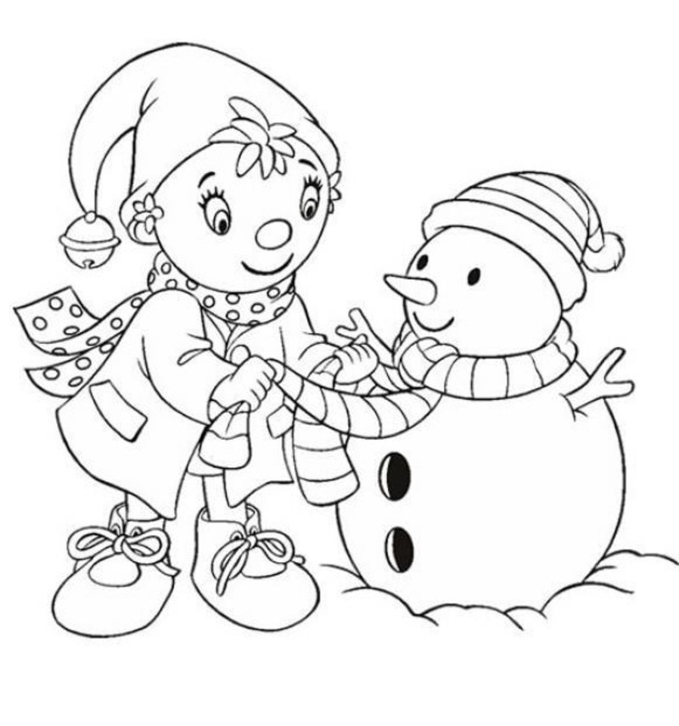

Partenaire B
