Français I Nom______________________________________
Unit 2 IPA (Mes Préférences)
Interprétation (Orale)
(https://www.youtube.com/watch?v=SCRvE2f-srw)
A. Watch this clip from a French movie that came out in 2008 and check each detail that Carl gives. Then add the information he gives for each detail you have checked. (He will not mention all of these.)
____A sport he likes to play _______________________________
____ A sport he likes to watch ______________________________
____Another type of game he likes to play______________________________
____A school subject he likes______________________________
____A group of people he likes______________________________
____A TV show he likes______________________________
____ A sport he doesn’t like______________________________
____A type of music he doesn’t like______________________________
____A type of teacher he doesn’t like______________________________
____A school subject he doesn’t like______________________________
____A type of person he doesn’t like______________________________
____A school he doesn’t like ______________________________
B. Guessing Meaning from Context.
1. Carl says, (:12) « J’aime aller en vacances aux Antilles. What do you think en vacances means? ____________________________
2. Carl says (:55), “Je n’aime pas la guerre en Iraq.” What do you think guerre means? ________________
3. Carl says (:51), “Je n’aime pas aller voir mon frère en prison.” What do you think mon frère means ? ___________________

Interprétation (Ecrite)
A. What is the purpose of the website where these posts appeared? Answer in English.
________________________________________________________________________________________________________________________________________________________________________________________________________________________________________________________________________
B. Supporting Details.
1. Check each detail that is mentioned in the text (not all are included).
2. Fill in the information that is given for each detail you have checked. Write in English.
#1
___ What Lidia likes to do (4 things) __________________________________________________________
__________________________________________________________________________________
___ What she does in the winter _____________________________________________________________
#2
___ Is this person a boy or a girl_____________________________________________________________
___ His/her favorite soccer team _____________________________________________________________
___ His/her favorite rugby team______________________________________________________________
___ The sport s/he plays________________________________________________________________
___ Two other sports s/he does____________________________________________________________
#3
___ The country Eloise lives in_______________________________________________________________
___ The languages she speaks_______________________________________________________________
___ Six things she loves
______________________________________________________________________________
______________________________________________________________________________
#4
___ The languages that Camille speaks_______________________________________________________
___ The language she’d like to learn _________________________________________________________
___ What she does on Saturdays ____________________________________________________________
___ The sport she likes________________________________________________________________
#5
___ The country Sirine lives in ______________________________________________________________
___ Her parents’ nationalities __________________________________________________________________
___ The languages she speaks______________________________________________________________
___ The language she’d like to learn _______________________________________
___ What she needs __________________________________________
#6
___ Who Marie wants to write to _____________________________________________________________
___ The sport she loves ________________________________________________________________
___ The countries she’d like to visit __________________________________________________________
#7
___ Her nationality________________________________________________________________
___ Her age ________________________________________________________________
___ The languages she speaks______________________________________________________________
___ The activities she likes (3) ______________________________________________________________
___ Who she’d like to write to________________________________________________________________
#8
___ Three things she likes________________________________________________________________
___ Four activities she does ________________________________________________________________
_________________________________________________________________________________
___ Two other activities she likes____________________________________________________________
___ The languages she speaks______________________________________________________________
#9
___ Is Rimchopin a boy or a girl? ___________________________________________________________
___ What does s/he like? ________________________________________________________________
___ What is his/her favorite pastime? _________________________________________________________
___ What else does s/he like to do? ________________________________________________________
#10
___ Where does Adele live? ________________________________
___ What she likes (Name 4) _______________________________________________________________
_______________________________________________________________________________________
#11
___ Where does Zakia live?____________________________________
___ What does she love? ______________________________________
___ What else does she like? _____________________________________
D. Guessing Meaning from Context. Find the underlined words/phrases and write what you think they mean in English. The information in parenthesis tells you which paragraph the word appears in.
1. Je me nomme Lydia (#1) _____________________________
2. Je fais aussi du tir à l’arc. (#2) __________________________________
3. J’ai trois frères. (#2) ________________________________
4. Je parle très bien le français, un peu l’arabe, un peu l’espagnol. (#5) ______________________________
5. …découvrir d’autres modes de vies et d’autres cultures (#7) _____________________________________
E. Inference. Answer the following question(s) in English, giving us much information from the article as possible to support your response.
1. What languages do you think they speak in Tunisia? Why do you think so?
_______________________________________________________________________________________________________________________________________________________________________________
F. Comparing Cultural Perspectives. Answer the following questions in English.
1. Compare the activities that French-speaking kids like to the activities that American kids like. Which ones are the same? Which ones are different? Why do you think this is?
_______________________________________________________________________________________________________________________________________________________________________________

Communication Interpersonnelle
Someone from the keypal site has responded to your post and (with your parents’ permission) you’ve decided to chat via Google Hangout. Ask him/her lots of questions about his/her preferences regarding various activities, music, classes, etc. Give as much information as possible to the questions you are asked!

Présentation
Write a post to the penpal website. Your post should be at least 75 words long and should include your name, age, and several sentences about your likes and dislikes.

________________________________________________________________________________________________________________________________________________________________________________________________________________________________________________________________________________________________________________________________________________________________________________________________________________________________________________________________________________________________________________________________________________________________________________________________________________________________________________________________________________________________________________________________________________________________________________________________________________________________________________________________________________________________________________________________________________________________________________________________________________________________________________________________________________________________________________________________________________________________________________________
____________________________________________________________________________________________________________________________________________________________________________________________________________________________________________________________________________________________________________________________________________________________________________________________________________________________________________________________________________________________________________________________________________________________________________________________________________________________________________________________________________________________________________________________________________________________________________________________________________
________________________________________________________________________________________________________________________________________________________________________________________________________________________________________________________________________________________________________________________________________________________________________________________________________________________________________________________________________________________________________________________________________________________________________________________________________________________________________

#1
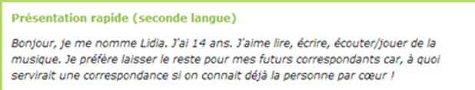

#2
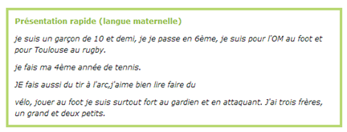
#3
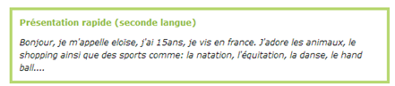
#4
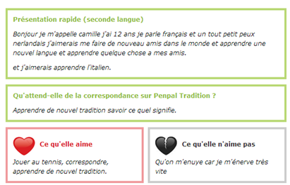
#5
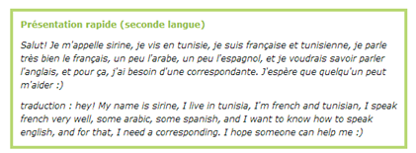
#6
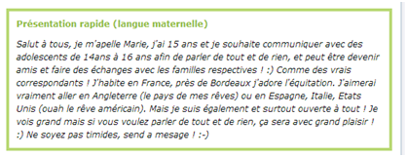
#7
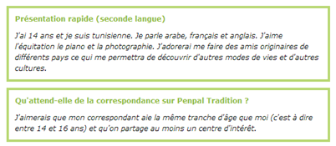
#8
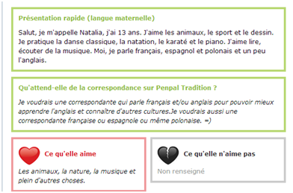
#9
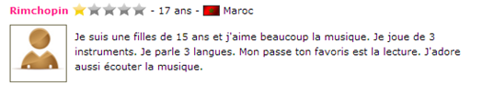
#10
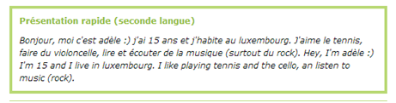
#11

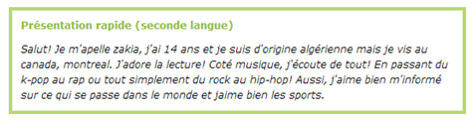

http://www.penpal-tradition.net/members/0-2-1-correspondant-francais-france-metropolitaine.html

