Partenaire A Nom ______________________________
Directions:
1. You have four screenshots from the Trotro video you watched and your partner has four different screenshots.
2. You and your partners will take turns telling what happened in the video in order to put the pictures in order.
Sample Conversation:
A: Trotro s’est réveillé. (This is the first thing that happened. Since it is picture D, both partners write “D” next to #1)
B: Puis, Trotro a pris son seau. (This is the second thing that happened. Both partner’s will write the corresponding
Letter next to #2.)
3. Continue until all 8 pictures have been put in the correct order.

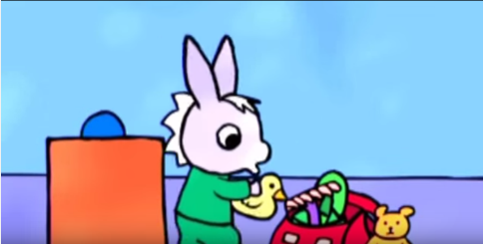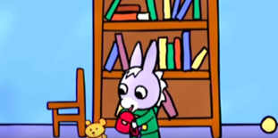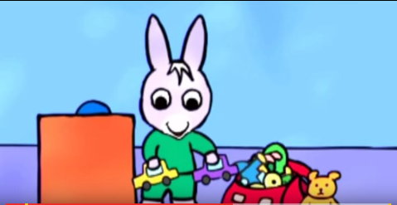
A. B. C.
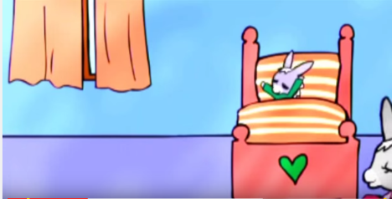
D.

Fill in the letters in the correct order below.

1. __D__ 2. ____ 3. ____ 4. ____ 5. ____ 6. ____ 7. ____ 8. ____

Partenaire B Nom ______________________________
Directions:
1. You have four screenshots from the Trotro video you watched and your partner has four different screenshots.
2. You and your partners will take turns telling what happened in the video in order to put the pictures in order.
Sample Conversation:
A: Trotro s’est réveillé. (This is the first thing that happened. Since it is picture D, both partners write “D” next to #1)
B: Puis, Trotro a pris son seau. (This is the second thing that happened. Both partner’s will write the corresponding
Letter next to #2.)
3. Continue until all 8 pictures have been put in the correct order.

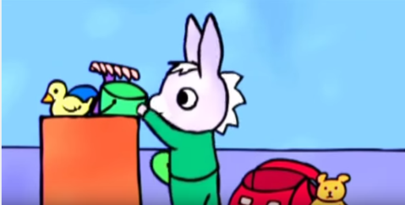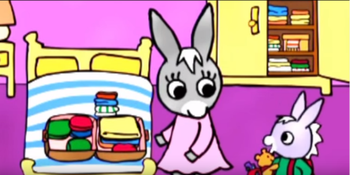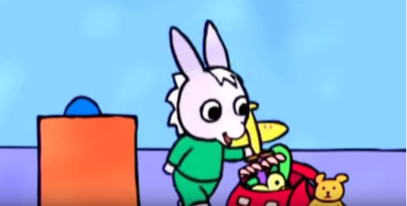
E. F. G.
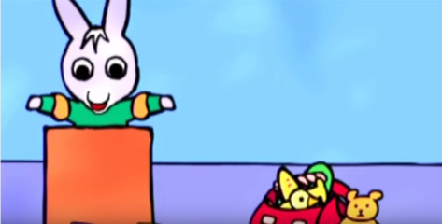
H.

Fill in the letters in the correct order below.

1. __D__ 2. ____ 3. ____ 4. ____ 5. ____ 6. ____ 7. ____ 8. ____

