Partenaire A Nom ______________________________
Directions:
1. You have five screenshots from the Petit Ours Brun video you watched and your partner has six different screenshots.
2. You and your partners will take turns telling what happened in the video in order to put the pictures in order.
Sample Conversation:
A: Petit Ours Brun est arrivé à la plage. (This is the first thing that happened. Since it is picture I, both partners write
“I” next to #1)
B: Puis, Maman a mis sa serviette sur le sable. (This is the second thing that happened. Both partners will write the
corresponding letter next to #2.)
3. Continue until all 11 pictures have been put in the correct order.

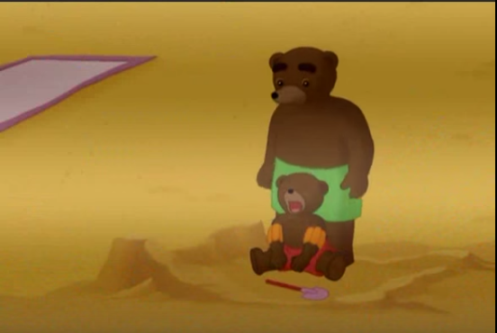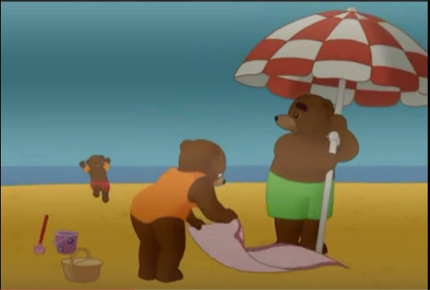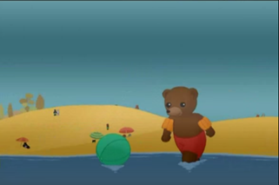
A. B. C.

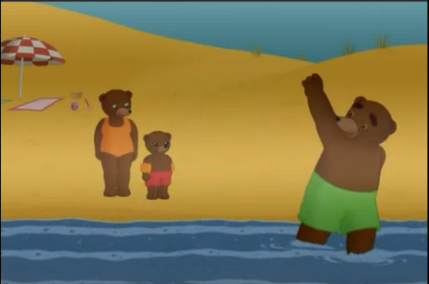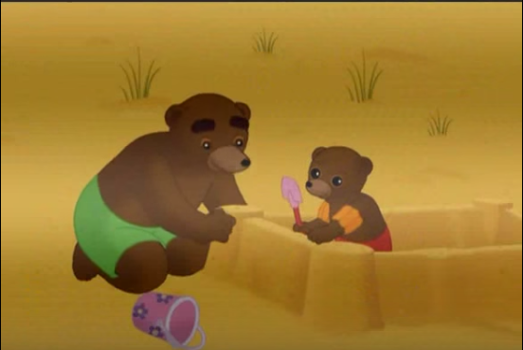
D. E.

Fill in the letters in the correct order below.

1. __I__ 2. ____ 3. ____ 4. ____ 5. ____ 6. ____ 7. ____ 8. ____ 9. ____ 10. ____ 11. ____

Partenaire B Nom ______________________________
Directions:
1. You have six screenshots from the Petit Ours Brun video you watched and your partner has five different screenshots.
2. You and your partners will take turns telling what happened in the video in order to put the pictures in order.
Sample Conversation:
A: Petit Ours Brun est arrivé à la plage. (This is the first thing that happened. Since it is picture I, both partners write
“I” next to #1)
B: Puis, Maman a mis sa serviette sur le sable. (This is the second thing that happened. Both partners will write the
corresponding letter next to #2.)
3. Continue until all 11 pictures have been put in the correct order.

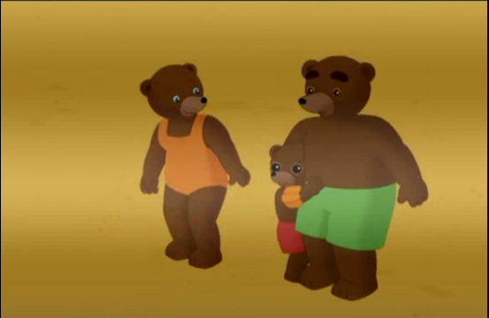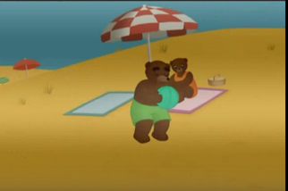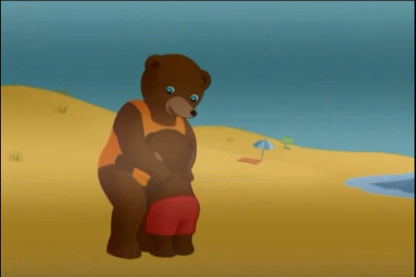
F. G. H.
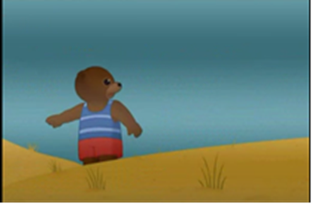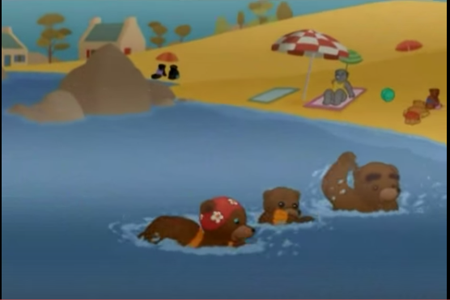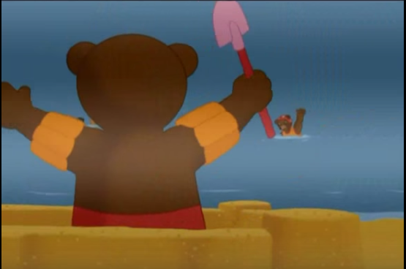
I. J. K.

1. __I__ 2. ____ 3. ____ 4. ____ 5. ____ 6. ____ 7. ____ 8. ____ 9. ____ 10. ____ 11. ____

