Partner A Nom _______________________________________
Classroom Object Matching Game

You and your partner have the same pictures but in a different order. Your pictures have letters below them and your partner’s pictures have numbers. Take turns describing your pictures so that you can fill in the chart below.

Letter | Number | Letter | Number | Letter | Number
a. | 12 | f. |  | k.
b. |  | g. |  | l.
c. |  | h.
d. |  | i.
e. |  | j.

Directions:
1. Describe the items that you see in Picture A. Here are some sample sentences:
- Il y a trois livres.
- Il y a un bureau.
- Il y a un professeur.
- Il y a une chaise.
- Il n’y a pas d’élèves.
2. Your partner will tell you the number below this picture on his/her paper and you will tell him/her the letter.
3. You will both fill out the table above.

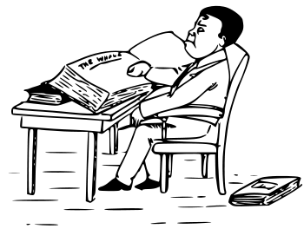 | 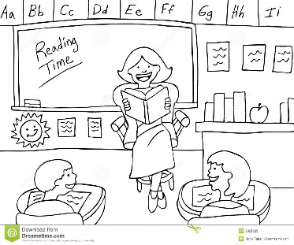 | 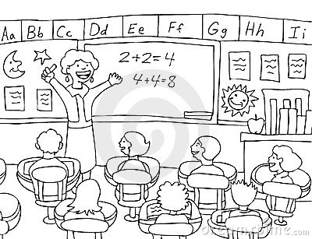 | 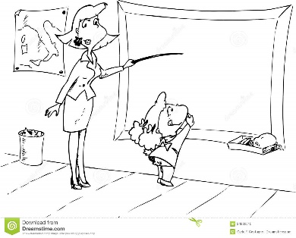
a. | b. | c. | d.
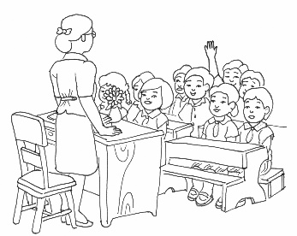 | 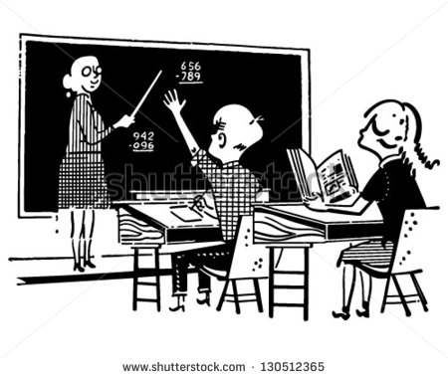 | 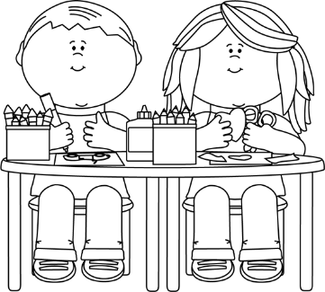 | 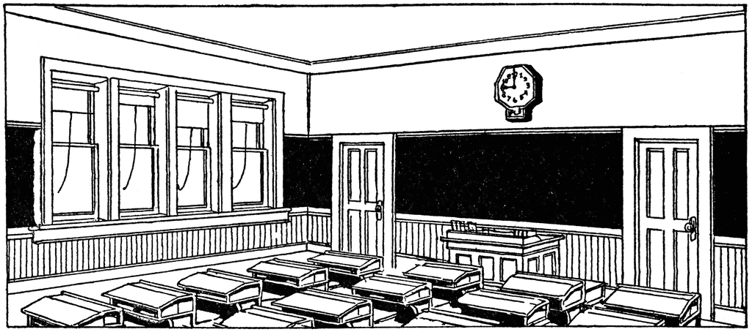
e. | f. | g. | h.
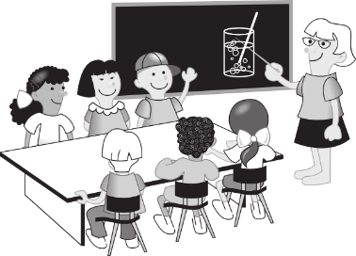 | 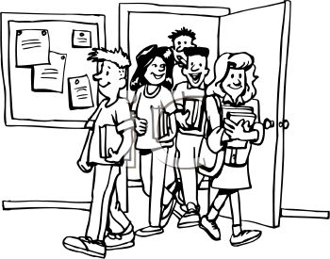 | 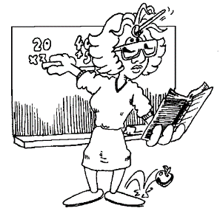 | 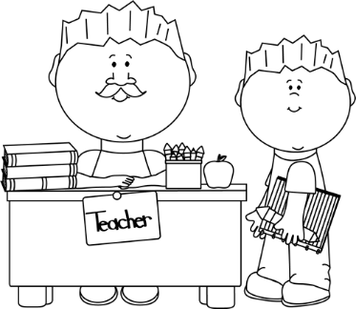
i. | j. | k. | l.
Partner B Nom _______________________________________
Classroom Object Matching Game

You and your partner have the same pictures but in a different order. Your pictures have numbers below them and your partner’s pictures have letters. Take turns describing your pictures so that you can fill in the chart below.

Number | Letter | Number | Letter | Number | Letter
1. |  | 6. |  | 11.
2. |  | 7. |  | 12. | a.
3. |  | 8.
4. |  | 9.
5. |  | 10.

Directions:
1. Describe the items that you see in Picture A. Here are some sample sentences:
- Il y a trois livres.
- Il y a un bureau.
- Il y a un professeur.
- Il y a une chaise.
- Il n’y a pas d’élèves.
2. Your partner will tell you the number below this picture on his/her paper and you will tell him/her the letter.
3. You will both fill out the table above.

1. | 2. | 3. | 4.
5. | 6. | 7. | 8.
 |  | 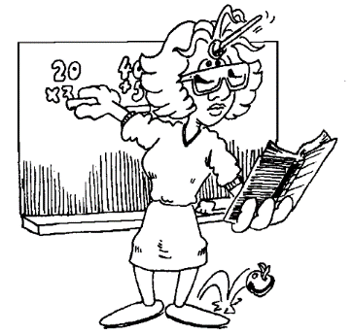
9. | 10. | 11. | 12.

