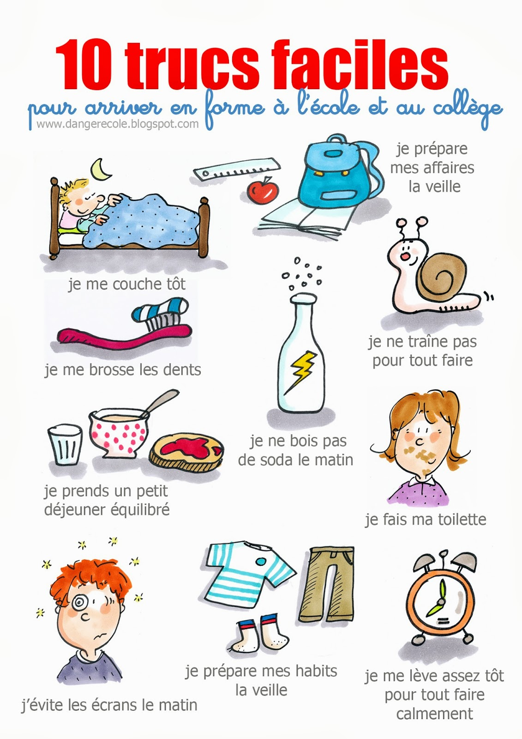

**Leçon #1**

**I. Interprétation Ecrite** (10 Trucs Faciles)

A. Key Word Recognition. Find the French words/phrases that best express the meanings of the following English

words/phrases.

School ________________________

Middle school________________________

I go to bed________________________

My things________________________

I don’t drink________________________

In order to do everything________________________

Screens________________________

In the morning________________________

Calmly_______________________

B. Main Idea. What is this poster about? Write in English.

____________________________________________________________________________________________________________________________________________________________________________________________________

C. Supporting Details. Check each detail that is given in the article. (You will not check every detail.) Then fill in the information that is given for each detail. Write in English.

___ Things you should do the night before _______________________________________________________________

___ What you should eat in the morning_______________________________________________________________

___ What you should drink in the morning_______________________________________________________________

___ When you should do your homework_______________________________________________________________

___ What time you should get up_______________________________________________________________

___ When you should take your shower_______________________________________________________________

D. Guessing Meaning from Context. Find the underlined words/phrases and write what you think they mean in English.

1. Je me couche tôt. _______________________________
2. Je prépare mes affaires la veille. _______________________________
3. Je me brosse les dents. _______________________________
4. Je ne traine pas tout faire. _______________________________
5. Je fais ma toilette. _______________________________
6. Je prépare mes habits la veille. _______________________________
7. J’évite les écrans le matin. _______________________________
8. Je me lève assez tôt pour tout faire calmement. _______________________________

E. Inference. Answer the following question in English. Give lots of information from the article to support your answer.

1. Where do you think you might see this poster hanging up? Why do you think so?

____________________________________________________________________________________________________________________________________________________________________________________________________

F. Author’s Perspective. Why do you think this poster was made? Answer in English. ____________________________________________________________________________________________________________________________________________________________________________________________________

**G. Comparing Cultural Perspectives.** Answer the following question in English.

1. How would this poster be different if it was made for American children? (“It would be written in English” is not an acceptable response.)

______________________________________________________________________________________________________________________________________________________________________________________________________________________________________________________________________________________________________

**II. Communication Interpersonnelle**

A: Found out whether your partner follows the advice given in this poster by asking the questions below. Write your partner’s answer (oui/non) as well as any additional information s/he gives you.

|  |  |  |
| --- | --- | --- |
|  | Oui/Non | Détails (Il/Elle …) |
| 1. Tu te couches tôt ? |  |  |
| 2. Tu prépares tes affaires la veille ? |  |  |
| 3. Tu te brosses les dents ? |  |  |
| 4. Tu bois du soda le matin ? |  |  |
| 5. Tu traines le matin ? |  |  |
| 6. Tu prends un petit déjeuner équilibré ? |  |  |
| 7. Tu fais ta toilette ? |  |  |
| 8. Tu évites les écrans le matin ? |  |  |
| 9. Tu prépares tes habits la veille ? |  |  |
| 10. Tu te lèves assez tôt pour tout faire calmement |  |  |

B: Answer your partner’s questions, giving a complete, detailed response. Here are some possible responses:

1. Tu te couches tôt?

Oui, je me couche à___h.

Non, je me couche tard parce que…

* j’ai beaucoup de devoirs à faire
* je préfère jouer à des jeux vidéo
* je préfère envoyer des textos à mes amis
* je n’arrive pas à m’endormir.

2. Tu prépares tes affaires la veille ?

Oui, je suis bien organisé (e).

Non, je ne suis pas bien organisé (e). J’attends toujours la dernière minute.

3. Tu te brosses les dents ?

Oui, je me brosse les dents après ma douche/après le petit déjeuner/quand je me lève/avant de partir.

Non, je ne me brosse pas les dents le matin.

4. Tu bois du soda le matin ?

Oui, je bois souvent du soda. Je bois du soda de temps en temps. J’adore le soda.

Non, je ne bois pas de soda. Je préfère le café/le thé/le jus/l’eau. Je ne bois rien le matin.

5. Tu traines le matin ?

Oui, je traine parce que je suis fatigué(e)/je ne veux pas aller à l’école/j’ai beaucoup de temps/etc.

Non, je ne me traine pas parce que j’ai beaucoup de choses à faire/je ne veux pas rater le bus/je me lève tard/etc.

6. Tu prends un petit déjeuner équilibré ?

Oui, je prends…. (des céréales/du lait/du toast/des œufs/du bacon/un fruit/un yaourt/etc.)

Non, je prends… (un pop-tart/un beignet/des gaufres/etc.

7. Tu fais ta toilette?

Oui, je me lave la figure dans le lavabo/prends une douche/prends un bain.

Non, je ne fais pas ma toilette.

8. Tu évites les écrans le matin ?

Oui, j’évite les écrans le matin.

Non, je regarde la télé/envoie des textos à mes amis/joue à des jeux-vidéos/etc.

9. Tu prépares tes habits la veille ?

Oui, je choisis un tee-shirt et un pantalon de mon placard/mon armoire/ma commode la veille.

Non, je prends un tee-shirt sale du plancher et le porte avec mon pantalon de pyjama.

10. Tu te lèves assez tôt pour tout faire calmement ?

Oui, je me lève à ___h. Puis, je …. Ensuite, je…. Enfin, je …

Non, je me lève trop tard et je dois me dépêcher le matin.

**III. Présentation Ecrite.**

Write a paragraph in which you tell what you do or don’t do to be prepared for school every day. Your paragraph should have at least 8 creative and detailed, connected sentences. Here are some words that you can use to connect your sentences:

* **d’abord** (first)
* **puis/ensuite** (then/next)
* **enfin** (finally)
* **mais** (but)
* **et** (and)
* **aussi (**also)
* **ou** (or)
* **parce que** (because)

____________________________________________________________________________________________________________________________________________________________________________________________________________________________________________________________________________________________________________________________________________________________________________________________________________________________________________________________________________________________________________________________________________________________________________________________________________

________________________________________________________________________________________________________________________________________________________________________________________________________________________________________________________________________________________________________________________________________________________________________________________________________________________________________________________________________________________________________________________________________________________________________________________________________________________________________________________________________________________________________________________________________________________________________________________________________________

**IV. Presentation Orale** – Tell what you do every day so that you are ready for school. You must name at least 8 things.

**Leçon #2**

**I. Interprétation Orale -***Trotro fait sa toilette* <https://www.youtube.com/watch?v=9CYEZqclXvg>

Answer the following questions in English. You do not need to write in complete sentences.

1. Trotro’s mom says, *Reveille-toi*. What do you think this means? ___________________________________
2. What does Trotro’s mom want him to do next? ___________________________________________________
3. What does he says about the water that’s coming out of the faucet? __________________________________
4. As he’s washing up, Trotro says, *D’abord*, *les mains*. What do you think *les mains* means? _________________
5. Then he says, *Ensuite se débarbouiller la figure*. What do you think *la figure* means? _____________________
6. How does he says you should brush your teeth? _________________________________________________
7. What does he say about his toothpaste? _________________________________________________________
8. What does his mom says when he sits down at the table? ___________________________________________
9. After Trotro eats, his mom says, “ *Oh là là Trotro, mais tu es tout sale*. What do you think *sale* means? _______

**II. Communication Interpersonnelle**

Discuss the video with your partner (in French) and put the pictures in the correct order by writing #1 below the first picture, a #2 below the second and so on.

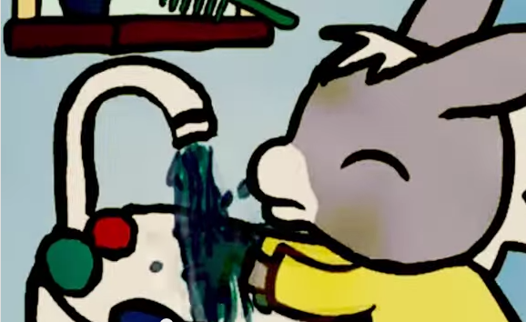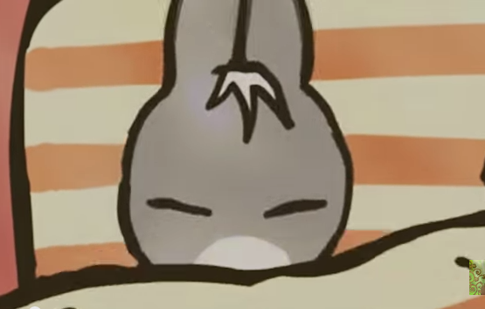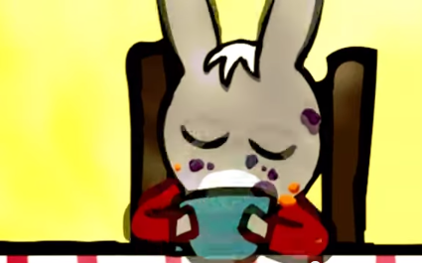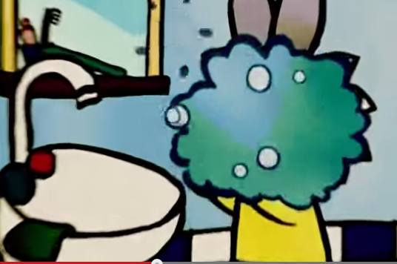

**___ ___ ___ ___**

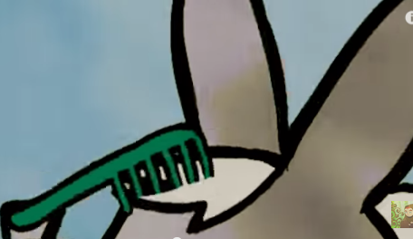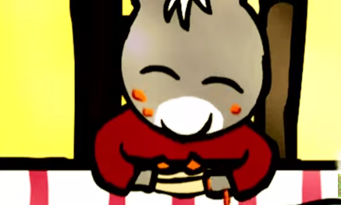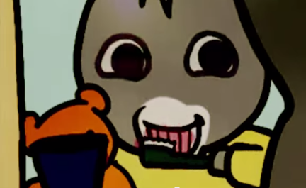

**___ ___ ___ ___**

**III. Présentation Ecrite**

Write a summary of the Trotro story in French, using the pictures above and any other details you remember. The following transition words will help you write your summary:

* D’abord – First of all
* Puis/Ensuite – Then/next
* Après ça – After that
* Enfin/Finalement – Finally

______________________________________________________________________________________________________________________________________________________________________________________________________________________________________________________________________________________________________

________________________________________________________________________________________________________________________________________________________________________________________________________________________________________________________________________________________________________________________________________________________________________________________________________

__________________________________________________________________________________________________________________________________________________________________________________________________________________________________________________________________________________________________________________________________________________________________________________________________________________________________________________________________________________________________________

**IV. Presentation Orale** – Summarize the Trotro video in French, giving at least one sentence for each picture.

**Leçon #3**

**I. L’Interprétation Ecrite** - <http://sante-medecine.commentcamarche.net/faq/4765-se-reveiller-pour-bien-commencer-la-journee>

**A. Key Word Recognition**. Find the French words/phrases that best express the meanings of the following English

words/phrases.

1. Try to go to bed ______________________________________
2. At the same time______________________________________
3. All week______________________________________
4. To fall asleep______________________________________
5. Choose a gentle ringtone _______________________________________________
6. To wake up______________________________________
7. Stay in your bed for a few seconds______________________________________
8. A glass of water______________________________________
9. Your breakfast______________________________________
10. Winter______________________________________
11. Summer______________________________________
12. A hot drink______________________________________
13. Bread______________________________________
14. A dairy product______________________________________
15. Your shower______________________________________
16. Hot water______________________________________
17. A little colder______________________________________
18. On foot______________________________________
19. By bike______________________________________
20. Mass transportation______________________________________

**B. Main Idea.** What is this text about? Write 2-3 sentences in English.

__________________________________________________________________________________________________________________________________________________________________________________________________

**C. Supporting Details.** Check each detail that is given in the article. (You will not check every detail.) Then fill in the information that is given for each detail. Write in English.

___ Something you can do so that you sleep better at night_________________________________________________

___________________________________________________________________________________________

___ Something you shouldn’t do if you want to sleep better at night_________________________________________

__________________________________________________________________________________________

___ The best types of ring tones for your alarm___________________________________________________________

___ The reason you should drink some water when you get up______________________________________________

___ What you should do before breakfast_______________________________________________________________

___ What you should do while you’re having breakfast____________________________________________________

___ What you should have for breakfast________________________________________________________________

__________________________________________________________________________________________

___ What you should avoid eating for breakfast__________________________________________________________

___ The reason you should use cold water at the end of your shower_________________________________________

___ The reason you should avoid looking at screens in the morning __________________________________________

___ Some routine activities you should do in the morning__________________________________________________

__________________________________________________________________________________________

___ Some ways to get more exercise in the morning______________________________________________________

__________________________________________________________________________________________

**D. Guessing Meaning from Context.** Find the underlined words/phrases and write what you think they mean in English.

1. Un bon réveil commence par un bon sommeil _____________________________

2. Lorsqu’on se réveille du pied gauche, c’est bien souvent le sommeil qui en est cause___________________________

3. Premier geste : on s’étire. _______________________________

4. Si vous prenez les transports en commun, descendez 2 arrêts plus tôt ________________________

**II. Communication Interpersonnelle**

**Partner A:** Ask your partner the following questions about his/her morning routine and take notes (in French) about his/her answers.

**Partner B:** Answer your partner’s questions with complete sentences in French. Use these phrases to add detail to your responses:

Q: Tu t’endors souvent avec un jeu vidéo ?

A : Je m’endors avec un jeu vidéo de temps en temps.

Je m’endors avec un jeu vidéo une/deux/trois fois par semaine.

Je m’endors rarement avec un jeu vidéo.

Je ne m’endors jamais avec un jeu vidéo.

1. Tu te couches à la même heure toute la semaine? Pourquoi ou pourquoi pas ? ______________________________

__________________________________________________________________________________________

2. Tu t’endors souvent avec la télévision allumée ? _______________________________________________________

3. Tu t’endors souvent avec un jeu vidéo ? ______________________________________________________________

4. Tu t’endors souvent avec un livre palpitant ? __________________________________________________________

5. Tu t’endors souvent au téléphone ? _______________________________________________________________

6. Tu as quelle sonnerie pour te réveiller? _______________________________________________________________

7. Tu t’étires souvent avant de te lever ? _______________________________________________________________

8. Tu prends souvent un verre d’eau quand tu te lèves ? ___________________________________________________

9. Tu fais souvent des exercices le matin ? ______________________________________________________________

10. Qu’est-ce que tu prends comme petit déjeuner? ______________________________________________________

11. Tu prends une douche le matin ? Tu te douches avec de l’eau chaude ou de l’eau froide ? _____________________

__________________________________________________________________________________________

12. Quels sont tes rituels du matin ? ___________________________________________________________________

__________________________________________________________________________________________

13. Comment est-ce que tu te rends à l’école ? __________________________________________________________

**III. Présentation Ecrite**

Write your partner a note in which you make 8-10 detailed suggestions about how s/he can get off to a better start in the morning. Make sure to include why each recommendation is important, based on the information in the article.

Here are some ways to write suggestions:

1. Tu dois + *infinitive* (unconjugated verb)

* Tu dois te coucher/t’endormir/choisir/prendre/faire/etc. *You must/have to …*

2. Il faut + *infinitive* (unconjugated verb) *It’s necessary to …*

* Il faut te coucher/t’endormir/choisir/prendre/faire/etc.

___________________________________________________________________________________________________________________________________________________________________________________________________________________________________________________________________________________________________

____________________________________________________________________________________________________________________________________________________________________________________________________________________________________________________________________________________________________________________________________________________________________________________________________

_____________________________________________________________________________________________________________________________________________________________________________________________________________________________________________________________________________________________________________________________________________________________________________________________________________________________________________________________________________________________________

________________________________________________________________________________________________________________________________________________________________________________________________________________________________________________________________________________________________________________________________________________________________________________________________________________________________________________________________________________________________________________________________________________________________________________________________________________________________________________________________________________________________________________________________________________________________________________________________________

**Leçon #4**

**I. Interpretation Orale** (<https://www.youtube.com/watch?v=YeQ_Jlf_UTY&feature=share>)

(Stop at :50.)

Watch the video and check each detail that is mentioned. Then watch again and fill in the details for each fact you have checked.

___ L’heure qu’elles se réveillent _________________

___ La durée de temps qu’elles se préparent ________________

___ Ce qu’elles mangent comme petit déjeuner __________________________________________________________

___ L’heure que le bus arrive _____________________

___ L’heure qu’elles arrivent à l’école _________________

___ Ce que les gens font dans le bus ___________________________________________________________________

___ Les cours qu’elles suivent ________________________________________________________________________

___ L’heure qu’elles finissent le matin ___________________________________________________________

___ La durée de leur pause pour déjeuner ______________________________

___ Où elles vont pour déjeuner _____________________________________________________________

___ Ce qu’elles mangent comme déjeuner ______________________________________________________________

__________________________________________________________________________________________

___ L’heure que leurs cours terminent _______________________________________________________________

**II. Communication Interpersonnelle**

Discuss how your routine compares to that of the girls in the video with a partner in French. Then fill in the following graphic organizer comparing these girls’ typical school day to yours for each aspect given in the center. The first one has been filled in for you.

*Note Grammaticale: Make sure to a) use the *reflexive pronoun* that matches your subject [if required] and b) *conjugate* your verb correctly. Here’s an example of a reflexive [-er] verb that is conjugated correctly:

|  |  |  |  |
| --- | --- | --- | --- |
| Se réveiller *– to wake up* | | | |
| Je me réveille | *I wake up* | Nous nous réveillons | *We wake up* |
| Tu te réveilles | *You wake up* | Vous vous réveillez | *You wake up* |
| Elle/Il se réveille | *S/he wakes up* | Elles/Ils se réveillent | *They wake up* |

Graphic Organizer

|  |  |  |
| --- | --- | --- |
| **Les Françaises** | **L’Aspect** | **Mon/Ma partenaire et moi** |
| Elles se réveillent à 7 h. | L’heure du réveil | Nous nous réveillons à _____ h. |
|  | La durée de la préparation |  |
|  | Ce qu’on prend comme petit déjeuner |  |
|  | L’heure de l’arrivée du bus |  |
|  | L’heure qu’on arrive à l’école |  |
|  | Ce qu’on fait dans le bus |  |
|  | La durée de la pause pour déjeuner |  |
|  | Ce qu’on prend comme déjeuner |  |

**III. Présentation Ecrite**

Write a paragraph comparing the day of a typical French teen to that of a typical American teen, using information from the video. Your paragraph should have at least 8 detailed and connected sentences.

______________________________________________________________________________________________________________________________________________________________________________________________________________________________________________________________________________________________________________________________________________________________________________________________________________________________________________________________________________________________________________________________________________________________________________________________________

______________________________________________________________________________________________________________________________________________________________________________________________________________________________________________________________________________________________________________________________________________________________________________________________________________________________________________________________________________________________________________________________________________________________________________________________________

____________________________________________________________________________________________________________________________________________________________________________________________________________________________________________________________________________________________________________________________________________________________________________________________________

**IV. Presentation Orale –** Talk about your typical morning in French. You should say at least 8 detailed sentences.

**Leçon #5**

**I. Interprétation Ecrite** « Mama, l’enfant sénégalais »

**A. Key Word Recognition**. Find the French words/phrases that best express the meanings of the following English words/phrases.

* a day _________________
* a boy_________________
* breakfast_________________
* West coast_________________
* friends (2 different words) ____________________
* every day______________________________
* scarves_________________
* homework________________

**B. Main Idea**. What is the main idea of this article? Write at least three sentences in English.

____________________________________________________________________________________________________________________________________________________________________________________________________ **C. Supporting Details.**

1. Check each detail that is mentioned in the article (not all are included).

2. Fill in the information that is given for each detail you have checked. Write in English.

___ Mama’s age ___________________________

___ Where Senegal is _______________________________________________________________________

___ What time he gets up___________________________

___ What he eats for breakfast___________________________

___ His dad’s job___________________________

___ His mom’s job ________________________________________

___ The main language in Senegal ___________________________

___ How Mama gets to school___________________________

___ Who he goes to school with______________________________________________________

___ When he goes to school___________________________

___ His favorite subject___________________________

___ The team he’s on in gym class___________________________

___ How he eats lunch___________________________

___ What he does in the afternoon______________________________________________________

___ What his best friend is like___________________________

___ What he has for dinner ______________________________________________________

___ When he does his homework___________________________

___ Where he does his homework______________________________________________________

___ Where he sleeps______________________________________________________

**D. Guessing Meaning from Context**. Find the underlined words/phrases and write what you think they mean in English. The information in parenthesis tells you which section word appears in.

1. “on me surnomme Mama.” (Bienvenue…) _________________________

2. “J’ai aussi des cours particuliers” (En route…) __________________________

3. Et pour distinguer les équipes » (Une classe…)_____________________

4. « On invite souvent les voisins ou les amis » (Un déjeuner…)________________________

5. « On mange avec la main droite. » (Un déjeuner…)________________________

**E. Cultural Comparison.** Answer the following question in English.

|  |  |
| --- | --- |
| **Differences** | **Cultural Practice/Perspective which contributes to the difference** |
|  |  |
|  |  |
|  |  |
|  |  |
|  |  |
|  |  |
|  |  |

1. Name at least 7 differences between Mama’s typical day and yours. Then explain why each difference exists—What cultural practices or perspectives are reflected in each difference.

**II. Communication Interpersonnelle**

Discuss Mama’s typical day in French with your partner and fill in the diagram comparing Mama’s day to his/hers. You do not need to write in complete sentences. Here are some question starters you can use:

* Où est-ce que tu….? *Where do you… ?*
* Quand est-ce que tu…? *When do you … ?*
* Qu’est-ce que tu … ? *What do you … ?*
* Quelle langue/Quelle matière/ est-ce que tu… ? *What language/subject do you ….?*
* Comment est-ce que tu … ? *How do you … ?*

|  |  |  |
| --- | --- | --- |
| **Mama** |  | **Mon/Ma Partenaire: ____________** |
|  | Son âge |  |
|  | Où il/elle habite |  |
|  | Quand il/elle se lève |  |
|  | Ce qu’il mange comme petit déjeuner |  |
|  | La langue qu’il/elle parle à la maison |  |
|  | Comment il/elle va à l’école |  |
|  | Quand il va à l’école |  |
|  | Sa matière préférée |  |
|  | Ce qu’il/elle fait l’après-midi |  |
|  | Une description de son meilleur ami (sa meilleure amie) |  |
|  | Ce qu’il/elle prend comme diner |  |
|  | Quand il/elle fait ses devoirs |  |
|  | Où il/elle fait ses devoirs |  |
|  | Où il/elle dort |  |

**III. Présentation Ecrite**

Imagine that you are writing an article about a typical day of an American student (your partner). Your article should have at least 125 words.

______________________________________________________________________________________________________________________________________________________________________________________________________________________________________________________________________________________________________________________________________________________________________________________________________________________________________________________________________________________________________________________________________________________________________________________________________

______________________________________________________________________________________________________________________________________________________________________________________________________________________________________________________________________________________________________________________________________________________________________________________________________________________________________________________________________________________________________________________________________________________________________________________________________

____________________________________________________________________________________________________________________________________________________________________________________________________________________________________________________________________________________________________________________________________________________________________________________________________

____________________________________________________________________________________________________________________________________________________________________________________________________________________________________________________________________________________________________________________________________________________________________________________________________________________________________________________________________________________________________________________________________________________________________________________________________________

________________________________________________________________________________________________________________________________________________________________________________________________________________________________________________________________________________________________________________________________________________________________________________________________________

Activité de partenaire “Devinez Qui”

Directions:

1. Imagine that you are one of people on the next page.
2. The pictures represent what you do each day.
3. You and your partner will take turns asking and answering questions in order to figure out which identity the other has chosen.

Example: *Tu te réveilles tôt?*  *Oui, je me réveille tôt.* or *Non, je ne me réveille pas tôt.*

1. Make only light, small marks on this page, as you will be playing more than once.
2. Continue playing until Madame says that your time is up.

Here are the pictures you will see and the activities that they represent:

|  |  |  |  |  |
| --- | --- | --- | --- | --- |
|  |  | http://images.clipartpanda.com/eating-breakfast-clipart-healthy-breakfast-clipartbreakfast_3_cereal_milkjpg-uk1sgi4e.jpg |  | http://images.clipartpanda.com/getting-dressed-clipart-clip-art-dress-829550.jpg |
| Se réveiller tôt | Se lever tout de suite | prendre le petit déjeuner | prendre une douche | s’habiller |
| MC900391052[1] |  |  | MC900440556[1] | MC900445736[1] |
| prendre un bain | se laver les mains | se laver le visage (la figure)/faire sa toilette | se brosser les dents | aller au lycée |
|  | http://comps.fotosearch.com/comp/UNN/UNN322/u21551102.jpg | MC900157225[1] | MC900088930[1] | MC900332924[1] |
| prendre le bus | rentrer à la maison à 3h | faire la sieste | faire ses devoirs | Se coucher tard |

Lisette

|  |  |  |  |  |  |  |  |
| --- | --- | --- | --- | --- | --- | --- | --- |
|  | MC900445736[1] |  | MC900332924[1] | MC900157225[1] | MC900088930[1] |  | http://comps.fotosearch.com/comp/UNN/UNN322/u21551102.jpg |

Ahmed

|  |  |  |  |  |  |  |  |
| --- | --- | --- | --- | --- | --- | --- | --- |
| MC900440556[1] | MC900088930[1] | http://images.clipartpanda.com/getting-dressed-clipart-clip-art-dress-829550.jpg | http://comps.fotosearch.com/comp/UNN/UNN322/u21551102.jpg | MC900157225[1] |  | MC900332924[1] |  |

Juliette

|  |  |  |  |  |  |  |  |
| --- | --- | --- | --- | --- | --- | --- | --- |
| MC900088930[1] | MC900445736[1] | http://comps.fotosearch.com/comp/UNN/UNN322/u21551102.jpg | MC900440556[1] | MC900157225[1] | MC900391052[1] | MC900332924[1] | http://images.clipartpanda.com/eating-breakfast-clipart-healthy-breakfast-clipartbreakfast_3_cereal_milkjpg-uk1sgi4e.jpg |

Nicolas

|  |  |  |  |  |  |  |  |
| --- | --- | --- | --- | --- | --- | --- | --- |
|  |  | http://images.clipartpanda.com/eating-breakfast-clipart-healthy-breakfast-clipartbreakfast_3_cereal_milkjpg-uk1sgi4e.jpg |  | http://images.clipartpanda.com/getting-dressed-clipart-clip-art-dress-829550.jpg | MC900157225[1] |  | MC900391052[1] |

Suzanne

|  |  |  |  |  |  |  |  |
| --- | --- | --- | --- | --- | --- | --- | --- |
|  | http://images.clipartpanda.com/getting-dressed-clipart-clip-art-dress-829550.jpg |  |  |  | MC900391052[1] |  | http://images.clipartpanda.com/eating-breakfast-clipart-healthy-breakfast-clipartbreakfast_3_cereal_milkjpg-uk1sgi4e.jpg |

Pierre

|  |  |  |  |  |  |  |  |
| --- | --- | --- | --- | --- | --- | --- | --- |
|  |  |  |  | http://images.clipartpanda.com/getting-dressed-clipart-clip-art-dress-829550.jpg | MC900391052[1] |  |  |

Fernando

|  |  |  |  |  |  |  |  |
| --- | --- | --- | --- | --- | --- | --- | --- |
|  |  | http://images.clipartpanda.com/eating-breakfast-clipart-healthy-breakfast-clipartbreakfast_3_cereal_milkjpg-uk1sgi4e.jpg | MC900332924[1] | http://images.clipartpanda.com/getting-dressed-clipart-clip-art-dress-829550.jpg | MC900391052[1] |  |  |

Safia

|  |  |  |  |  |  |  |  |
| --- | --- | --- | --- | --- | --- | --- | --- |
| http://images.clipartpanda.com/getting-dressed-clipart-clip-art-dress-829550.jpg |  |  | MC900440556[1] | MC900157225[1] | MC900088930[1] | MC900332924[1] | MC900445736[1] |

Michele

|  |  |  |  |  |  |  |  |
| --- | --- | --- | --- | --- | --- | --- | --- |
| MC900440556[1] | MC900445736[1] |  | http://comps.fotosearch.com/comp/UNN/UNN322/u21551102.jpg | MC900391052[1] | MC900088930[1] | MC900332924[1] |  |