Français 2
Unit 1 Matching Activity – Partner A

Directions:
1. Write a – x in a column on a separate sheet of paper.
2. Describe one of your pictures below to your partner, giving him/her the letter, too.
3. S/he will tell you the number of the same picture on his/her paper.
4. Write the number next to the corresponding letter on your (separate) paper.
5. Continue, taking turns, until your column of letters/numbers is complete. If necessary, ask follow up questions in order to determine which picture is a match.
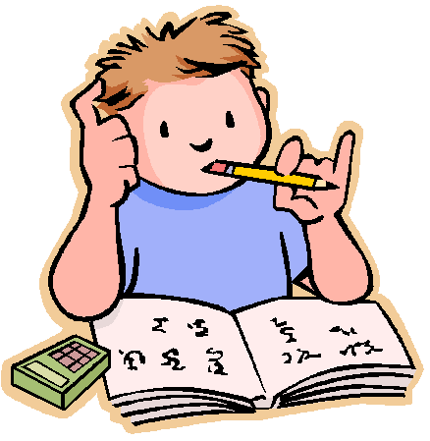 |  |  |  |  | 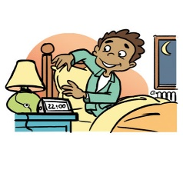
a. | b. | c. | d. | e. | f.
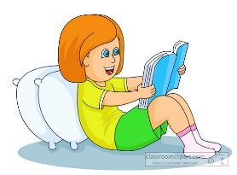 | 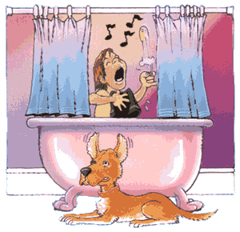 |  |  |  | 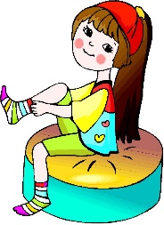
g. | h. | i. | j. | k. | l.
 |  | 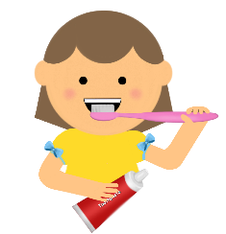 | 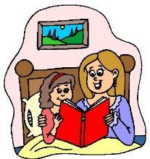
m. | n. | o. | p. | q. | r.
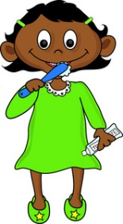
s. | t. | u. | v. | w. | x.

Français 2
Unit 1 Matching Activity – Partner B

Directions:
1. Write 1-24 in a column on a separate sheet of paper.
2. Describe one of your pictures below to your partner, giving him/her the number, too.
3. S/he will tell you the letter of the same picture on his/her paper.
4. Write the letter next to the corresponding number on your (separate) paper.
5. Continue, taking turns, until your column of letters/numbers is complete. If necessary, ask follow up questions in order to determine which picture is a match.
1. | 2. | 3. | 4. | 5. | 6.
 | 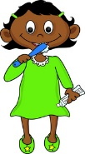
7. | 8. | 9. | 10. | 11. | 12.
13. | 14. | 15. | 16. | 17. | 18.
19. | 20. | 21. | 22. | 23. | 24.

