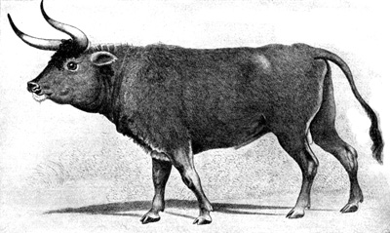 | 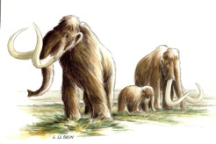 | 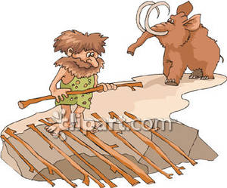 | 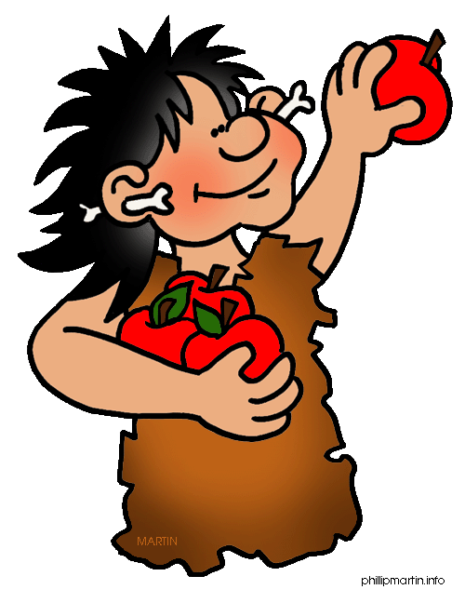 | 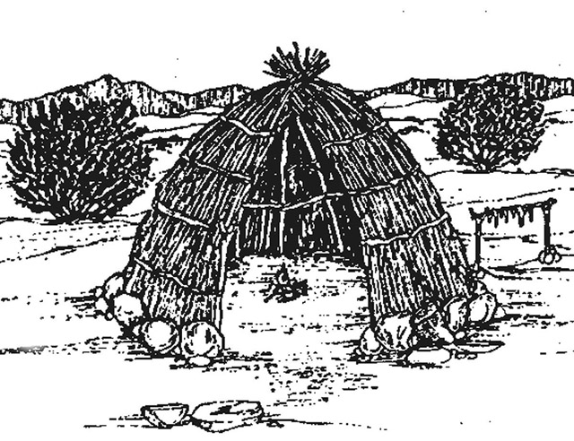 | 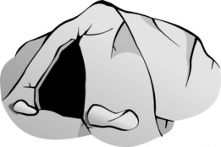
l’aurochs | le mammouth laineux | un piège | la cueillette | une hutte | une grotte
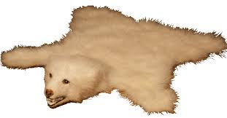 | 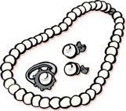 | 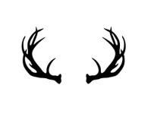 |  | 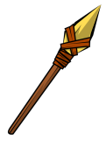 | 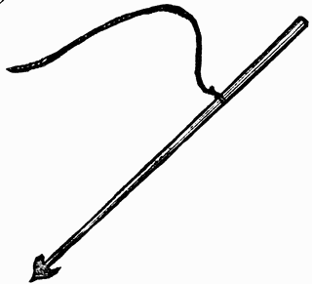
une peau d’animal | des bijoux | du bois | une aiguille à coudre | une sagaie | un harpon
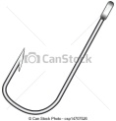 | 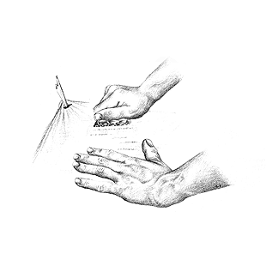 | 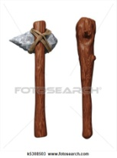 | 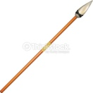 | 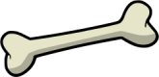 | 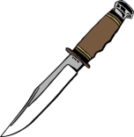 la manche  la lame
un hameçon | un racloir | une hache et un bâton | une flèche | un os | un couteau
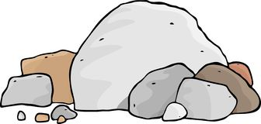 | 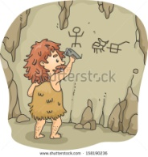 | 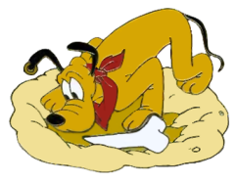 | 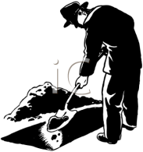
un rocher | une paroi | enterrer | une fosse
Français 3 Nom ________________________________________
La Préhistoire

A. Vocabulaire

B. Grammaire
A. Qui/Que/Dont
1. Qui
- Is the subject of the clause it introduces
- Is usually followed by a verb (which may have an object pronoun in front of it)
- Is used to refer to both people and things
- Is translated as who, which, or that

Exemples:
a. Le Neandertal est le premier home qui a enterré ses morts.
b. Les garçons qui ont découvert Lascaux cherchaient leur chien.
c. Cette grotte, qui a été fermée en 1963, est très célèbre.

2. Que
- Is the direct object of the clause it introduces
- Is usually followed by the subject of the clause
- Is used to refer to both people and things
- Is translated as whom, which or that

Exemples:
a. Le premier animal que l’homme a domestiqué était le chien.
b. Les métaux que l’homme a utilisés au Néolithique étaient le cuivre et l’or.
c. Les peintures que l’homme préhistorique a peintes sur les murs étaient très grandes.

* In the passé composé, the past participle will agree with the direct object that is being replaced by que. (See b and c)

3. Dont
- Replaces the preposition de plus a relative pronoun
- Is placed immediately after its antecedent (the word it replaces)
- Is used to refer to both people and things
- Is translated as whom, that, whose, of which, etc.

These common verbs and expressions require a de, so you will often use dont with them:
se souvenir de | to remember
s’occuper de | to take care of
avoir besoin de | to need
parler de | to talk about
être amoureux de | to be in love with
avoir peur de | to be afraid of
avoir honte de | to be ashamed of
se servir de | to use

Exemples:
a. La peinture dont l’homme préhistorique se servait était composée de minéraux.
b. Les outils dont l’homme préhistorique avait besoin étaient la sagaie et le harpon.
c. Le premier homme préhistorique dont on a trouvé les tombeaux est le Neandertal.
d. L’homme préhistorique dont le corps était le plus trapu était le Neandertal.
e. L’homme dont on a trouvé les peintures était Cro-Magnon.

Devoirs #1: Translate these sentences. Each one will have qui, que or dont.
1. The boys that discovered this cave were very lucky.
2. Montignac, which is in southwest France, is a small village.
3. Jacques is the boy who suggested they explore the hole.
4. The hole that they explored is on the Lascaux hill.
5. The boy whose dog fell in the hole was curious.
6. The boys prepared what they needed for their expedition.
7. The hole that they found was the entrance to a cave.
8. It was a cave whose walls were covered in paintings.
9. The biggest bull that they saw was 16 feet high.
10. The specialist that they called was Abbey Henri Breuil.

