Français 2 Nom ________________________________
These pictures show what you and members of your family did in Martinique. Write a caption for each picture on the lines below. The first one has been done for you.
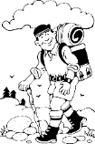 | 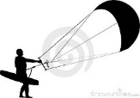 | 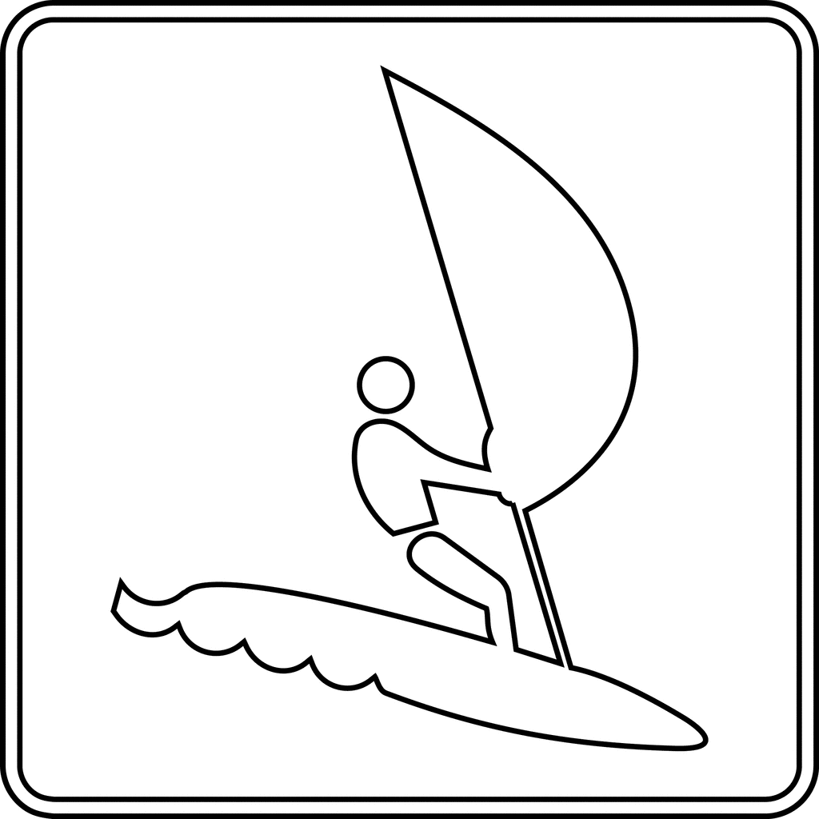 | 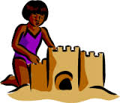 | 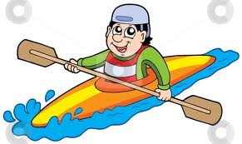 | 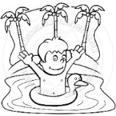 | 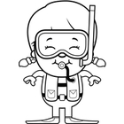 | 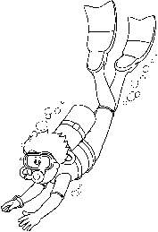
Mon père | Mon frere | Je | Ma sœur et moi | Mes parents | Mes sœurs | Ma mere | Mon frere et moi
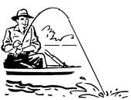 | 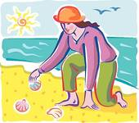 | 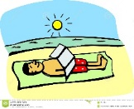 | 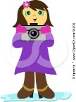 | 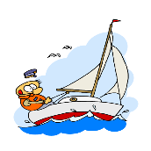 | 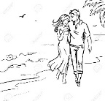 | 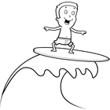 | 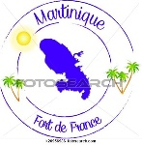
Mes freres | Toute la famille | Ma sœur et moi | Mes sœurs | Je | Mes parents | Mon frere | Nous

- Mon père a fait de la randonnée.
- ___________________________________________________________________________________________
- ___________________________________________________________________________________________
- ___________________________________________________________________________________________
- ___________________________________________________________________________________________
- ___________________________________________________________________________________________
- ___________________________________________________________________________________________
- ___________________________________________________________________________________________
- ___________________________________________________________________________________________
- ___________________________________________________________________________________________
- ___________________________________________________________________________________________
- ___________________________________________________________________________________________
- ___________________________________________________________________________________________
- ___________________________________________________________________________________________
- ___________________________________________________________________________________________
- ___________________________________________________________________________________________

