Français 2
La Saint Valentin Name _______________________________________

A. Key Word Recognition. Find the French words/phrases that best express the meanings of the following English words/phrases.

1. The United Kingdom _________________________
2. The Netherlands_________________________
3. less than_________________________
4. a piece of jewelry_________________________
5. average budget_________________________
6. is celebrated _________________________
7. a diet book_________________________
8. a household appliance_________________________
9. a makeover_________________________
10. a scale _________________________

B. What is the main idea of this infographic? Answer in English.
____________________________________________________________________________________________________________________________________________________________________________________________________

C. Supporting Details.
1. Check each detail that is mentioned in the article (not all are included).
2. Fill in the information that is given for each detail you have checked. Write in English.

___ The amount of money spent on Valentine’s Day flowers in 2011. _________________
___ The average price of a bouquet of flowers in the U.S. _________________
___ The average price of a bouquet of flowers in France_________________
___ The percentage of Americans that give jewelry for Valentine’s Day_________________
___ The percentage of French people that give jewelry for Valentine’s Day_________________
___ The percentage of French couples that think Valentine’s day is the most romantic day of the year ______________
___ The percentage of French people who give practical gifts _________________
___ The percentage of French people who give romantic gifts _________________
___ The percentage of French couples who don’t celebrate Valentine’s Day because it’s so commercial _____________
___ A country where Valentine’s Day is celebrated between friends _________________

D. Guessing Meaning from Context. Find the underlined words/phrases and write what you think they mean in English.

1. 12% des Français optent pour des cadeaux très romantiques (un massage à deux, un vol en montgolfière, une balade à cheval) ________________________
2. La Saint Valentin représente 40% du chiffre d’affaires des bijoutiers et des fleuristes. ________________________
3. 85% des femmes interrogées souhaitent recevoir une bague. ________________________
4. une crème anti rides ________________________
5. Un objet déco “ramasse poussière” ____________________________

E. Comparing Cultural Perspectives. Answer the following questions in English.
Compare French and American perspectives on Valentine’s Days based on what you read in the infographic.

____________________________________________________________________________________________________________________________________________________________________________________________________
____________________________________________________________________________________________________________________________________________________________________________________________________

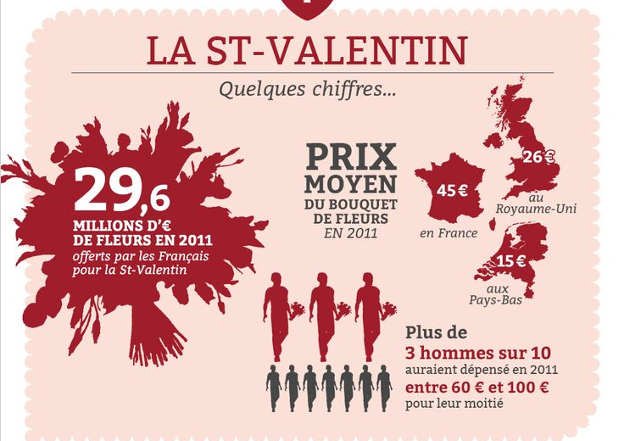

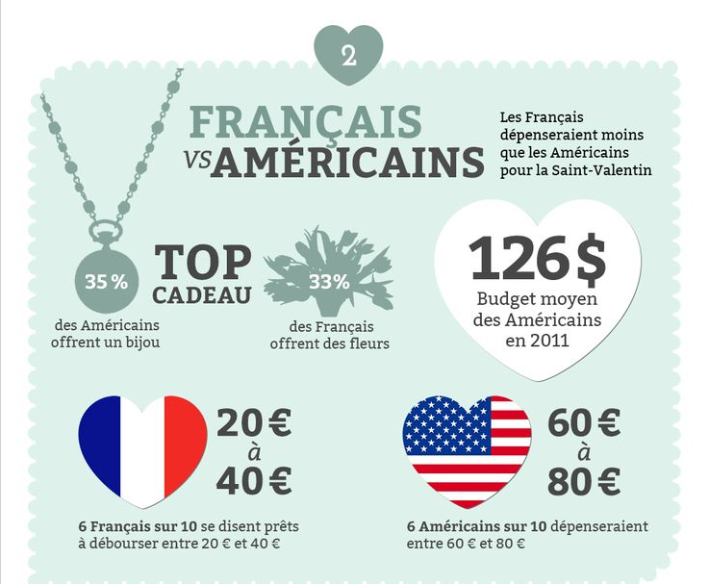
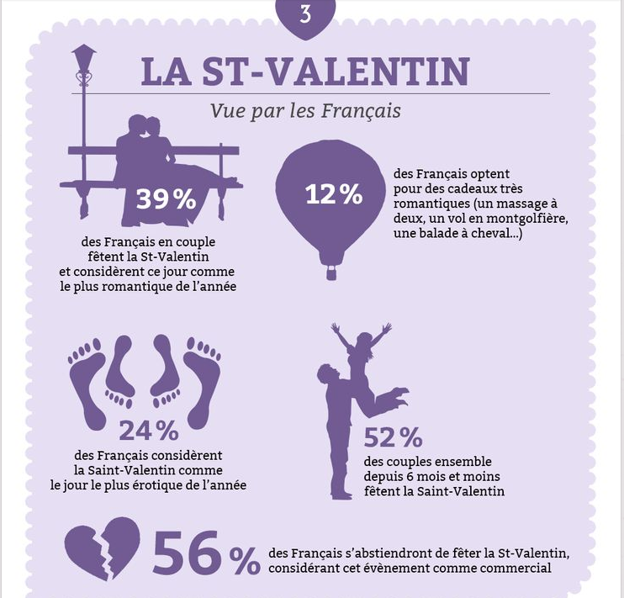

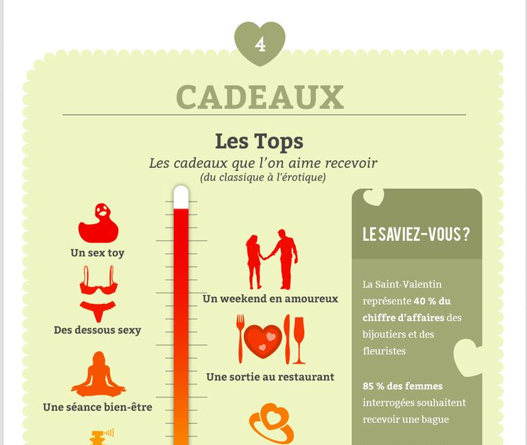
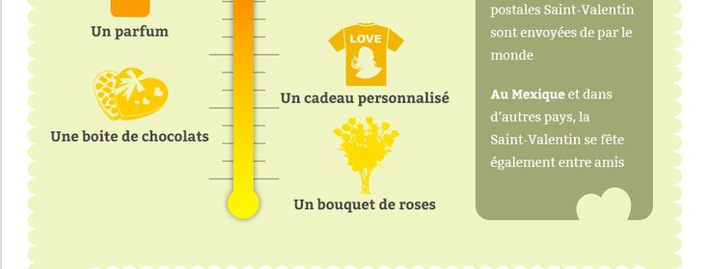

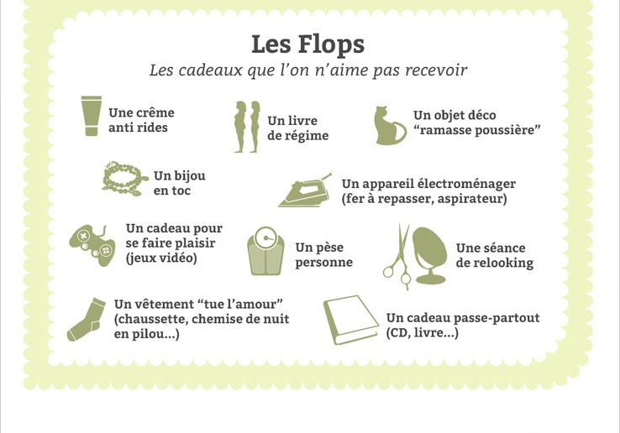

http://fr.locita.com/societe/infographie-la-saint-valentin-un-vrai-business-107822

