Français 2 : Vocabulaire de la Martinique Nom _____________________________
Ce que j’ai vu…

 | 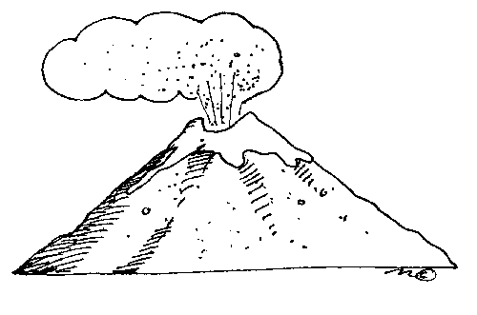 | 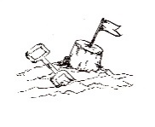 | 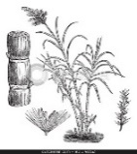
Un cocotier | Un volcan | Le sable | La canne à sucre | Un moustique | Une épave | Une chute d’eau
 |  |  |  | 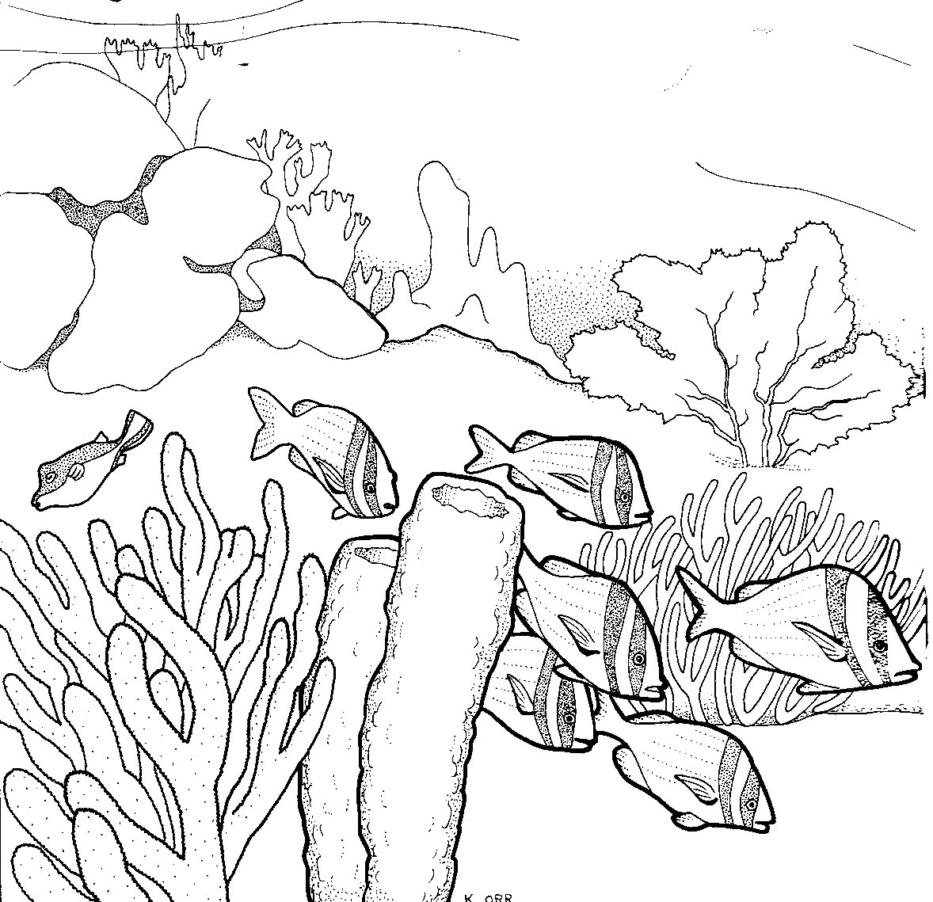
Un dauphin | Un requin | Un poulpe/une pieuvre | Du corail | Un récif | Un pécheur | Une vague

Ce que j’ai fait :
 | 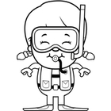 | 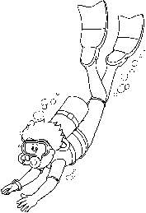 | 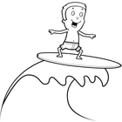
Se baigner/faire de la baignade | Faire de la plongée libre/ avec un tuba | Faire de la plongée sous-marine (avec bouteille) | Surfer | Bâtir un château de sable | Faire du kayak
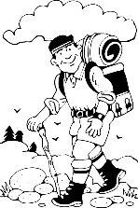 | 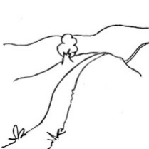 | 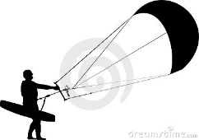 | 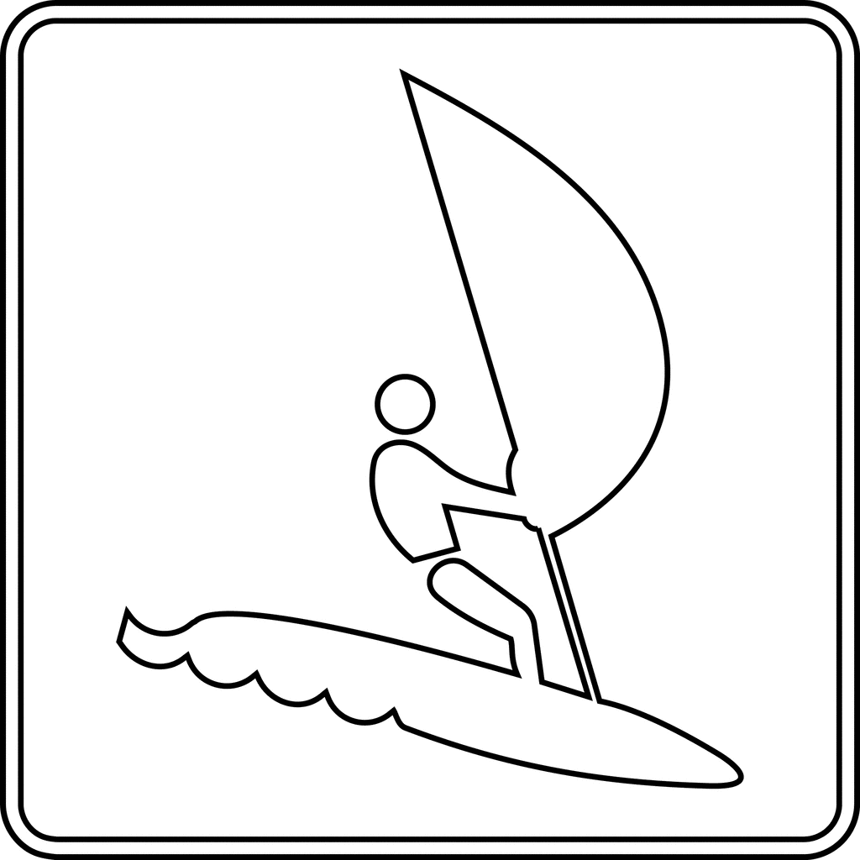 | 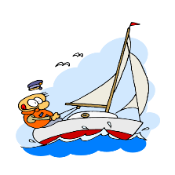
Faire de la randonnée | Un sentier | Faire du kitesurf | Faire de la planche à voile | Faire de la voile | Ramasser des coquillages
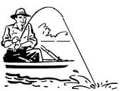 |  | 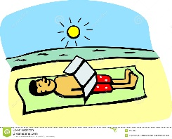
Pécher/aller à la pêche | Visiter la capitale | Se bronzer | Faire une photo | Se promener (faire une promenade) sur la plage
Ce que j’ai mis :

 |  | 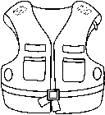 |  | 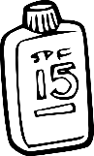
Un maillot de bain | Des palmes | Un gilet de sauvetage | Des lunettes de soleil | De la crème solaire

Past Tense Notes

A. For the past few weeks you have been learning how to say what you did. Do you remember what these sentences mean?
- J’ai discuté avec mes amis. __________________________________________________________________
- J’ai acheté un café. __________________________________________________________________
- J’ai parlé à un prof. __________________________________________________________________
- J’ai passé un examen. __________________________________________________________________
- J’ai raté un examen. __________________________________________________________________
- J’ai écouté le prof. __________________________________________________________________
- J’ai acheté mon déjeuner. __________________________________________________________________
- J’ai envoyé des SMS. __________________________________________________________________
- J’ai regardé la télé. __________________________________________________________________
- J’ai joué à des jeux-vidéos. __________________________________________________________________
These verbs are all regular –er verbs. Fill in the blanks to describe the rules for making the passé compose of regular –er verbs.
1. The past tense in French requires ________________ parts.
2. The first verb is usually the conjugated form of the “helping verb” ____________________________.
3. The second part (called a past participle) is formed by removing the –er and adding _______________.
4. If you have forgotten the conjugation of avoir, make sure you study it.
avoir
j’ai | nous avons
tu as | vous avez
il/elle a | ils ont

Now try writing these sentences in French:
1. We discussed the test. __________________________________________________________________
2. She bought a coffee. __________________________________________________________________
3. My friends talked to their teacher. __________________________________________________________________
4. We took a test. __________________________________________________________________
5. You (tu) failed the test. __________________________________________________________________
6. You (vous) listened to the teacher. __________________________________________________________________
7. My friend bought her lunch. __________________________________________________________________
8. We sent some texts. __________________________________________________________________
9. You (tu) watched TV. __________________________________________________________________
10. My brothers played video games. __________________________________________________________________

B. Here are some other sentences you have been using. Do you remember what they mean?

- J’ai pris le petit déjeuner. ______________________________________________________________
- J’ai réussi à un examen. ______________________________________________________________
- J’ai dormi. ______________________________________________________________
- J’ai fait mes devoirs. ______________________________________________________________
- J’ai appris le tableau périodique. ______________________________________________________________
- J’ai compris la leçon de français. ______________________________________________________________
- J’ai lu « To Kill a Mockingbird. » ______________________________________________________________
- J’ai écrit une composition. ______________________________________________________________
These verbs are not –er verbs but they still follow most of the same rules.
1. Begin by conjugating the helping verb ___________________________.
2. Then write the past participle. Here are the past participles of some common verbs.
l’infinitif | le participe passé | l’infinitif | le participe passé
boire | bu | faire | fait
lire | lu | dormir | dormi
mettre | mis | écrire | écrit
prendre  - apprendre  - comprendre | pris  - appris  - compris | voir | vu
réussir | réussi (most –ir verbs end in i)

Now try writing these sentences in French.

- Mes parents had breakfast. ______________________________________________________________
- You (tu) passed the test. ______________________________________________________________
- She slept. ______________________________________________________________
- They did their homework. ______________________________________________________________
- We learned the passé composé. ______________________________________________________________
- You (vous) understood the lesson. ______________________________________________________________
- The students read Le Petit Prince. ______________________________________________________________
- She wrote a composition. ______________________________________________________________
C. There are a few verbs that have a different rule in French. Do you remember what these sentences mean?
- Je suis arrivé à l’heure ______________________________________________________________
- Je suis allée au CDI. ______________________________________________________________
- Je suis restée à l’école______________________________________________________________
- Je suis parti. ______________________________________________________________
- Je suis rentrée à la maison. ______________________________________________________________
These verbs are different because they take ______________________ instead of avoir as their helping verbs. You must also make _______________________ between the subject and the past participle for these verbs.
Agreement means that you will add an ___________ if the subject is feminine, an ______________ if it is plural and an __________________ if it is feminine and plural.

In case you’ve forgotten, here is how être is conjugated.
être
je suis | nous sommes
tu es | vous êtes
il/elle/on est | ils/elles sont

Here is the complete list of the 16 verbs which use être. You don’t have to memorize all of them, but you should know the ones with a * because you will be using them a lot.

infinitive | past partiple | infinitive | past participle
aller (to go) * | allé | retourner (to return) | retourné
rentrer (to go back) * | rentré | venir (to come) | venu
sortir (to go out) * | sorti | naitre (to be born) | né
arriver (to arrive) * | arrivée | entrer (to enter) | entré
partir (to leave) * | parti | tomber (to fall) | tombé
rester (to stay) * | restée | monter (to go up) | montée
revenir (to come back) | revenu | mourir (to die) | mort
devenir (to become) | devenu | descendre (to go down) | descendu

Try writing these sentences in French.

1. You (tu [f]) arrived on time. ______________________________________________________________
2. We went to the media center. ______________________________________________________________
3. She stayed at school. ______________________________________________________________
4. He left. ______________________________________________________________
5. They [m.] went home. ______________________________________________________________
D. Reflexive verbs (the ones with the « se » in front of them) also use être as their helping verbs. Here are some examples that you’ve been using. Do you remember what they mean?
- Je me suis réveillé à 7h. ______________________________________________________________
- Je me suis levée tout de suite. ______________________________________________________________
- Apres ca, je me suis habillée. ______________________________________________________________
- Je me suis brossé les dents après le déjeuner. _____________________________________________________
- Je me suis couchée à 11h. ______________________________________________________________
Note: There is agreement between the subject and the past participle of reflexive verbs, unless there is a direct object (like les dents).

Now try writing these sentences in French.

- She woke up at 8:00. ______________________________________________________________
- She got up right away. ______________________________________________________________
- We got dressed quickly. ______________________________________________________________
- You (tu [f]) brushed your teeth. ______________________________________________________________
- My sisters went to bed at 8:00. ______________________________________________________________

