Français 1 Partenaire A

1. | 2. | 3. | 4.
 |  | 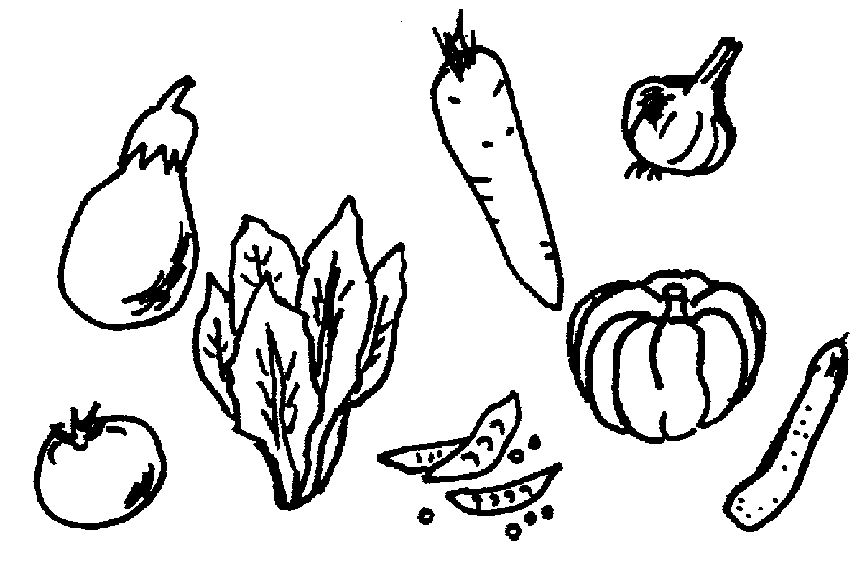
5. | 6. | 7. | 8.
 |  | 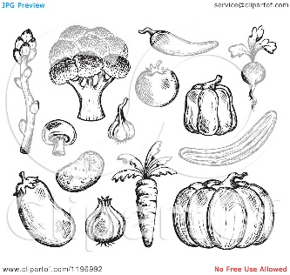
9. | 10. | 11. | 12.

Directions:
1. Put a book or a binder between you and your partner so you can’t see each other’s papers.
2. Write #1-#12 on a separate sheet of paper.
3. Describe picture #1 to your partner, giving as much information is possible. You will not know every word, just say the ones that you can. (something = quelque chose)
4. Answer any questions that your partner has, and then write “M” (même) if you think that you and your partner have the same picture.
5. Write “D” (différent) if you think you and your partner have a different picture.
6. Next it is your partner’s turn to describe, although you should ask any questions you can in order to make sure you are correctly choosing “m” or “d.”
7. Continue, taking turns, until you have filled in #1 - #12.

Français 1 Partenaire A

1. | 2. | 3. | 4.
5. | 6. | 7. | 8.
9. | 10. | 11. | 12.

Directions:
1. Put a book or a binder between you and your partner so you can’t see each other’s papers.
2. Write #1-#12 on a separate sheet of paper.
3. Listen to your partner’s description of picture #1 and ask follow up questions in order to decide whether you have the same or different pictures. You will not know every word, just use the ones that you know. (something = quelque chose)
4. Write “M” (même) if you think that you and your partner have the same picture.
5. Write “D” (différent) if you think you and your partner have a different picture.
6. Now it is your turn to describe #2.
7. Continue until you have filled in #1 - #12.

