V. La Cantine Scolaire
A. Watch this video and answer the following questions in English. https://www.youtube.com/watch?v=ov2rhs6FoEg
- What food items can you hear the children talking about in the background? ______________________________
- How many French schoolchildren eat in the school cafeteria each year? ______________________________
- How many meals are prepared each year? ______________________________
- How many courses are included in each meal? ______________________________
- What is the first one? ______________________________
- Which main dishes does Anne-Sophie mention? ______________________________
- How many times per week does the main dish come with a starchy (feculent) side dish? ______________________________
- How many times a week does the main dish come with a green vegetable? ______________________________
- What dairy product does she mention? ______________________________
- How many times a week is fresh fruit offered for dessert? ______________________________
- According to Anne-Sophie, what does each menu include? ______________________________
- What menu item is difficult to convince children to eat? ______________________________
- What vegetable do the children generally dislike? ______________________________
- How do they prepare the vegetables so that the kids will eat them? ______________________________
- How many times do children have to try a new vegetable before they’ll accept it? ____________________________
- What does she say about the French population, in general? ______________________________
- Besides nutrition, what else does she think they need to do to avoid this problem? ___________________________
B. Ask your partner the following questions and write down his/her answers in French.
1. Combien de fois par semaine est-ce que tu achètes ton déjeuner à la cantine? ________________________________
2. Qu’est-ce que tu y achètes ? ________________________________________________________________________
3. Quels sont les meilleurs plats dans notre cantine ? ___________________________________________________________________________________
4. Quels plats sont les moins bons ? ____________________________________________________________________________________
5. Quand tu apportes ton déjeuner, qu’est-ce que tu apportes ? __________________________________________________________________________________
6. Pourquoi est-ce que tu préfères acheter ton déjeuner ? (Encerclez sa réponse.)
- La nourriture dans la cantine est délicieuse.
- Les repas sont équilibrés.
- Je n’ai pas le temps de préparer mon déjeuner.
- J’aime prendre un repas chaud.
- ______________________________________________________________________________
7. Pourquoi est-ce que tu préfères apporter ton déjeuner ? (Encerclez sa réponse.)
- La nourriture dans la cantine est dégoutante.
- La nourriture dans la cantine n’est pas bonne pour la santé.
- J’ai des allergies.
- Les repas dans la cantine sont chers.
C. Read the comic and complete the following activities.
Les petits conseils de Pic et Pik: le déjeuner à la cantine
Key Word Recognition. Find the French words/phrases that best express the meanings of the following English words/phrases.
1. lunch ________________________________________
2. cafeteria ____________________________________
3. sausage _____________________________________
4. It’s good. ____________________________________
5. It’s easy to spread. _______________________________________
6. The entire tray ____________________________________
7. bread_____________________________________
8. I mustn’t play with food ________________________________________
9. Don’t talk too loud_____________________________________
10. cafeteria ladies_____________________________________
11. I’m not hungry anymore. _____________________________________
What is the main idea of this article? Answer in English.
______________________________________________________________________________________________________________________________________________________________________________________________________________________________________________________________________________________________________
Supporting Details.
1. Check each detail that is mentioned in the article (not all are included).
2. Fill in the information that is given for each detail you have checked. Write in English.

___ The reason the boy behind Pic wants him to hurry up __________________________________________________
___ What Pic knocked over yesterday_______________________________________________
___ The reason Pic’s friend wants to trade food ________________________________________________________
___ The reason Pic agrees to the trade_______________________________________________
___ The number of times Pic has to write the sentence he gets as a punishment. _______________________________
___ The reason Pic doesn’t eat his vegetables_______________________________________________
___ The reason Pic wants his orange back _______________________________________________
___ The reason Pic’s friend gives him back the pâté_______________________________________________
___ The reason you shouldn’t talk too loud in the cafeteria_______________________________________________
___ The reason you shouldn’t make a mess in the cafeteria_______________________________________________
___ The reason Pik trades his orange ________________________________________________________________
___ The reason his friend thinks they’ll be able to play soccer at recess ____________________________________
___ The reason you should eat a little of everything at the cafeteria _______________________________________
___ The reason you should eat slowly and chew your food well ___________________________________________

Guessing Meaning from Context. Find the underlined words/phrases and write what you think they mean in English. The information in parenthesis tells you which paragraph the word appears in.
1. Une table propre, c’est aussi plus agréable (bottom of page 40, 2nd bullet) ____________________________________
2. Arrête, on va se faire priver de récré (p. 41, 4th frame) _____________________________________________
3. Et les oranges, c’est plein de vitamines. (p. 41, 5th frame) _________________________________
4. Sinon, tu risques d’avoir mal au ventre. (p. 41, 2nd bullet) _________________________________________________

Inference. Answer the following questions in English, giving as much information from the article as possible to support your response.
1. Which brother do you think would be a better student council president? Why do you think so? Give examples from the text.
______________________________________________________________________________________________________________________________________________________________________________________________________________________________________________________________________________________________________
____________________________________________________________________________________________________________________________________________________________________________________________________

Author’s Perspective. Check the perspective or point of view you think the author adopted as s/he wrote this article and justify your answer with information from the text.

___Comic ___ Factual ___ Moral ___ Historical

Justification from text: ______________________________________________________________________________
_________________________________________________________________________________________________
______________________________________________________________________________________________________________________________________________________________________________________________________________________________________________________________________________________________________
Comparing Cultural Perspectives. Answer the following question in English.

1. How would this comic have been different if it had appeared in an American magazine? (“It would be written in English” does not count as an answer!)
_________________________________________________________________________________________________
______________________________________________________________________________________________________________________________________________________________________________________________________________________________________________________________________________________________________

D. Imagine that you are the cafeteria monitor at Pic and Pik’s school. You have noticed that while some kids are well behaved in the cafeteria, others need a refresher on appropriate behavior. Here are some of the good and bad behaviors you have noticed:

Certains élèves ont l’habitude de...
- Dire « merci » aux dames dans la cantine
- Prendre beaucoup de temps pour choisir un plat
- Echanger leurs fruits pour un plat gras
- Jouer avec leur nourriture
- Manger leurs légumes
- Manger trop vite
- Parler trop fort
- Manger salement
- Manger un peu de tout
- Se battre
- Mâcher bien leurs aliments
- Recycler leurs bouteilles d’eau
- Débarrasser leur table
- Manger beaucoup de gâteaux

You are in charge of writing a list of rules, based on what you have noticed the students doing.
Start each rule with one of the following expressions:
- Il faut… (It is necessary to…)
- Il ne faut pas (It’s necessary not to …)
Here are some examples:
- Il faut dire « merci » aux dames dans la cantine.
- Il ne faut pas prendre beaucoup de temps pour choisir un plat.

Write the rest of the rules below:
- _____________________________________________________________________________________
- _____________________________________________________________________________________
- _____________________________________________________________________________________
- _____________________________________________________________________________________
- _____________________________________________________________________________________
- _____________________________________________________________________________________
- _____________________________________________________________________________________
- _____________________________________________________________________________________
- _____________________________________________________________________________________
- _____________________________________________________________________________________

E. Interview your partner and check how often s/he does each of the following things.
Note to person being interviewed: Make sure to answer in a complete sentence:

Q: Tu dis “merci” aux dames dans la cantine?
A : Oui, je dis souvent « merci » aux dames dans la cantine. (souvent goes after the verb)
A : Oui, Je dis « merci » aux dames dans la cantine de temps en temps. (de temps en temps goes at the end of the sentence)
A : Non, je ne dis jamais « merci » aux dames dans la cantine. (ne jamais goes around the verb)

 | souvent | De temps en temps | jamais
Tu dis « merci » aux dames dans la cantine ?
Tu prends souvent beaucoup de temps pour choisir un plat ?
Tu échanges tes fruits pour un plat gras ?
Tu joues souvent avec ta nourriture ?
Tu manges tes légumes ?
Tu manges trop vite ?
Tu parles trop fort ?
Tu manges salement ?
Tu manges un peu de tout ?
Tu te bats ?
Tu mâches bien tes aliments ?
Tu recycles tes bouteilles d’eau ?
Tu débarrasses ta table ?
Tu manges beaucoup de gâteaux ?

F. You and your partner are both being considered for student of the month. Write a note to Madame in which you explain why she should pick you, and not your partner. Give lots of examples comparing your behavior in the cafeteria.

Chère Madame,
Je pense que vous devez me choisir comme Elève du Mois.__________________________________________________ ______________________________________________________________________________________________________________________________________________________________________________________________________________________________________________________________________________________________________
____________________________________________________________________________________________________________________________________________________________________________________________________
______________________________________________________________________________________________________________________________________________________________________________________________________________________________________________________________________________________________________
____________________________________________________________________________________________________________________________________________________________________________________________________
G. Watch the video about new rules for school cafeterias and answer the following questions.
https://www.youtube.com/watch?v=HhMS09Parfs
1. How many different dishes will the students have to choose from each day?
2. Which dairy products are mentioned?
3. Which main dishes are mentioned?
4. How often are the following items included?
- Cut-up raw vegetables
- Fried foods
5. Which cafeterias are exempt from these new rules?
6. When did these new rules go into effect?
https://www.youtube.com/watch?v=ezeVFqoOcfg
- How many meals are prepared each day in the school cafeterias of this community?
- How many different school cafeterias are there?
- How many children have lunch each day in the cafeteria shown in the video?
- Explain the difference between how nursery school kids and elementary kids are served.
- What does the girl in the black and pink jacket say about her meal?
- What does the boy with the long-sleeved gray shirt and white tee-shirt say about the meal?
- What food items does the boy with glasses mention?
- What fruit did the boy in the gray long-sleeved shirt eat? Why?
(No questions after 1:10)
VI. Le Restaurant

A. (Homework) Watch this video https://www.youtube.com/watch?v=wfmVpzPqg20 and write the French words and phrases with the following meanings.
Appetizers ____________________________
Main dishes____________________________
Desserts____________________________
Drinks____________________________

For an appetizer, I’d like____________________________
For a main dish, I’d like____________________________
For my drink, I’d like____________________________
For dessert, I’d like____________________________

Home-made pate____________________________
Soup of the day____________________________
Green salad____________________________
Smoked salmon____________________________
Snails____________________________
A plate of cold cuts____________________________
Roast chicken____________________________
Bream (a fish) w/potatoes ________________________
Mushroom omelette____________________________
Duck confit____________________________
Roast beef____________________________
Steak and fries____________________________
Ham sandwich____________________________
Side dish____________________________
Cheese plate____________________________
Chocolate mousse____________________________
Chocolate cake____________________________
Crème brulée____________________________
Apple tart____________________________
Coffee____________________________
Mineral water____________________________
Coke____________________________
Vous avez choisi? ____________________________
Qu’est-ce que vous prenez? ____________________________
Je vous apporte quelque chose à boire ? ____________________________
C’est tout ? ____________________________
C’était très bon merci. ____________________________
L’addition s’il vous plait. ____________________________
Oui, tout de suite. ____________________________

B. Listen to the following song: https://www.youtube.com/watch?v=GJs2MYPWSk8
C. Watch this video and write what you think the following words/phrases mean. https://www.youtube.com/watch?v=_y8o2kEm1vM
Vous êtes combien _____________________________________________________
Je te conseille_____________________________________________________
Ça a l’air bon_____________________________________________________
Vous avez choisi ? _____________________________________________________
On voudrait commander. _____________________________________________________
Et comme boisson, qu’est-ce que vous voulez prendre ? ___________________________________________________
Mademoiselle, l’addition s’il vous plait. _____________________________________________________
D. Practice the following conversation with a partner. Take turns being the waiter/waitress and the customer.
Waiter: Greet the customer
Customer: Greet the waiter
Waiter: Ask what the customer would like to drink.
Customer: Tell the waiter what you’d like to drink (You may not order an alcoholic beverage)
Waiter: Bring drinks and ask what appetizer s/he would like
Customer: Tell the waiter what appetizer you’d like.
Waiter: Ask what main dish the customer would like.
Customer: Say what main dish you’d like.
Waiter: Find out what dessert the customer would like
Customer: Say what dessert you’d like.
Waiter: Ask how the food was.
Customer: Say that it was good and ask for the check.
E. Read the infographic about dining out in Paris and complete the following activities.
Key Word Recognition. Find the French words/phrases that best express the meanings of the following English
words/phrases.

Pretty_____________________________
Customer_____________________________
People_____________________________
Time_____________________________
Chinese restaurants_____________________________
Reasonable prices_____________________________
You see people _____________________________
Friendly service_____________________________
Slow service_____________________________
Average food_____________________________
Long wait_____________________________
Noisy atmosphere_____________________________

Main Idea. What is this infographic about?
____________________________________________________________________________________________________________________________________________________________________________________________________
__________________________________________________________________________________________________

Supporting Details. Check each detail that is given in the article. (You will not check every detail.) Then fill in the information that is given for each detail. Write in English.
___ Reasons that Parisians like to eat in restaurants _______________________________________________________
______________________________________________________________________________________________________________________________________________________________________________________
___ The number of restaurants in Paris _________________________________
___ The length of time it would take to try out every one, if you tried one new restaurant per day __________________
___ The district in Paris (each has a number) with the most restaurants ___________________________
___ The number of three star restaurants in Paris ________________________________
___ The number of Mexican restaurants in Paris________________________________
___ The number of Indian restaurants in Paris ______________________________
___ The percentage of restaurant searches that lead immediately to reservations ______________________
___ The percentage of people that read a restaurant’s reviews before making a reservation there __________________
___ The percentage of people that would rather ask their friends’ opinions than read a review _____________________
___ The percentage of people in the Paris region that prefer to eat local food __________________________________
Inference/Comparing Cultural Perspectives. Answer the following questions in English.
1. Why do you think there are so many different cultures are represented by restaurants in Paris?
______________________________________________________________________________________________________________________________________________________________________________________________________________________________________________________________________________________________________
2. Why do you think that earning Michelin stars are so important to French restaurants?
______________________________________________________________________________________________________________________________________________________________________________________________________________________________________________________________________________________________________
F. Listen to the podcast and answer the following questions. https://www.youtube.com/watch?v=b7yEUEw3UOo
What meal are these people going to have? ____________________________________________
What does the waiter give them? ____________________________________________
The waiter asks, “Vous allez prendre un apéritif pour commencer?” What do you think an apéritif is ? ____________________________________________
What does the woman order? ____________________________________________
What does the man order? ____________________________________________
The waiter asks, “La cuisson pour l’entrecôte—bleue, saignante, à point, très cuite? » What do you think he’s asking ? ____________________________________________
How does the woman want her steak? ____________________________________________
What do they order to drink? ____________________________________________
What does the woman order for dessert? ____________________________________________
What does the man order? ____________________________________________
How is the man going to pay for the meal? ____________________________________________
How much tip does the woman think they should leave? ____________________________________________
G. Discuss your favorite restaurants with your partner. Here are some phrases to help you.
1. Tu dines souvent dans les restaurants ? Pourquoi ou pourquoi pas ?
- Mes parents n’ont pas le temps de faire la cuisine.
- Nous préférons la cuisine dans les restaurants.
- Les restaurants sont trop chers.
- C’est notre culture de manger à la maison.
2. Quel restaurant est-ce que tu préfères?
3. Pourquoi est-ce que tu l’aimes ?
- La cuisine est bonne.
- Il est près de ma maison.
- J’aime l’ambiance.
- Ce n’est pas cher./Les prix sont raisonnables.
- Le service est bon.
- Les plats sont copieux.
4. Qu’est-ce que tu commandes quand tu vas à ce restaurant?
H. https://www.youtube.com/watch?v=0w0BrI0_vlU Listen to the recording and answer the following questions
1. What three courses are included in a “Formule?”
2. Which appetizer are they having?
3. What does the waiter say about the dish the woman asks about?
4. How does the man want his meat prepared?
5. What do they order to drink?
6. What does the waiter ask about their choice in water?
7. Did they like their food?
8. What does the woman order for dessert?
9. Why can’t she get it?
10. What does she order instead?
11. Why can’t she have this?
12. What dessert does the waiter recommend?
13. What dessert does the man order?
14. What does the waiter ask next?
15. What does the man ask for at the end?
I. http://www.doctissimo.fr/html/nutrition/mag_2001/mag0803/nu_4337_resto_kilo.htm Read the article and complete the following activities.
Key Word Recognition. Find the French words/phrases that best express the meanings of the following English words/phrases.

No problem ________________________________
Appetizer________________________________
Main dish________________________________
Meat ________________________________
Fish ________________________________
Vegetables________________________________
French fries________________________________
Starchy sides________________________________
Rice ________________________________
Make good choices! _____________________________

5 | Identifies all key words appropriately with context of the text.
4 | Identifies majority of key words appropriately within context of the text.
3 | Identifies half of key words appropriately within the context of the text.
2 | Identifies less than half of key words appropriately within the context of the text.
1 | No response

Main Idea. What is this article about?
____________________________________________________________________________________________________________________________________________________________________________________________________

5 | Identifies the complete main idea(s) of the text.
4 | Identifies the key parts of the main idea(s) of the text but misses some elements.
3 | Identifies some part of the main idea(s) of the text.
2 | Identifies a minor idea from the text.
1 | No response

Supporting Details. Check each detail that is given in the article. (You will not check every detail.) Then fill in the information that is given for each detail. Write in English.

___ Reasons people go to restaurants ___________________________________________________________________
___________________________________________________________________________________________
___ Reasons people overeat when they go to restaurants ___________________________________________________
___________________________________________________________________________________________
___ Appetizers you should avoid in French restaurants if you’re trying to eat healthy _____________________________
___________________________________________________________________________________________
___ Appetizers that are good for you ____________________________________________________________________
___ The maximum amount of bread you should have _______________________________________________________
___ Healthiest main dishes ____________________________________________________________________________
___ Main dishes you should avoid ______________________________________________________________________
___ Side dish that you should only have occasionally _______________________________________________________
___ Side dish you should choose _______________________________________________________________________
___ Side dishes that you should only have in reasonable quantities ___________________________________________
___ Desserts you should avoid ________________________________________________________________________
___ Healthiest desserts ______________________________________________________________________________
___ Healthiest beverages _____________________________________________________________________________
___ Substitutions you can ask the waiter to make __________________________________________________________
___ Healthiest pizza toppings __________________________________________________________________________
___ Ways to save calories at a pizza restaurant ____________________________________________________________

5 | Identifies all supporting details in the text and accurately provides information from the text to explain these details.
4 | Identifies the majority of supporting details in the text and provides information from the text to explain some of these details.
3 | Identifies some supporting details in the text and may provide limited information from the text to explain these details. Or identifies the majority of the supporting details but is unable to provide information from the text to explain these details.
2 | Identifies some supporting detail but is unable to provide information from the text to support them.
1 | No response

Guessing Meaning from Context. Find the underlined words/phrases and write what you think they mean in English.
- La plupart du temps, les restaurants français vous proposent le choix entre plusieurs entrées et plats principaux. ______________________
- Ne succombez pas trop souvent aux pâtisseries ou aux crèmes glacées _________________________
- Eventuellement, partagez une pizza individuelle à deux, en complétant d'une entrée de légumes. ____________
- Evitez par contre les lasagnes ou les cannellonis ! ________________________
5 | Infers meaning of unfamiliar words and phrases in the text. Inferences are accurate.
4 | Infers meaning of unfamiliar words and phrases in the text. Most of the inferences are plausible although some may not be accurate.
3 | Inferences of meaning of unfamiliar words and phrases are largely inaccurate or lacking.
2 | Is unable to infer the correct meaning of any of the words or phrases.
1 | No response
Inference. Answer the following question in English. Give lots of information from the article to support your answer.
1. Who do you think is the target audience for this website? (men, women, teens, kids?) Why do you think so?
________________________________________________________________________________________________________________________________________________________________________________________________________________________________________________________________________________________________________________________________________________________________________________________________________
5 | Infers and interprets the text’s meaning in a highly plausible manner.
4 | Infers and interprets the text’s meaning in a partially complete and/or partially plausible manner.
3 | Inferences and interpretations of the text’s meaning are largely incomplete or not plausible.
2 | Inference is incomplete and not plausible
1 | No response.

Author’s Perspective. Select the perspective or point of view you think the author adopted as s/he wrote this article and justify your answer with information from the text.

___ It’s best to avoid eating out if you’re trying to eat healthy or lose weight.
___ You can follow a healthy diet even when you eat out if you make good choices
___ It’s okay to take a break from your diet on special occasions
______________________________________________________________________________________________________________________________________________________________________________________________________________________________________________________________________________________________________

5 | You identified the author’s perspective and provided a detailed justification.
4 | You identified the author’s perspective and provided adequate justification.
3 | You identified the author’s perspective but your justification lacked detail.
2 | You identified the author’s perspective, but did not provide adequate justification from the text.
1 | No response.

Comparing Cultural Perspectives. Answer the following question in English.
Do you think it’s easier to eat healthy in French restaurants or American restaurants? Why do you think so?
______________________________________________________________________________________________________________________________________________________________________________________________________________________________________________________________________________________________________

5 | Identifies cultural perspectives/norms accurately. Provides a detailed connection of cultural products/practices to perspectives.
4 | Identifies some cultural perspectives/norms accurately. Connects cultural products/practices to perspectives.
3 | Identification of cultural perspectives/norms is mostly superficial or lacking. And/or connection of cultural practices/products to perspectives is superficial or lacking.
2 | Unable to identify a pertinent cultural perspective/norm.
1 | No response.

Raw Score _______________/
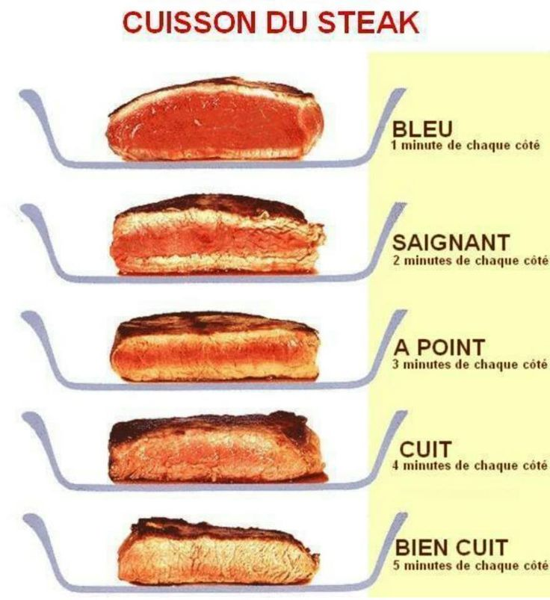

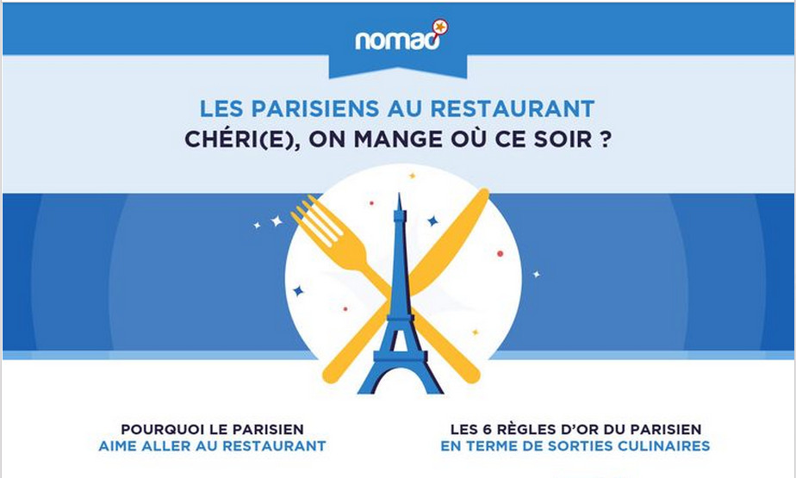
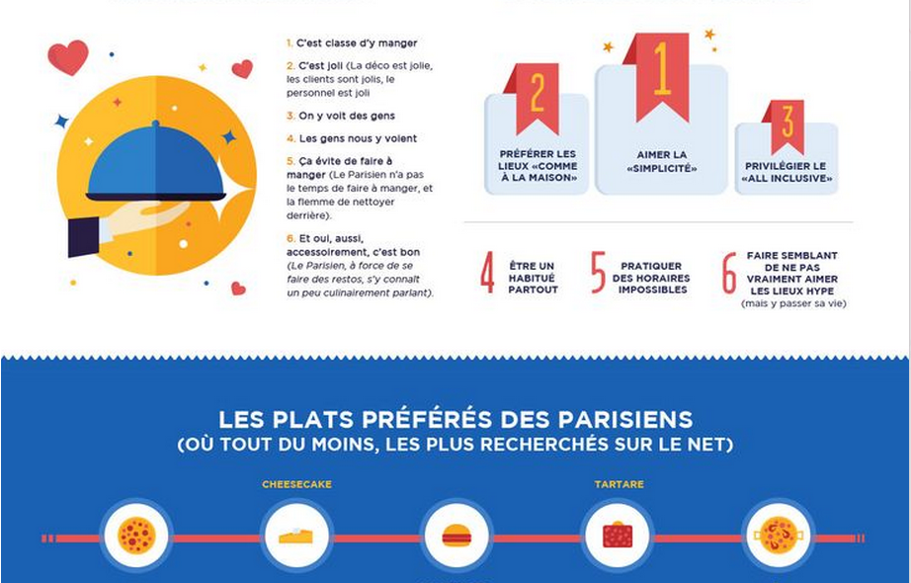
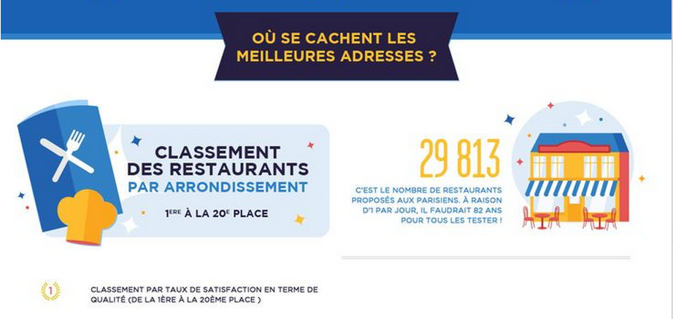
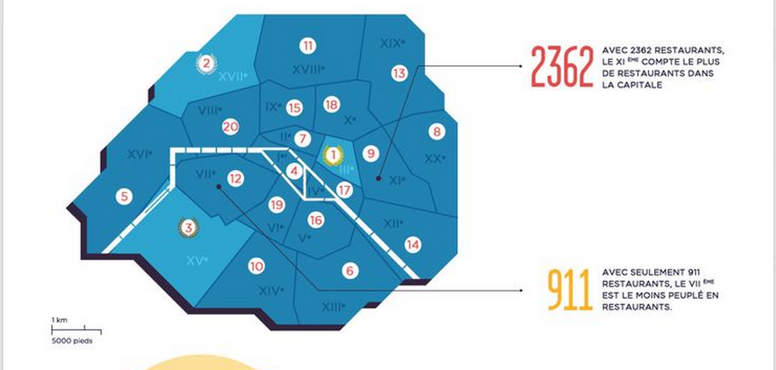
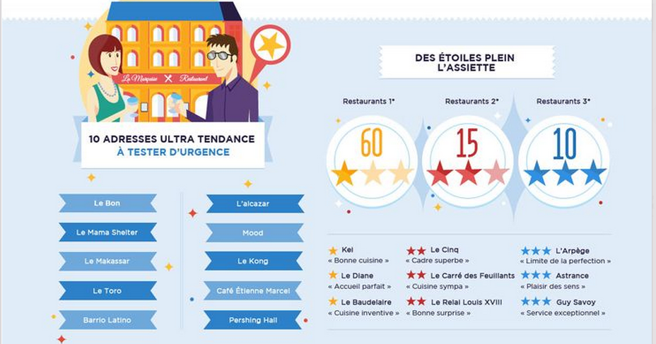

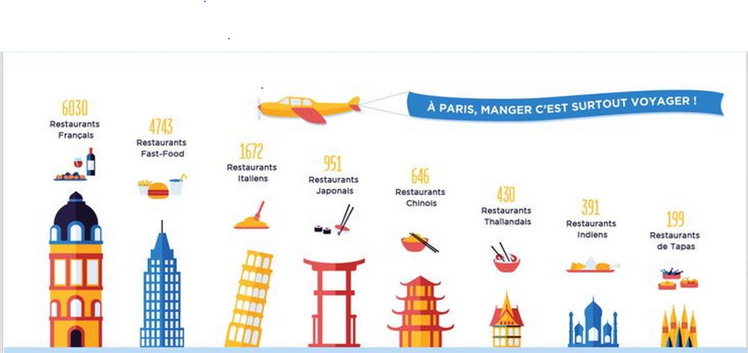
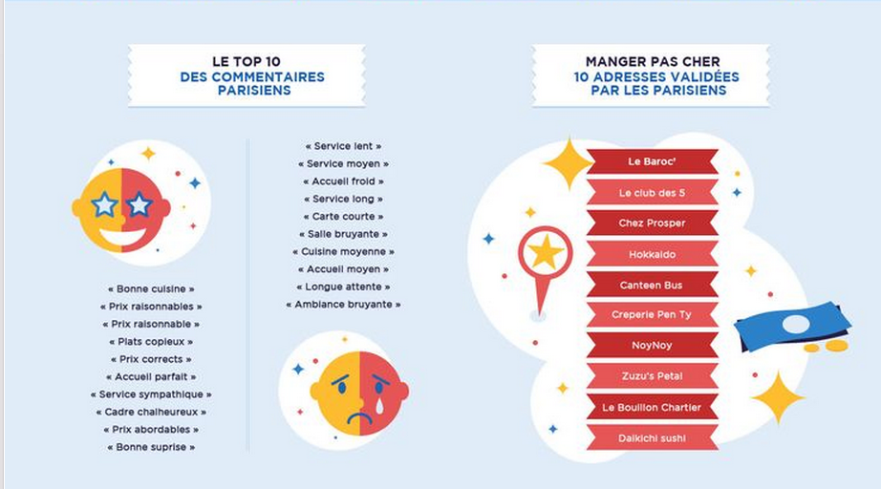
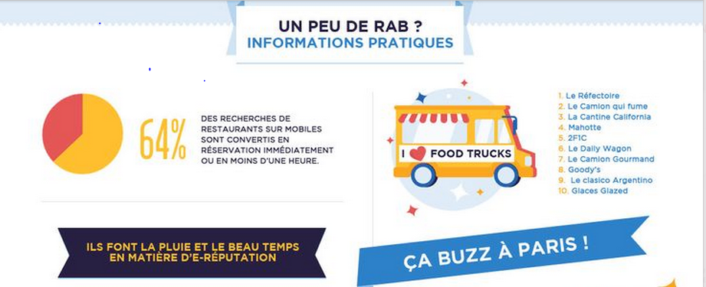

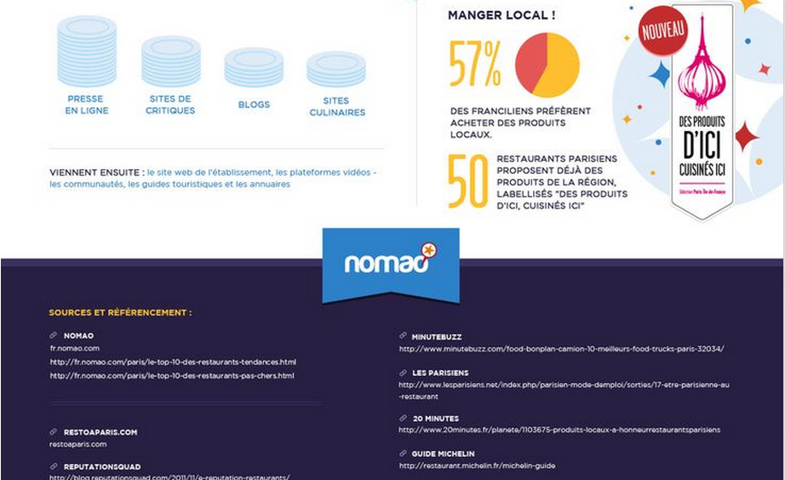

http://didoune.fr/blog/2013/10/01/infographie-sur-les-restaurants-parisiens/

