Français I Nom _____________________________________
Unit 4 IPA

Interpretive Reading
Note: An “au pair” is a young person (usually a woman) who comes from foreign country to live with a host family and help with child care and housework.

A. Key Word Recognition. Find the French words/phrases that best express the meanings of the following English words/phrases.

1. young ____________________________
2. A family____________________________
3. Activities____________________________
4. School____________________________
5. she likes____________________________
6. daughter____________________________
7. mother____________________________
8. she plays____________________________
9. movie theater____________________________

5 | Identifies all key words appropriately with context of the text.
4 | Identifies majority of key words appropriately within context of the text.
3 | Identifies half of key words appropriately within the context of the text.
2 | Identifies less than half of key words appropriately within the context of the text.
1 | No response

B. What is the main idea of this document? Answer in English.
______________________________________________________________________________________________________________________________________________________________________________________________________________________________________________________________________________________________________

5 | Identifies the complete main idea(s) of the text.
4 | Identifies the key parts of the main idea(s) of the text but misses some elements.
3 | Identifies some part of the main idea(s) of the text.
2 | Identifies a minor idea from the text.
1 | No response

C. Supporting Details.
1. Check each detail that is mentioned in the article (not all are included).
2. Fill in the information that is given for each detail you have checked. Write in English.
___Gabrielle’s age ___________________
___The grade that Gabrielle is in___________________
___What Gabrielle looks like __________________________________________________________________________
___What Gabrielle’s personality is like___________________________________________________________________
___When Gabrielle goes to school_____________________________________________________________________
___Gabrielle’s favorite subject________________________________________________________________________
___When she has free time/doesn’t go to school__________________________________________________________
___The activities that Gabrielle does (name as many as you can) _____________________________________________
__________________________________________________________________________________________________
___The language that Gabrielle is learning_____________________________
___Anna’s age___________________
___What Anna likes to do (name as many as you can) _____________________________________________
__________________________________________________________________________________________________
___Jerome’s age___________________
___What he likes (name as many as you can) _____________________________________________
__________________________________________________________________________________________________
___Who“R” is___________________________________
___Who“S” is ___________________________________
___The type of personality they’d like their au pair to have__________________________________________________
___The activities you can do in Riom____________________________________________________________________
__________________________________________________________________________________________________

5 | Identifies all supporting details in the text and accurately provides information from the text to explain these details.
4 | Identifies the majority of supporting details in the text and provides information from the text to explain some of these details.
3 | Identifies some supporting details in the text and may provide limited information from the text to explain these details. Or identifies the majority of the supporting details but is unable to provide information from the text to explain these details.
2 | Identifies some supporting detail but is unable to provide information from the text to support them.
1 | No response

D. Guessing Meaning from Context.
Find the underlined words/phrases and write what you think they mean in English. The information in parenthesis tells you which paragraph the word appears in.
(All words found in the A notre sujet portion of the text.)
- Gabrielle adore aller jouer avec ses nombreux copains et copines du square voisin (1st par.) ________________
- Le père de Jérôme, R. bactériologiste en retraite, habite la moitié de l’année à Toulon.. (3rd par.) ________________
- Toute la famille habite un appartement de 150 m2 avec un jardin de 90m 2. (4th par.) ________________
- Le domicile est situé à 5 minutes de pied de la gare de Riom d’où partent de fréquents trains pour Clermont-Fernand ou pour Vichy (4th par.) ________________
5 | Infers meaning of unfamiliar words and phrases in the text. Inferences are accurate.
4 | Infers meaning of unfamiliar words and phrases in the text. Most of the inferences are plausible although some may not be accurate.
3 | Inferences of meaning of unfamiliar words and phrases are largely inaccurate or lacking.
2 | Is unable to infer the correct meaning of any of the words or phrases.
1 | No response

E. Inference. Answer the following question(s) in English, giving us much information from the article as possible to support your response.
1. Why do you think this family wants to hire an “au pair?” __________________________________________________
__________________________________________________________________________________________________
2. Do you think this family will get many replies to their post? Why or why not? _________________________________
__________________________________________________________________________________________________
__________________________________________________________________________________________________

5 | Infers and interprets the text’s meaning in a highly plausible manner.
4 | Infers and interprets the text’s meaning in a partially complete and/or partially plausible manner.
3 | Inferences and interpretations of the text’s meaning are largely incomplete or not plausible.
2 | Inference is incomplete and not plausible
1 | No response.

F. Comparing Cultural Perspectives. Answer the following questions in English.
The United States did not start an au pair program until 1989, while it has been popular in Europe since WWII. Why do you Americans might be less interested in having an au pair than a French family would be?
__________________________________________________________________________________________________
__________________________________________________________________________________________________
__________________________________________________________________________________________________
__________________________________________________________________________________________________

5 | Identifies cultural perspectives/norms accurately. Provides a detailed connection of cultural products/practices to perspectives.
4 | Identifies some cultural perspectives/norms accurately. Connects cultural products/practices to perspectives.
3 | Identification of cultural perspectives/norms is mostly superficial or lacking. And/or connection of cultural practices/products to perspectives is superficial or lacking.
2 | Unable to identify a pertinent cultural perspective/norm.
1 | No response.

G. Would you like to work as an au pair for this family? Why or why not? Answer in French, and cite specific details from the post.
______________________________________________________________________________________________________________________________________________________________________________________________________________________________________________________________________________________________________

Raw Score ______________/30

Converted Score ___________/10

Conversion Table
28-30 = 11
26-27 = 10
24-25 = 9
20-23 = 8
16-19 = 7
12-15 = 6
11 or below = 5

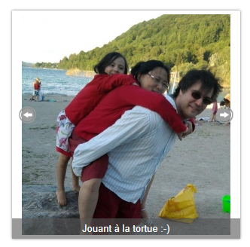
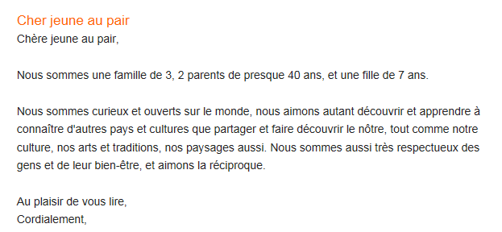
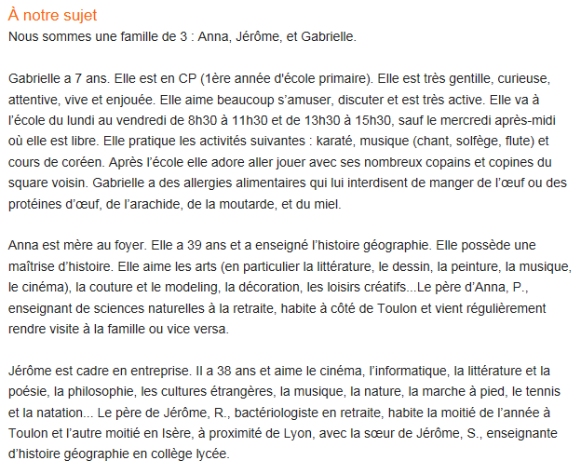
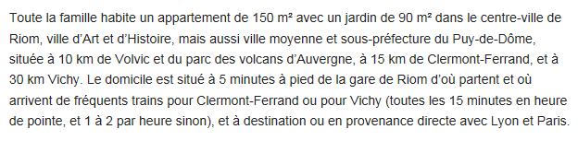
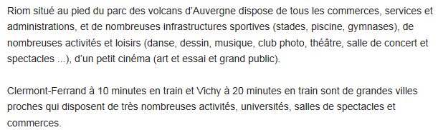
https://www.aupair-world.fr/aupair_detail?&a=2296059#letter_two
Interpretive Listening
https://www.youtube.com/watch?v=ag6y7LlTMUk&list=PL5742D94B61ABB683&index=6
A. Listen to the video and fill in as much information as you can about Gautier. Write in English.
- His age __________________________________
- His birthday__________________________________
- His family members____________________________________________________________________
- Whom he lives with__________________________________
- Where he lives__________________________________
- What he does for a living__________________________________
- His height__________________________________
- His hair __________________________________
- His eyes__________________________________
- Types of music he likes: ____________________________________________________________________
- Sports/Activities he likes: ____________________________________________________________________
- Sports/Activities he doesn’t like: ________________________________________________________________
Rubric:
10+ | Gives relevant, accurate information for most details and demonstrates consistent ability to identify cognates and make inferences about new words.
9/10 | Gives relevant, accurate information for many details, including those based new cognates and occasional inferences.
8 | Gives relevant, accurate information for those items which contain previously-learned vocabulary.
7 | Gives relevant, accurate information for many items, but is not able to identify all previously-learned vocabulary.
6 | Gives relevant, accurate information for some items, but is unable to identify many previous-learned vocabulary items.
5 | Is able to give little, if any, accurate information.

Presentational Writing
Imagine that your parents have decided to hire a French au pair to help take care of you and your siblings, as well as to help around the house. Your parents don’t know French, so you will have to write the post for them. In your post you will describe each person who lives in your house, including you. Make sure to include the following information for each person:
- What s/he looks like
- What his/her personality is like
- The activities that s/he likes and when s/he does them

Cher/Chère __________________________
____________________________________________________________________________________________________________________________________________________________________________________________________________________________________________________________________________________________________________________________________________________________________________________________________________________________________________________________________________________________________________________________________________________________________________________________________________
____________________________________________________________________________________________________________________________________________________________________________________________________________________________________________________________________________________________________________________________________________________________________________________________________________________________________________________________________________________________________________________________________________________________________________________________________________
______________________________________________________________________________________________________________________________________________________________________________________________________________________________________________________________________________________________________________________________________________________________________________________________________________________________________________________________________________________________________________________________________________________________________________________________________________________________________________________________________________________________________________
____________________________________________________________________________________________________________________________________________________________________________________________________________________________________________________________________________________________________________________________________________________________________________________________________________________________________________________________________________________________________________________________________________________________________________________________________________

Score | Indicators
10+ | You exceeded the expectations for this assignment by providing an abundance of creative detail, using complicated structures with no errors, including a varied vocabulary, and organizing your work carefully.
9/10 | You thoroughly addressed the prompt with accurate, relevant and interesting detail.  Your work was well-organized with appropriate transitions.  You used level-appropriate structures and varied vocabulary to express your meaning with few errors.
8 | You adequately addressed the prompt; most information was accurate and relevant.  Your work was well-organized with some transitions.  You used level-appropriate structures and vocabulary with only minor errors which did not impede comprehension.
7 | You partially addressed the prompt; your work would have benefited from additional relevant detail.  Your work lacked organization— the lack of an introduction, conclusion, or adequate transitions made it appear choppy or difficult to follow.  You relied on simple structures and repetitive vocabulary, or made errors which occasionally interfered with comprehension.
6 | Your work fell significantly short of expectations due to a lack of relevant detail.  Your work was disorganized; you jumped around from one topic to another and/or did not include an introduction and conclusion.  You made errors in grammar and/or vocabulary which significantly impeded comprehension.
5 | You did not meet the stated expectations for this assignment. See Madame for a retake.
Presentational Speaking
Imagine that you are making a video to send to the au pair agency. Tell your future au pair all about the members of your family that she/he will meet. Make sure to include the following information about each person who lives with you:
- a physical description (hair/eye color, size)
- information about his/her personality
- information about his/her likes/dislikes/preferences.
- information about his/her activities

Score | Indicators
10+ | You exceeded the stated expectations for this assignment.  You used complex structures and varied vocabulary with no errors.  You spoke fluently with excellent pronunciation.
9/10 | You thoroughly addressed the prompt with accurate, relevant and interesting detail.  Your presentation was well-organized with smooth transitions.  You were able to speak without relying on written notes.  You used level-appropriate structures and varied vocabulary to express your meaning with few errors.  You spoke fluently with excellent pronunciation.
8 | You adequately addressed the prompt; most information was accurate and relevant.  Your presentation was logically organized.  You glanced at your visual aid/notecards, but only occasionally.  You used level-appropriate structures and vocabulary with only minor errors which did not impede comprehension.  You may have spoken with a slight accent and occasional pauses.
7 | Your presentation fell slightly short of stated expectations due to a lack of adequate, pertinent detail.  Your presentation occasionally lacked adequate transitions between ideas.  You paused to check the script on your visual aid or notes.  You relied on simple structures and repetitive vocabulary, or made errors which occasionally interfered with comprehension.  You may have spoken with considerable accent and/or frequent pauses.
6 | Your presentation fell significantly short of stated expectations.  Your presentation lacked organization; you jumped around between ideas rather than presenting your information in a logical order.  You read directly from your visual aid or notes.  You made errors in grammar and/or vocabulary which significantly impeded comprehension.  You may have spoken with significant pronunciation errors or long pauses.
5 | Your presentation did not meet stated expectations in terms of content, organization, vocabulary/grammatical structures, and pronunciation.

Commentaire du prof _______________________________________________________________________________
______________________________________________________________________________________________________________________________________________________________________________________________________________________________________________________________________________________________________

